H46S
Honda NC750 X/S

Kit for left side: |  |  |  |  | Kit for right side:
ID. | Description | Cat.N | Qt |  |  | ID. | Description | Cat.N | Qt
1 | Bolt M6x25 | 877 | 3 |  |  | 1 | Bolt M6x25 | 877 | 3
2 | Bolt M12x90x1,25mm | 919 | 1 |  |  | 2 | Bolt M12x80x1,25mm | 891 | 1
3 | Alu spacer d=70mm | 350 | 1 |  |  | 3 | Alu spacer d=11mm | 17 | 1
4 | Bolt M12x40 | 857 | 1 |  |  | 4 | Alu adapter d=60mm | 349 | 1
5 | Bolt M10x30mm | 846 | 2 |  |  | 5 | Bolt M12x25 | 860 | 1
6 | Steel adapter | 654 | 1 |  |  | 6 | Bolt M10x35mm | 976 | 2
7 | Steel clamp | 656 | 1 |  |  | 7 | Steel adapter | 655 | 1
8 | Washer M12 | 803 | 1 |  |  | 8 | Steel clamp | 659 | 1
9 | Tape 3M |  | 1 |  |  | 9 | Washer M12 | 803 | 1
10 | Bolt M4x16 | 876 | 2 |  |  | 10 | Bolt M4x16 | 876 | 2
 |  |  |  |  |  | 11 | Tape 3M |  | 1

Assembly left side:

- Take out lower fairing and bolt M12 from frame.
- Steel adapter ID.6 fit on the frame by bolt M12x90x1,25mm ID.2 with washer M12 ID.8, tighten easy.
- Place steel clamp ID.7 and bolts M10x30mm ID.5 tighten it to steel adapter, place 3M tape wher is touching with frame. Bolt M12x90x1,25mm ID.2 tighten firstly than steel clamp.
- By bolts M12x40 ID.4 mounting dural adapter ID.3 for slider.
- By bolts ID.1 assembly slider. Into the slider insert alu cover, tighten it by bolts ID.10.
Assembly right side:
- Take out lower fairing, coolant bottle and bolt M12 from frame.
- Steel adapter ID.7 fit on the frame by bolt M12 ID.2 with washer ID.9. Insert spacer ID.3 between frames and adapter. Tighten it easy.
- Place steel clamp ID.8 and bolts M6 ID.6 tighten to steel adapter, place 3M tape wher is touching with frame,bolt M12x80x1,25mm ID.2 tighten firstly than steel clamp.
- By bolt M12x25 ID.5 mounting dural adapter ID.4 for slider.
- By bolts ID.1 assembly slider. Into the slider insert alu cover, tighten it by bolts ID.10.

Mounting back to bike coolant bottel and lower fairing.
Warning - on the threads of the screws we recommend using premium adhesive moderate (blue).

Assembly pictures:

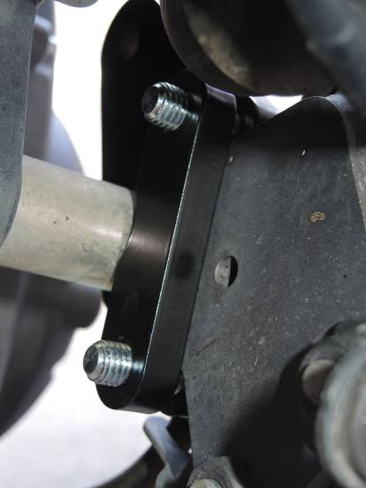
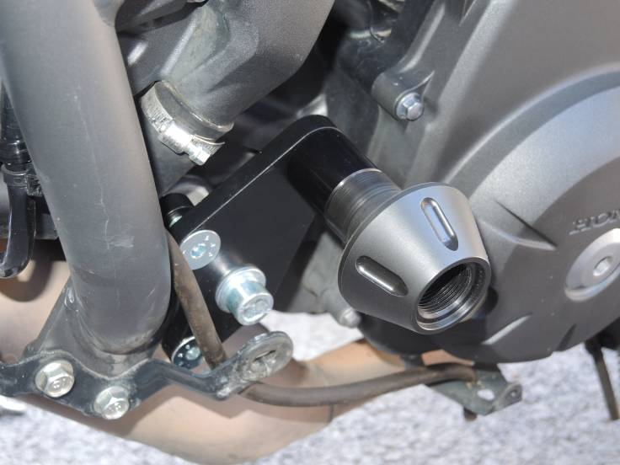
Ilust.photos,place for fits is same.

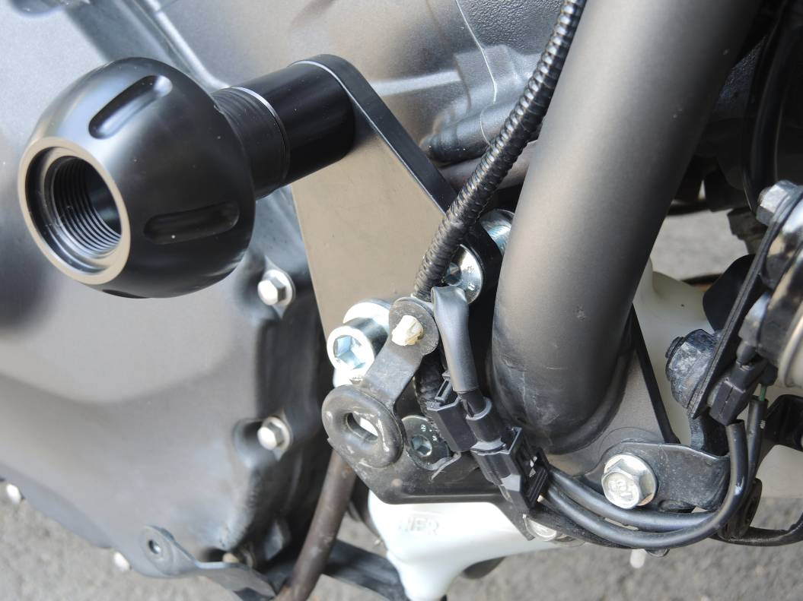
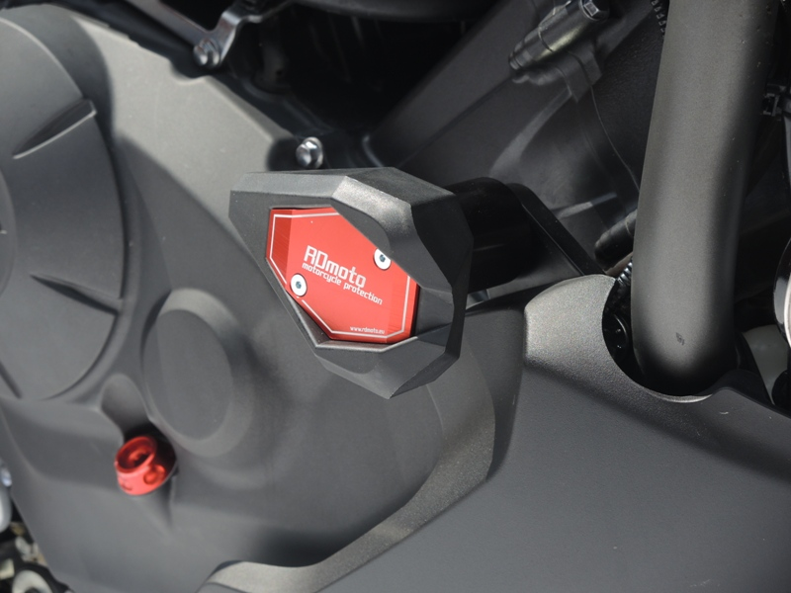
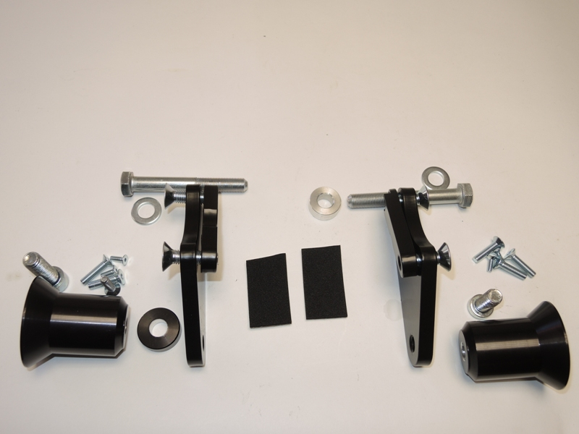
5
8
2
6
8
2
7
8
3
4
5
1
6
2
9
1
5
6
7
4
3

