H49SD
Honda NC750 DCT

Kit for left side: |  |  |  |  | Kit for right side:
ID. | Description | Cat.No | Qty |  |  | ID. | Description | Cat.N | Qty
1 | Duralumin bracket | 537 | 1 |  |  | 1 | Duralumin bracket | 537 | 1
2 | Bolt M12x90x1,25mm | 919 | 1 |  |  | 2 | Bolt M12x80x1,25mm | 891 | 1
3 | Dural.reduction | DV149 | 1 |  |  | 3 | Dural.cylinder d=11mm | 17 | 1
4 | Dural.cylinder d=50mm | 209 | 1 |  |  | 4 | Dural.reduction d=90mm | 157 | 1
5 | Bolt M10x35mm | 976 | 2 |  |  | 5 | Bolt M12x110 | 946 | 1
6 | Steel adapter | 655 | 1 |  |  | 6 | Bolt M10x35mm | 976 | 2
7 | Steel bracket | 659 | 1 |  |  | 7 | Steel adapter | 654 | 1
8 | Washer M12 | 803 | 1 |  |  | 8 | Steel bracket | 656 | 1
9 | Tape 3M | 3M | 1 |  |  | 9 | Washer M12 | 803 | 1
10 | Bolt M8x25 | 815 | 2 |  |  | 10 | Tape 3M | 3M | 1
11 | Washer-spring M8 | 800 | 2 |  |  | 11 | Bolt M8x25 | 815 | 2
12 | Bolt M12x80 | 956 | 1 |  |  | 12 | Washer-spring M8 | 800 | 2
 |  |  |  |  |  | - |  | - | -

Instruction to left side:

- Dismantle lower fairing and original bolt from frame M12.
- Steel adapter ID.6 mount on the frame use bolt M12x90x1,25mm ID.2 and washer M12 ID.8.
- Stell bracket ID.7 mount by bolts M10x30mm ID.5. Stick on 3M tape ID.9 on frame.
- On the bolt ID.12 insert dural.bracket ID.1, under the bracket put reduction ID.3 with cylinder ID.4.
- This kit mounting on the steel adapter ID.6. For slider gripping use bolts and washers ID.11 and ID.10.

Instruction to right side:

- Take out coolant bottle and original bolt M12 from frame.
- Mount steel adapter ID.7 same so on the left side, but between the frame and adapter inser dural. cylinder d=11mm ID.3.
- Steel bracket with threads ID.8 put on the back side to frame and mount by bolts ID.6.
- Mount back coolant bottle on the bike.
- On the bolt ID.5 insert dural.bracket ID.1, under the bracket put reduction ID.4.
- This kit mounting on the steel adapter ID.7. For slider gripping use bolts and washers ID.11 and ID.12.
Put fairing back on the bike.
Warning – use glue of all threads- medium strong.
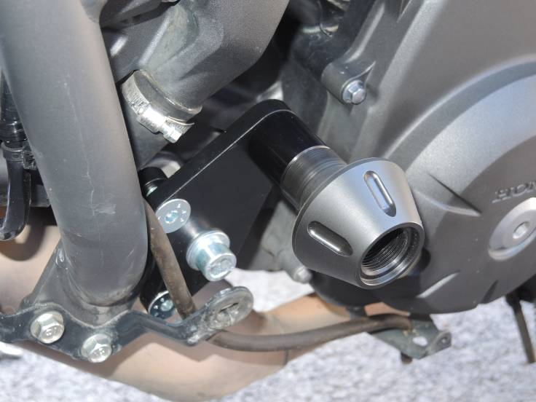
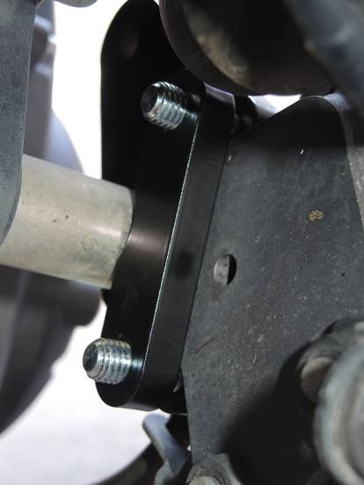
Ilustration photos with PH protectors

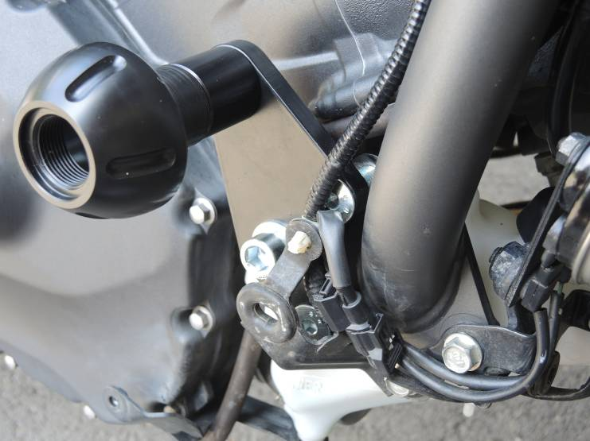
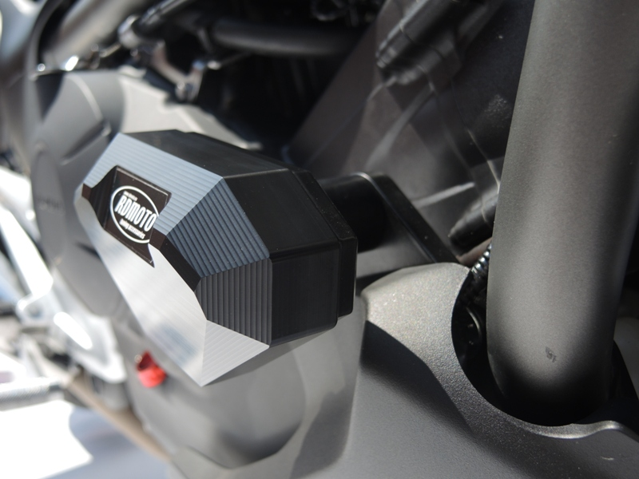
3
1

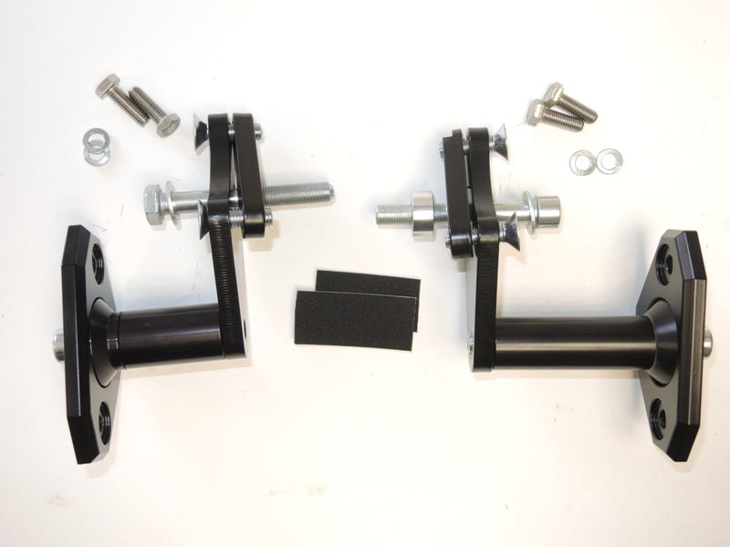
11,10
8
12,11
7
7

2
5
6
2

1
4
3
9
6

12
5
8
9
4
10

