H4SD
Honda CBR1000RR 2006-2007

Left side kit: |  |  |  |  | Right side kit:
ID. | Description | Cat.N | Qt |  |  | ID. | Description | Cat.N | Qt
1 | SLD adapter | 537 | 1 |  |  | 1 | SLD adapter | 537 | 1
2 | Bolt M12x80x1,25mm | 891 | 1 |  |  | 2 | Bolt M12x90x1,25mm | 919 | 1
3 | Alu. spacer - 21,5mm | 85 | 1 |  |  | 3 | Bolt M12x85x1,25mm | 902 | 1
4 | Dural. cylinder – 40mm | 12 | 1 |  |  | 4 | Alu.spacer - 19mm | 83 | 1
5 | Bolt M8x25mm | 831 | 1 |  |  | 5 | Alu. spacer - 17mm | 84 | 1
6 | Poly. cylinder M8 - 20mm | X6 | 1 |  |  | 6 | Dural. cylinder – 40mm | 12 | 1
7 | Washer M8 | 802 | 1 |  |  | 7 | Washer M8 | 802 | 2
8 | Steel adapter | 521 | 1 |  |  | 8 | Steel adapter | 522 | 1
9 | Alu. spacer - 10mm | 120 | 1 |  |  | 9 | Alu. spacer - 10mm | 120 | 1
10 | Bolt M6x30mm | 864 | 1 |  |  | 10 | Bolt M6x30mm | 864 | 1
11 | Tape 3M | - | 1 |  |  | 11 | Tape 3M | - | 1
12 | Washer M12 | 803 | 1 |  |  | 12 | Washer M12 | 803 | 2
13 | Bolt M10x60 | 850 | 1 |  |  | 13 | Bolt M10x60 | 850 | 1
14 | Washer M10 (stringed) | 801 | 1 |  |  | 14 | Washer M10 (stringed) | 801 | 1
15 | Bolt M8x25 | 815 | 2 |  |  | 15 | Bolt M8x25 | 815 | 2
 | 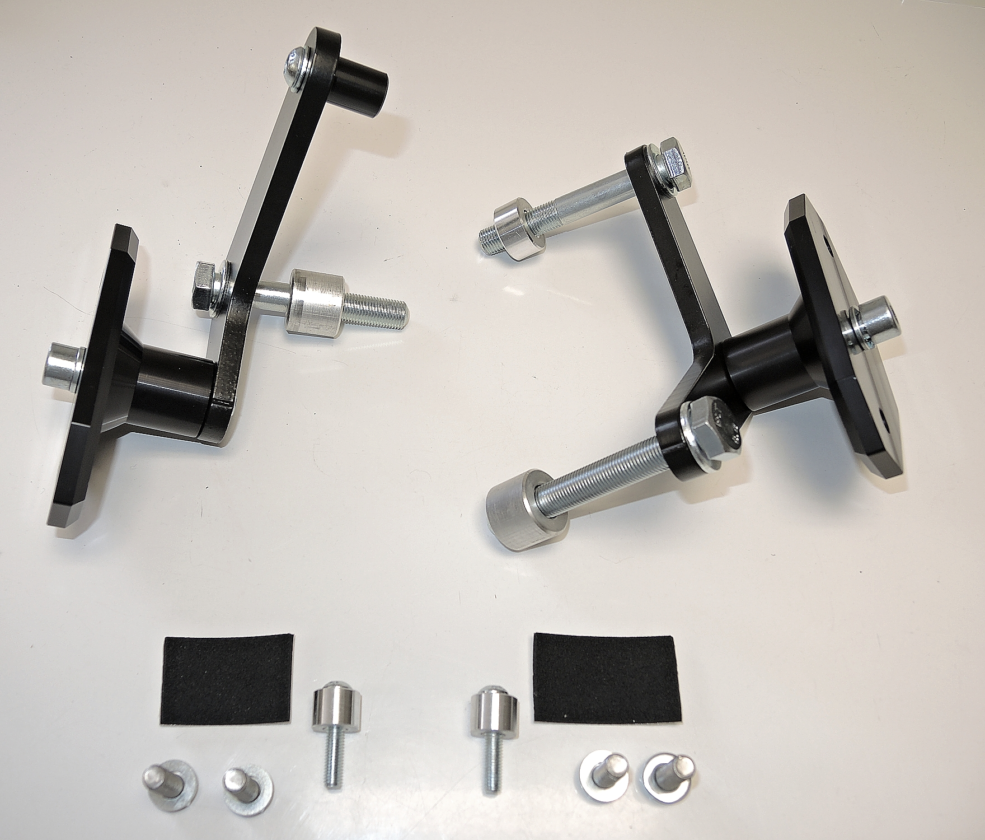
 | ID5+6+7
ID8
ID2+12
 |  | ID3 |  |  |  | ID3+12 | ID8
ID1
ID5
ID13+14

ID13+14
ID1
ID6
ID4
ID2+12

ID4

ID11
ID9+10
ID9+10

ID15+7
ID15+7

Left side instructions:

- Remove fairing of motorcycle.
- Prepare mounting kit for SLD.
  - Fit poly cylinder ID6 using bolt ID5 and washer ID7 on steel adapter ID8.
  - Fit steel adapter on the motorcycle using bolt ID2+ID12 and cylinder ID3.
  - Stick 3M tape ID11 on the alu adapter from back side.
- Put fairing back on motorcycle and repace original bolt + add alu cylinder according to the picture 3.
- Fit SLD adapter (ID1) with dural cylinder (ID4) on the steel adapter using bolt (ID13+ID14).
- Fit protector using two bolts (ID15+ID7).

Right side instructions:

- Remove fairing of motorcycle.
- Stick 3M tape ID11 on the alu adapter from back side.
- Place spacer ID4 – P1 and ID5 – P2 under the adapter and tighten it using bolts ID2-P1 and ID3-P2 according to the picture 2.
- Put fairing back on motorcycle and repace original bolt using bolt ID10 + add alu cylinder according to the picture 3.
- Fit SLD adapter (ID1) with dural cylinder (ID6) on the steel adapter using bolt (ID13+ID14).
- Fit protector using two bolts (ID15+ID7).

Note: Use medium strong glue on all threads.

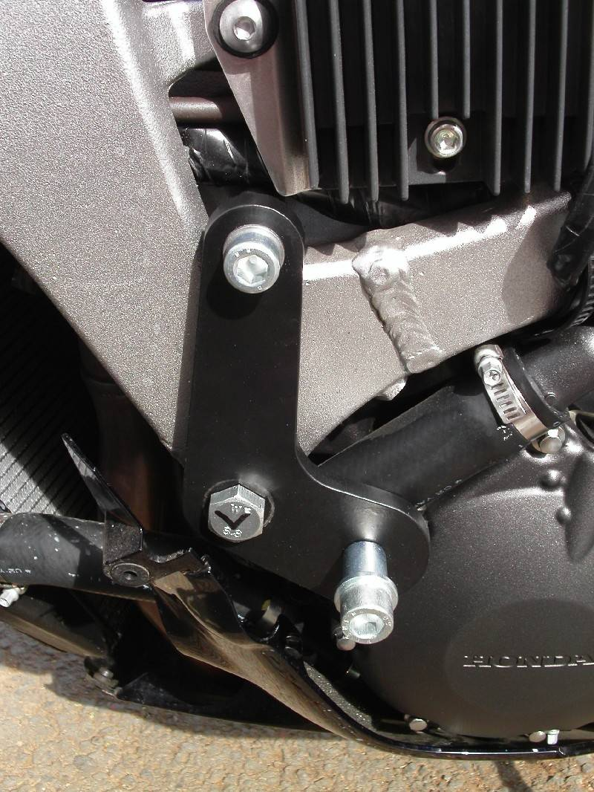
Picture 1
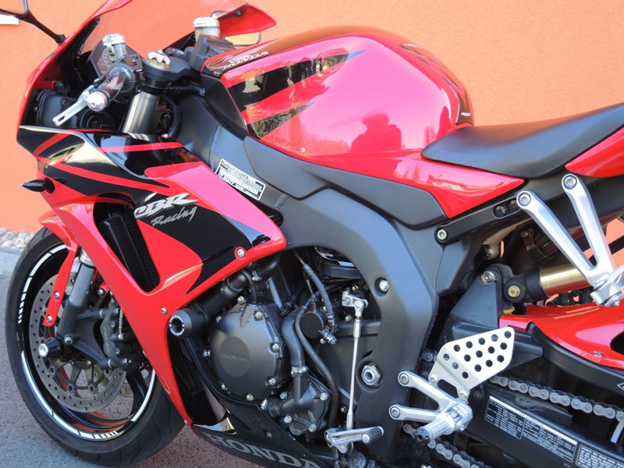
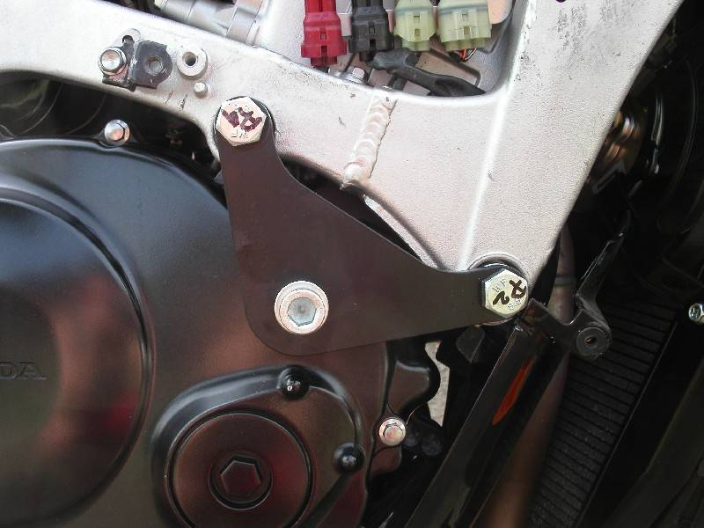
P1
ID4 +ID2+ID12
P2
ID5+ID3+ID12

Picture 3
Picture 2
ID9 + ID10

