H4S
Honda CBR1000RR 2006-2007

Left side kit |  |  |  |  | Right side kit
ID | Description | Cat.no. | Pcs |  |  | ID | Description | Cat.no. | Pcs
1 | Dural. cylinder - slider adapter | 317 | 1 |  |  | 1 | Dural. cylinder – slider adapter | 317 | 1
2 | Bolt M12x80x1,25mm | 891 | 1 |  |  | 2 | Bolt M12x90x1,25mm | 919 | 1
3 | Dural. cylinder 21,5mm | 85 | 1 |  |  | 3 | Bolt M12x85x1,25mm | 902 | 1
4 | Bolt M10x25mm | 868 | 1 |  |  | 4 | Dural. cylinder 19mm | 83 | 1
5 | Bolt M8x25mm | 831 | 1 |  |  | 5 | Dural. cylinder 17mm | 84 | 1
6 | poly nut M8 d=20mm | X6 | 1 |  |  | 6 | Bolt M10x25 | 868 | 1
7 | Washer (spring) M8 | 800 | 1 |  |  | - | ----- | -- | -
8 | Dural adapter | 521 | 1 |  |  | 8 | Dural adapter | 522 | 1
9 | Dural. cylinder 10mm | 120 | 1 |  |  | 9 | Dural. cylinder 10mm | 120 | 1
10 | Bolt M6x30mm | 864 | 1 |  |  | 10 | Bolt M6x30mm | 864 | 1
11 | Tape 3M |  | 1 |  |  | 11 | Tape 3M |  | 1
12 | Bolt M4 | 876 | 2 |  |  | 12 | Bolt M4 | 876 | 2
13 | Bolt M6 | 877 | 3 |  |  | 13 | Bolt M6 | 877 | 3
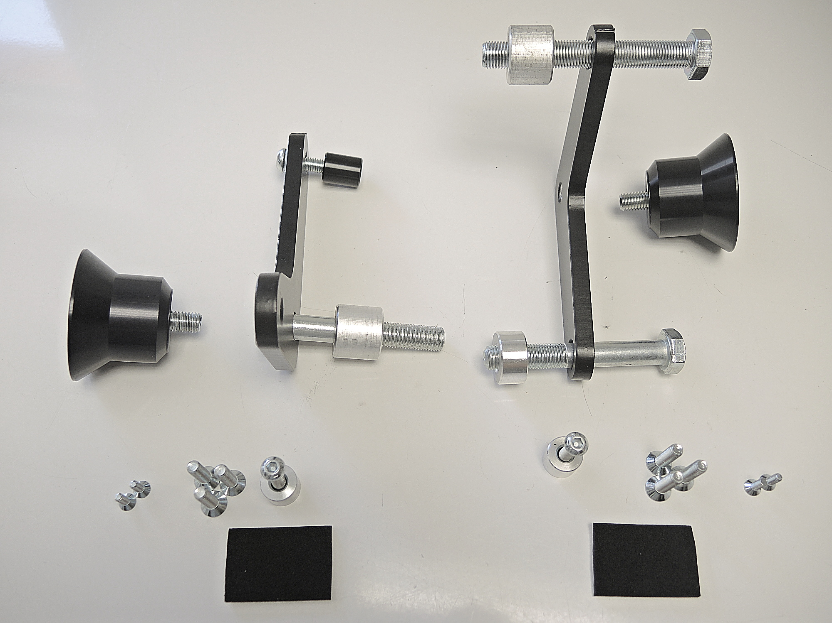

5+3

8
5+6+7
1+6

8

3
2
1+4

4+2

13
9+10
12
13
12

9+10

Instructions for the left side:

- Remove fairing from the motorcycle.
- Mount Bolt ID5 with poly nut ID6 and washer M8 (ID7) on the dural adapter (ID8).
- Stick 3M tape on the back side of adapter.
- Place dural. cylinder ID3 under adapter and fit adapter using bolt ID2 on the frame of motorcycle.
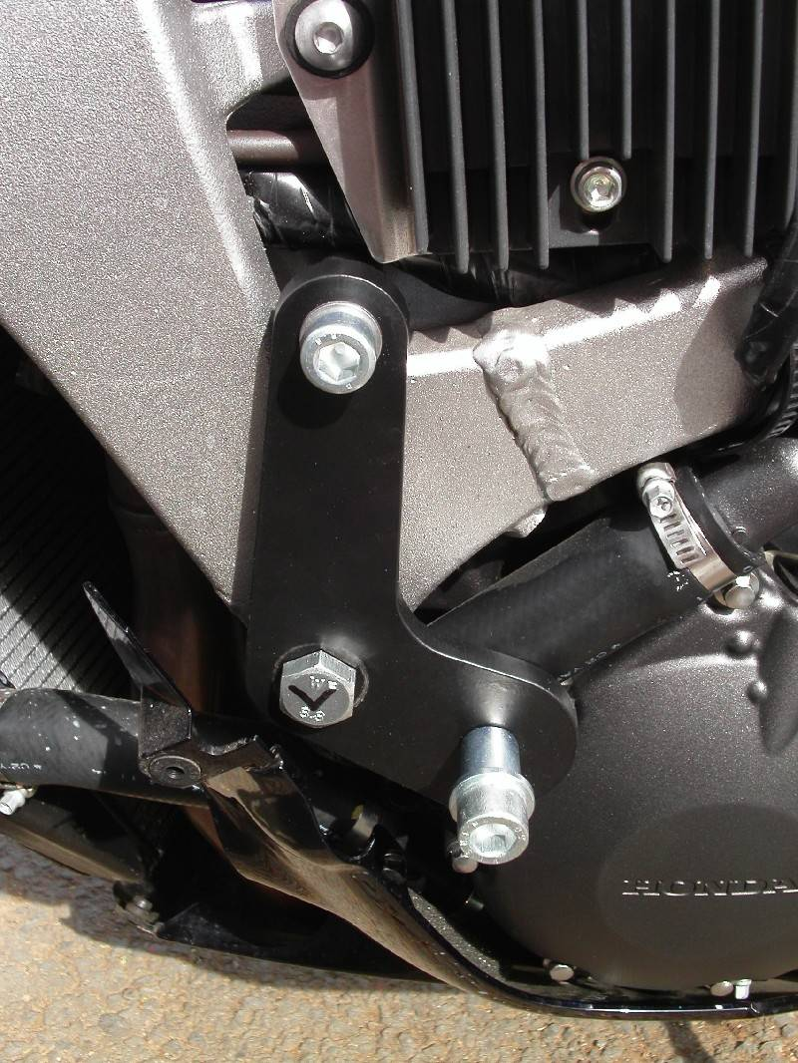
- Mount fairing back using cylinder ID9 and bolt ID10.
- Now mount dural cylinder ID1 using M10 bolt ID4 on the dural adapter ID8.
- Mount slider on the dural cylinder using three bolts M6.
- Mount coloured cover using two bolts M4.

Instructions for the right side

- Remove fairing from the motorcycle.
- Stick 3M tape on the back side of adapter ID8.
- Place dural cylinders under adapter and mout it on the frame using bolts M12 (P1-ID4+ID2 and P2-ID5+ID3).
- Mount fairing back using cylinder ID9 and bolt ID10.
- Now mount dural cylinder ID1 using M10 bolt ID4 on the dural adapter ID8.
- Mount slider on the dural cylinder using three bolts M6.
- Mount coloured cover using two bolts M4.

We recommend to use the glue on all threads (blue color – medium strong).

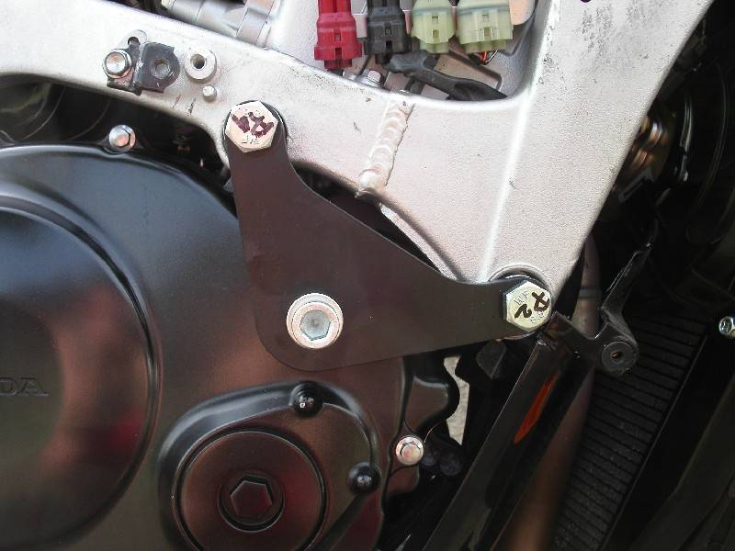
P1
P2

