H4
Honda CBR1000RR 2006-2007

Left side kit: |  |  |  |  | Right side kit:
ID. | Description | Cat.N | Qt |  |  | ID. | Description | Cat.N | Qt
1 | Steel box | X1 | 1 |  |  | 1 | Steel box | X1 | 1
2 | Bolt M12x80x1,25mm | 891 | 1 |  |  | 2 | Bolt M12x90x1,25mm | 919 | 1
3 | Alu. spacer d=21,5mm | 85 | 1 |  |  | 3 | Bolt M12x85x1,25mm | 902 | 1
4 | Bolt M10x35mm | 847 | 1 |  |  | 4 | Alu.spacer d=19mm | 83 | 1
5 | Bolt M8x25mm | 831 | 1 |  |  | 5 | Alu. spacer d=17mm | 84 | 1
6 | Poly. nut M8 d=20mm | X6 | 1 |  |  | 6 | Bolt M10x35mm | 847 | 1
7 | Washer M8 | 800 | 1 |  |  | - | ----- | -- | -
8 | Alu. adapter | 521 | 1 |  |  | 8 | Alu. adapter | 522 | 1
9 | Alu. spacer d=10mm | 120 | 1 |  |  | 9 | Spacer d=10mm | 120 | 1
10 | Bolt M6x30mm | 864 | 1 |  |  | 10 | Bolt M6x30mm | 864 | 1
11 | Tape 3M |  | 1 |  |  | 11 | Tape 3M |  | 1

Assembly left side:

- Take off fairing from the bike.
- Assembly alu. adapter ID.8, place poly nut ID.6 by bolt ID.5+ washer ID.8 on the alu. adapter.
- Stick 3M tape ID.11 on the alu adapter from back side.
- Under the adapter place spacer ID.3 and tighten it by bolt ID.2 on the frame.
- Check all bolts and place fairing back the bike. UFor more space use spacer ID.9 and bolts ID.10.
- Insert steel box into the protector ID.1 with bolt ID.4 and washer ID.7. Mount this set on the adapter.
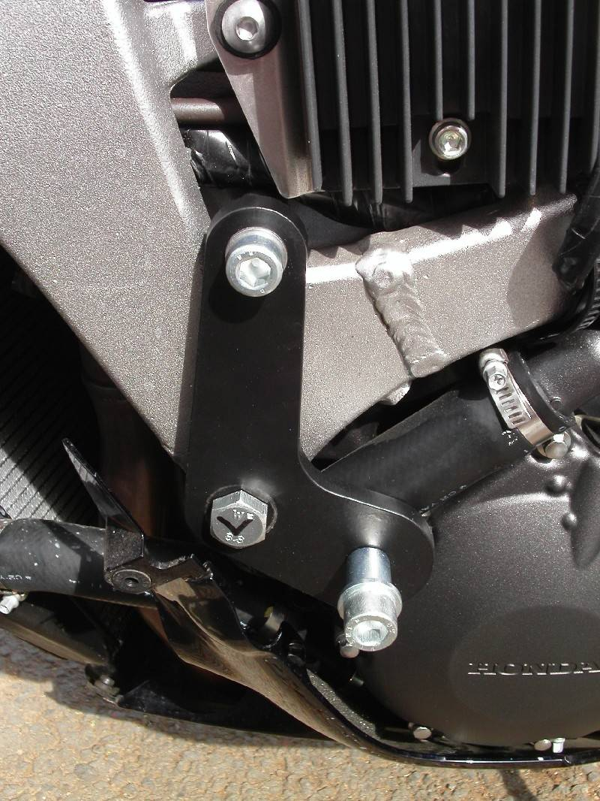

Assembly right side:

- Take off fairing from the bike.
- Stick 3M tape ID.11 on the alu adapter from back side.
- Place spacer under the adapter (ID.4 –P1) + (ID.5 –P2) and bolts (ID.2-P1) + (ID.3-P2) tighten adapter to chassi.
- Check all bolts and place fairing back the bike. UFor more space use spacer ID.9 and bolts ID.10.
- Insert steel box into the protector ID.1 with bolt ID.6. Mount this set on the adapter.

Note: Use medium strong glue on the bolts.

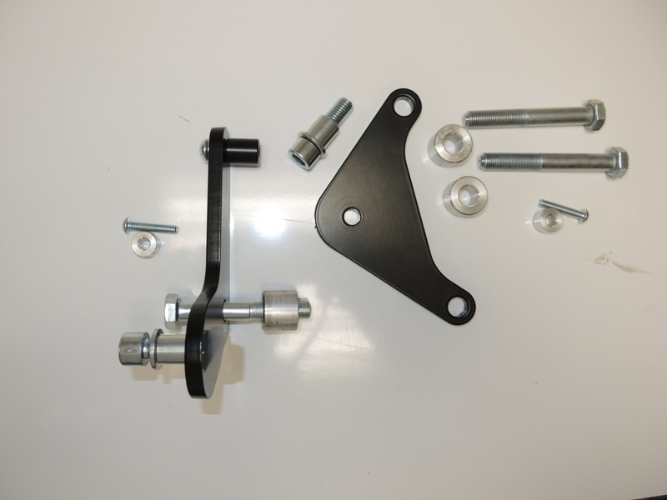
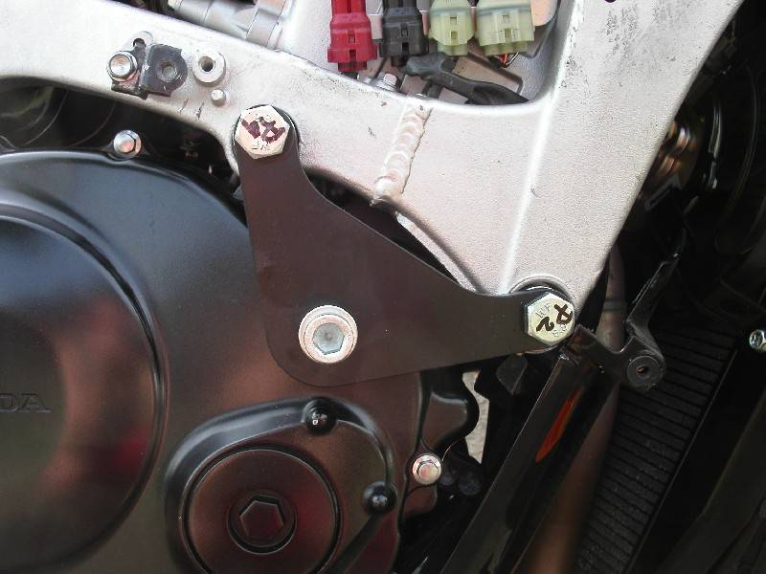
P1
P2

