H5-2
Honda CBF600 2008-
Honda CB600F Hornet 2007-

Kit for the left side |  |  |  |  | Kit for the right side
ID. | Description | Cat.N | Pcs |  | ID. | Description | Cat.N | Pcs
1 | Steel box M12 | X2 | 1 |  | 1 | Steel box M12 | X2 | 1
2 | Bolt M12x105x1,25mm | 912 | 1 |  | 2 | Bolt M12x95x1,25mm | 900 | 1
3 | Duralumin cylinder d=15mm | 148 | 1 |  | 3 | Duralumin cylinder d=15mm | 148 | 1

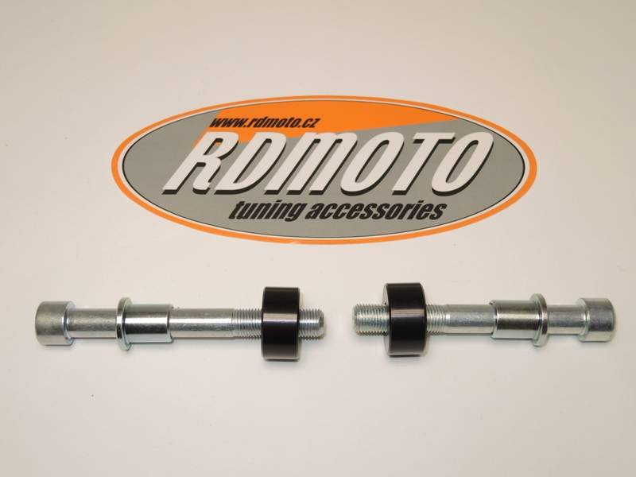

Installation:

- Installation of the left and right protector make in gripping about the attached photo below.
- Insert the steel box M12 (ID. 1) into the protector. Put the duralumin cylinder (ID. 3) under the protector on the left side and use the bolt (ID. 2) for tightening.
- Put the duralumin cylinder (ID. 3) under the protector on the right side and use the bolt (ID. 2) for tightening.
- At first finish the one side and then mount the second side.

Warning – we recommend to use safety glue on threads of all bolts (moderate strong – blue colour).

