H50SDM
Honda MSX 125_2014-16 (Grom)

Fitting kit left side: Fitting kit right side:
ID | Description | Cat.n | QT
1 | Mounting plate | 690 | 1
2 | Dural.spacer l=57mm | 1166 | 1
3 | Engine bar l=225mm |  | 1
4 | Nylon cut nuts M10 | 810 | 2
5 | Washer M10 | 804 | 2
6 | Bolt M6x40 | 865 | 2
7 | Dural. spacer l=10mm | 1164 | 1
8 | Dural. spacer l=9mm | 1165 | 1
ID | Description | Cat. | QT
1 | Mounting plate | 691 | 1
2 | Dural.spacer l=21mm | 1158 | 1
3 | Conecting bar l=230mm |  | 1
4 | Nylon cut nuts M10 | 810 | 2
5 | Washer M10 | 804 | 2
6 | Bolt M6x50 | 972 | 1

Assembly kit for protectors:
ID | Description | Cat.n | QTY
9 | Plastic cover | X35 | 4
10 | Dural. spacer l=60mm | 14 | 1
11 | Dural. spacer l=90mm | 238 | 1
12 | Bolt M10x90 | 880 | 1
13 | Bolt M10x120 | 881 | 1
14 | Washer spring M10 | 801 | 2
15 | Nylon nut cut M10 | 810 | 2
16 | Dural. holder for SLDM | 537/B | 2
17 | Bolt M6x20 | 1024 | 4
18 | Washer M6 | 1023 | 4

Instruction to assembly:
- Remove the nut on the engine bolt on the left side of the bike.
- Remove original bolt from the engine.
- Remove the engine case bolts 2 pices from the left side, 1 piece from the right side.
- Take the shorter engine bar l=225mm ID.3 and insert it thru the engine (replace original bolt).
- Place dural. cylinder l=57mm ID.2. on the bar from the left hand side. Place dural. cylinder l=21mm ID.2. on the bar from the right hand side. Place mounting plates from right side and tighten it by nylonce nuts ID.4 and place washer ID.5.
- Make assembly mounting plates into the engine case, use bolt ID.6
- The mounting plate assembly can now be offerd up the right side of the bike. Conecting bar insert in front of the engine and do assembly. Connecting bar tighten by nut ID.4 and washer ID.5.
- Now you can make assembly left side. Bolts ID.6 place throught the mounting plate. There are two dural. spacers. The porter spacer l=9mm is insert on the bolt place down.
- Insert mounting plate on the engine bar and connecting bar.
- Two bolts M6 with spacers mounting into the engine case.
- Tighten mounting plate by nuts ID.4 and washers ID.5.
- After this chec all bolts and nuts, now you can put plastic covers ID.9.

Crash protecotrs assembly instruction:
- Left side:
- Dural. bracket ID.16 with dural. spacer ID.10 (porter) place on the bolt ID.12. This kit mounting from back side by nut and washer ID.14,ID.15 into the mounting plate on the engine.
- Slider mounting on the dural. holder by bolts ID.17 with washers ID.18.
- Right side:
- Dural. bracket ID.16 with dural. spacer ID.11 place on the bolt ID.13.
- This kit mounting from back side by nut and washer ID.14,ID.15 into the mounting plate on the engine.
- Slider mounting on the dural. holder by bolts ID.17 with washers ID.18.

Warning: We recommend use the glue of all threads. Medium strong.

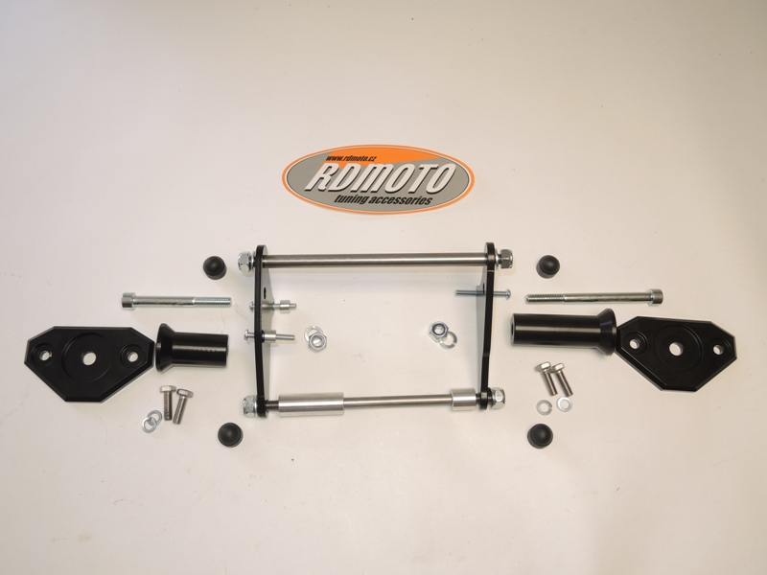

2
1
2
1
4,5
3
3
4,5
4,5
4,5
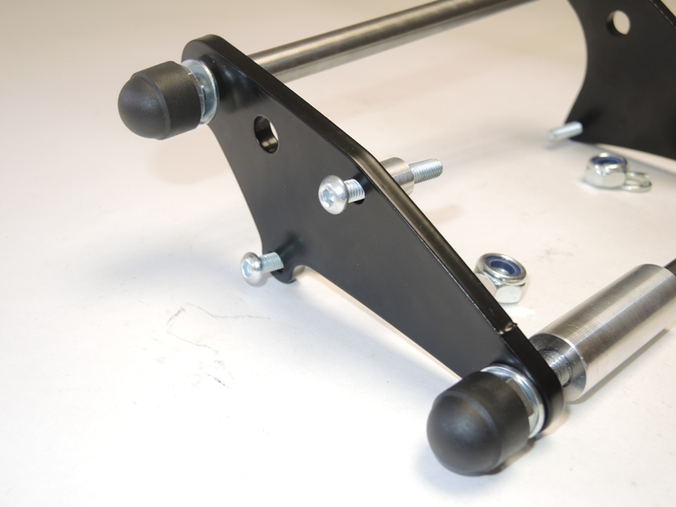
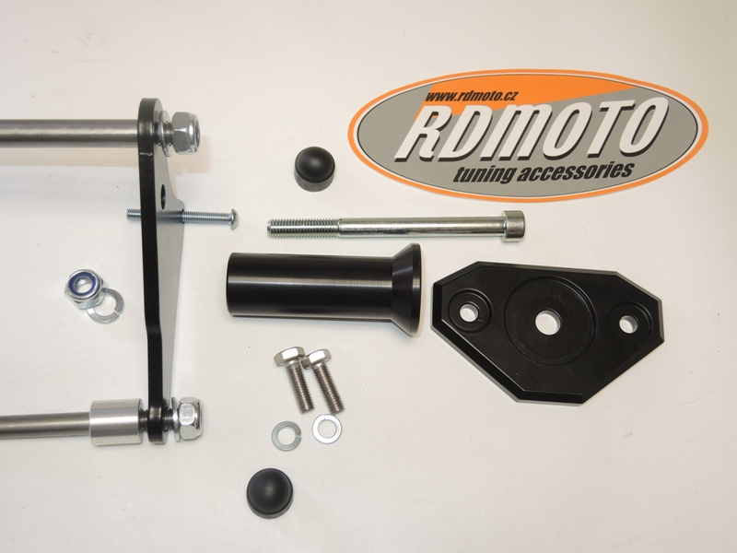
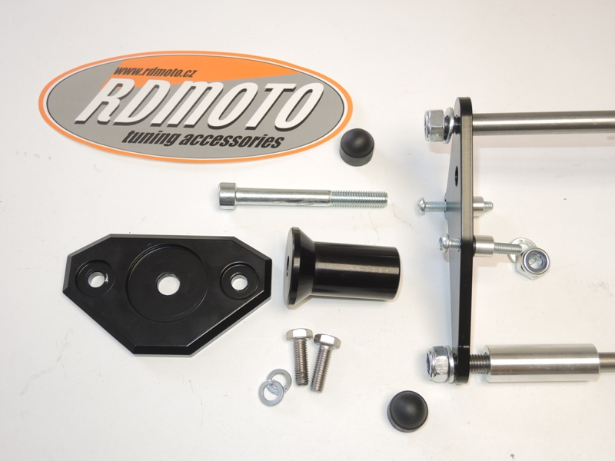
6
6
6
7
8
9
9
10
15
14
13
12
11
16
17.18
16
17.18

