H50S
Honda MSX 125_2014-16

Fitting kit left side: Fitting kit right side:
ID | Description | Cat.N | Qt
1.1 | Steel adapter | 690 | 1
2.1 | Alu. spacer d=57mm | 1166 | 1
3.1 | Stainless steel rod 10x225x30x30 |  | 1
4 | Nut M10 | 810 | 2
5 | Washer M10 | 804 | 2
6.1 | Bolt M6x40 | 865 | 2
7 | Alu.spacer l=10mm | 1164 | 1
8 | Alu.spacer l=9mm | 1165 | 1
ID | Description | Cat.N | Qt
1.2 | Steel adapter | 691 | 1
2.2 | Alu. spacer d=21mm | 1158 | 1
3.2 | Connecting bar 12x230xM10x20x20 |  | 1
4 | Nut M10 | 810 | 2
5 | Washer M10 | 804 | 2
6.2 | Bolt M6x50 | 972 | 1
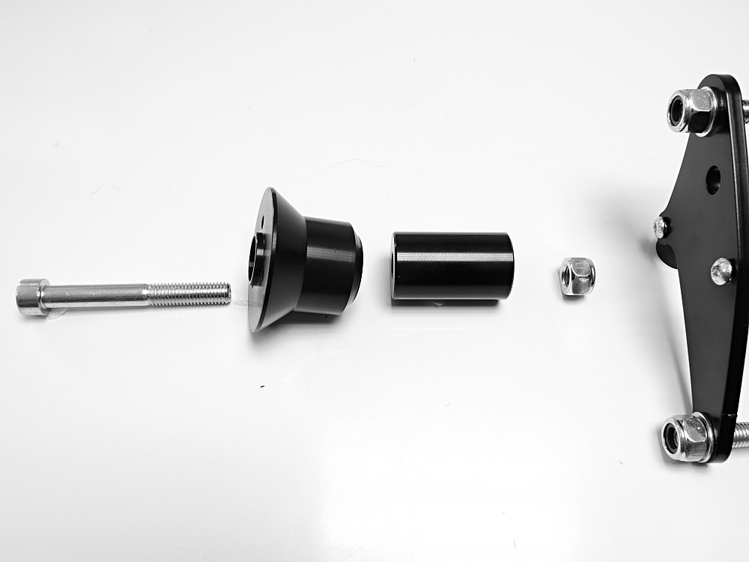
picture 1

Kit for protectors:
ID | Description | Cat.N | Qt
9 | Plastic cap | X35 | 4
10 | Alu. spacer d=70 (right) | 7 | 1
11 | Alu. spacer d=50 (left) | 5 | 1
12 | Bolt M10x100 (right) | 885 | 1
13 | Bolt M10x80 (left) | 852 | 1
14 | Bolt M6x25 | 877 | 6
15 | Bolt M4x16 | 876 | 4
16 | Nut M10 | 810 | 2
17 | Slider adapter | 313 | 2

Slider adapter
cylinder
Steel adapter
Nut
Bolt

picture 2
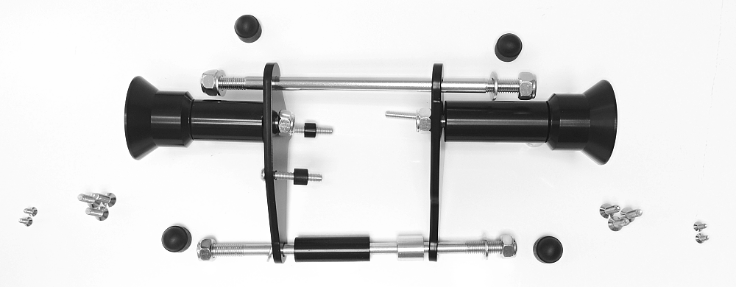
15
9
13+17+11+16
14
12+17+10+16
2.1
2.2
1.2
1.1
6.1+8
6.1+10
6.2

Instructions for fitting kit:

- Dismantle nut on the left side of engine.
- Remove original bolts from engine.
- Fit mounting kit according to the picture 2.
  - Shorter steel rod (ID3.1) pass through engine.
  - Shorter alu spacer (ID8) is on the lower bolt M6 (ID6.1).
  - Longer alu spacer (ID2.1) is on the left
- Cover all four M10 bolts using plastic caps (ID9)

Instructions for sliders:

- Fit sliders accoridnig to the picture 1.
  - Put slider adapter (ID17), alu spacer (ID10 on the right, ID11 on the left) on M10 bolt (ID12 on the right, ID13 on the left).
  - Tighten the M10 bolts using M10 nuts (ID16).
  - Fit slider on the slider adapter (ID17) using three M6 bolts (ID14).
  - Fit coloured cover using two M4 bolts (ID15).

We recommended to use the glue on all threads (medium strong – blue colour).
6
6
9
9
10
12
16
17.18

