H50
Honda MSX 125

Fitting kit left side: Fitting kit right side:
ID | Description | Cat.N | Qt
1 | Fitting bracket | 690 | 1
2 | Alu. spacer d=57mm | 1166 | 1
3 | Stainless steel rod 10x225x30x30 |  | 1
4 | Nut M10 | 810 | 2
5 | Washer M10 | 804 | 2
6 | Bolt M6x40 | 865 | 2
7 | Alu.spacer l=10mm | 1164 | 1
8 | Alu.spacer l=9mm | 1165 | 1
ID | Description | Cat.N | Qt
1 | Fitting bracket | 691 | 1
2 | Alu. spacer d=21mm | 1158 | 1
3 | Connecting bar 12x230xM10x20x20 |  | 1
4 | Nut M10 | 810 | 2
5 | Washer M10 | 804 | 2
6 | Bolt M6x50 | 972 | 1

Kit for protectors:
ID | Description | Cat.N | Qt
9 | Plastic cap | X35 | 4
10 | Alu. spacer d=70 | 7 | 1
11 | Alu. spacer d=50 | 5 | 1
12 | Bolt M10x95 | 822 | 1
13 | Bolt M10x110 | 879 | 1
14 | Steel box | X1 | 2
15 | Washer | 801 | 2
16 | Nut M10 | 810 | 2

Fitting instruction:
- Dismantle nut on the left side of engine. As shown on the picture.
- Take off the bolt from engine.
- From left side take off two bolts from engine case.
- Shorter steel rod d=225mm ID.3 place through the engine, replace orignal bolt.
- Insert spacer d=57mm ID.2 from lef side. Insert spacer d=21mm ID.2 from right side. Now place steel brackets and easy tighten nut ID.4 with washer ID.5.
- Assembly bolts for engine case ID.6 for right side.
- Use bolts ID.6 from left side. Insert alu spacer d=9mm on the bolt M6 from back side.
- Place steel rod infront part, for tighten use nut ID.4 and washers ID.5.
- Now tighten all connections and bolts, place plastic covers on the nuts.

Assembly for cash protectors:
- Left side:
- On the bolt ID.12 insert steel box ID.14. This kit insert inside the protector. Under the protector place alu. spacer ID.11.

- This kit assembly on the steel bracke, tighten it by nut ID.15 and washer ID.16 from back side.
- Right side:
- On the bolt ID.13 insert steel box ID.14. This kit insert into the protector. Place alu. spacer under the protector ID.10.
- This kit assembly on the steel bracket and tighte it by nut ID.15 with washer ID.16 from the back side.

During assembly use glue of all threads. Medium strong.

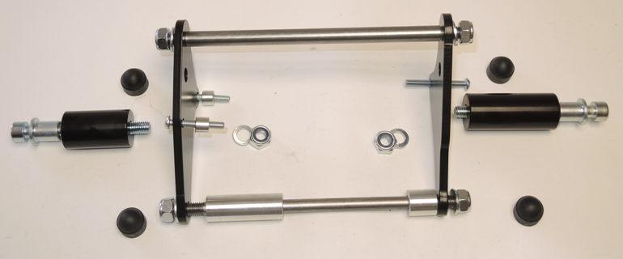

6
6
9
9
10
12
16
17.18
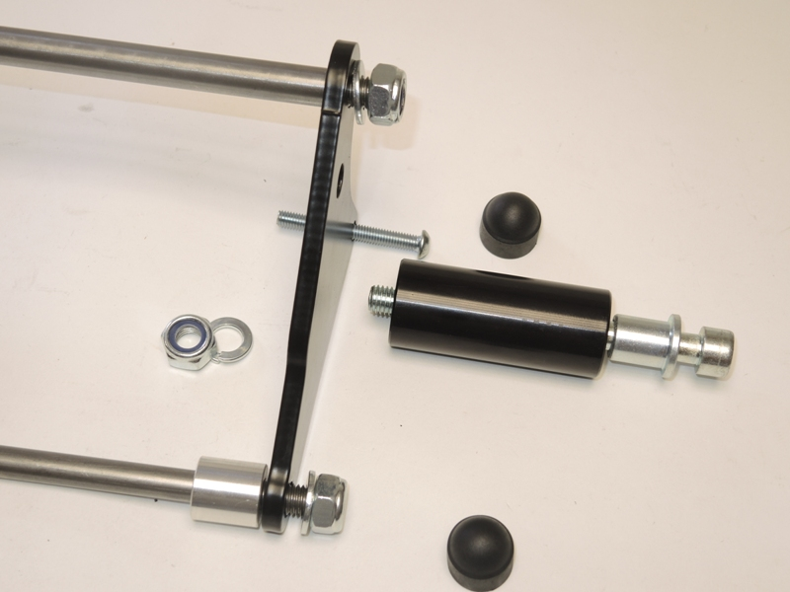
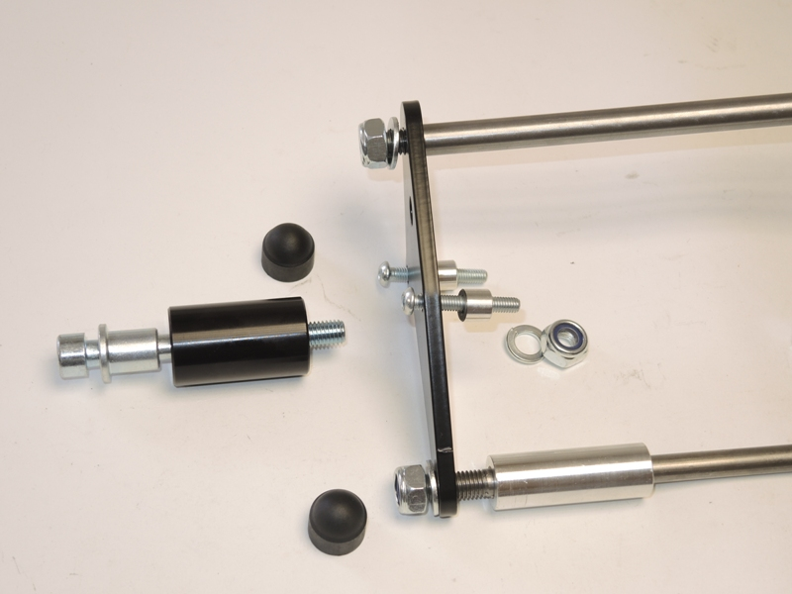
2
6
7
2
1
4,5
9
3
4,5
15,16
4,5
8
14
12
11
4,5
9
1
3
2
9
9
10
14
13
15,16
6

