H52

**Honda CB 125 F ´14-**

**Fitting kit:**

|  |  |  |  |
| --- | --- | --- | --- |
| **ID** | **Description** | **Cat.N** | **QTY** |
| 1 | Steel sleeve | X1 | 2 |
| 2 | duralumin adapter l=80mm- Left side | 259 | 1 |
| 3 | duralumin adapter l=90mm- Right side | 260 | 1 |
| 4 | bolts M10x50mm | 849 | 2 |
| 5 | M10x130x30x30  2  1  4 | - | 1  5  3  1  4 |

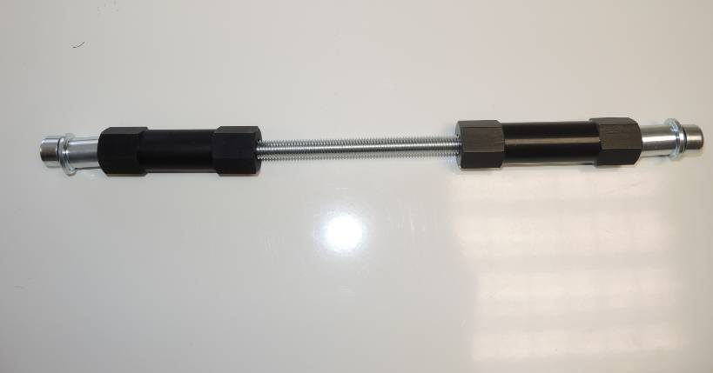

**Installation:**

Dismantle original bolt from chassi. Insert threaded bar and assmbly ID.2 part from left side and ID.3 part from right side.

Insert steel sleeves ID.1 into the protectors. By bolts M10x50 assembly ant tighten protectors on the special aluminium holders.

**Note: We recommend to use glue for all threads during assembly.**

19

20

13,14

5

17

18

5

6

9

1

8

12

14

11

13

10

15,12

7,12

8,11

11,16

3

2

4