H53
Honda CBR500R 2016-

Left side kit: Right side kit:
ID | Desription | Cat.no | Pcs
 | Bolt M10x80x1,25 | 920 | 1
2 | Washer M10 | 804 | 1
3 | Bolt M6x35 | 989 | 2
4 | Dural. cylinder - 30,5mm | 197 | 1
5 | Steel insert | X1 | 1
6 | Bolt M10x90 | 880 | 1
7 | Steel adapter | 714 | 1
8 | Special cylinder | 190 | 1
ID | Desription | Cat.no | Pcs
1 | Bolt M10x90x1,25 | 890 | 1
2 | Washer M10 | 804 | 1
3 | Bolt M6x35 | 989 | 2
4 | Dural. cylinder - 44mm | 199 | 1
5 | Steel insert | X1 | 1
6 | Bolt M10x80 | 852 | 1
7 | Ocelový adaptér | 715 | 1
8 | Special cylinder | 191 | 1
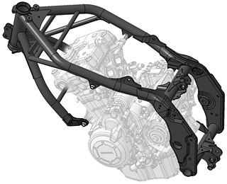
Instructions:
2
4
3

- Remove fairing of motorcycle.
- Remove original bolt from the frame.
- Mount steel adapter ID7 using two bolts ID3 and bolt ID1+ID2+ID4.
- Mount fairing back on the motorcycle.
- Insert steel insert ID5 into protectors and insert bolt ID6 through this kit.
- Put special cylinder ID8 on the bolt.
- Mount this kit into the steel adapter.

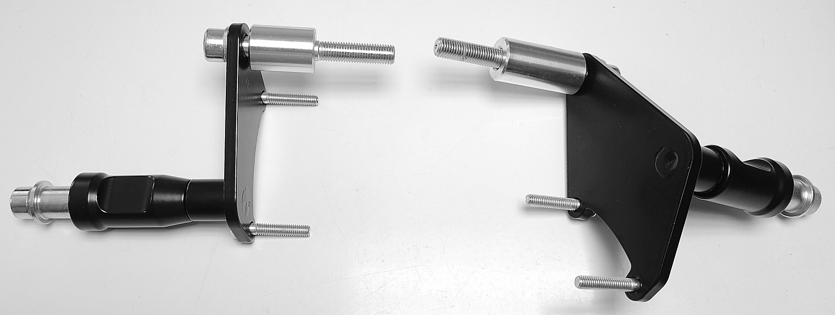
We recommend to use the glue on all threads (medium strong).
ID8
ID1+ID2+ID4
ID7
ID3
ID3
ID5
ID6

