H54*
Honda VTR1000 SP2

Kit for Left Side |  |  |  |  | Kit for Right Side
ID. | Description | Cat. No. | Pcs. |  |  | ID. | Description | Cat. No. | Pcs.
1 | Steel Insert M12 | X2 | 1 |  |  | 1 | Steel Insert M12 | X2 | 1
2 | Steel Nut M12 | X12 | 1 |  |  | 2 | Steel Nut M12 | X12 | 1
3 | Alu. roller l=102mm | 1186 | 1 |  |  | 3 | Alu. roller l=62mm | 1187 | 1
4 | Alu. roller l=21,5mm | 85 | 1 |  |  | 4
5 | M12x(1,25)x485x30x30 |  | 1 |  |  | 5

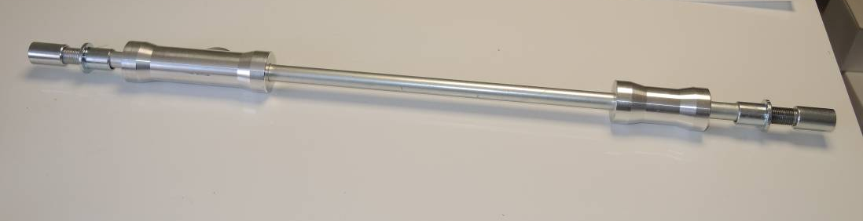

It is necessary to dril a hole for protectors into the hood of your bike.

Unscrew the original bolt from motorcycle frame. Put the rollers onto the rod, then protectors and tighten all by special nut.

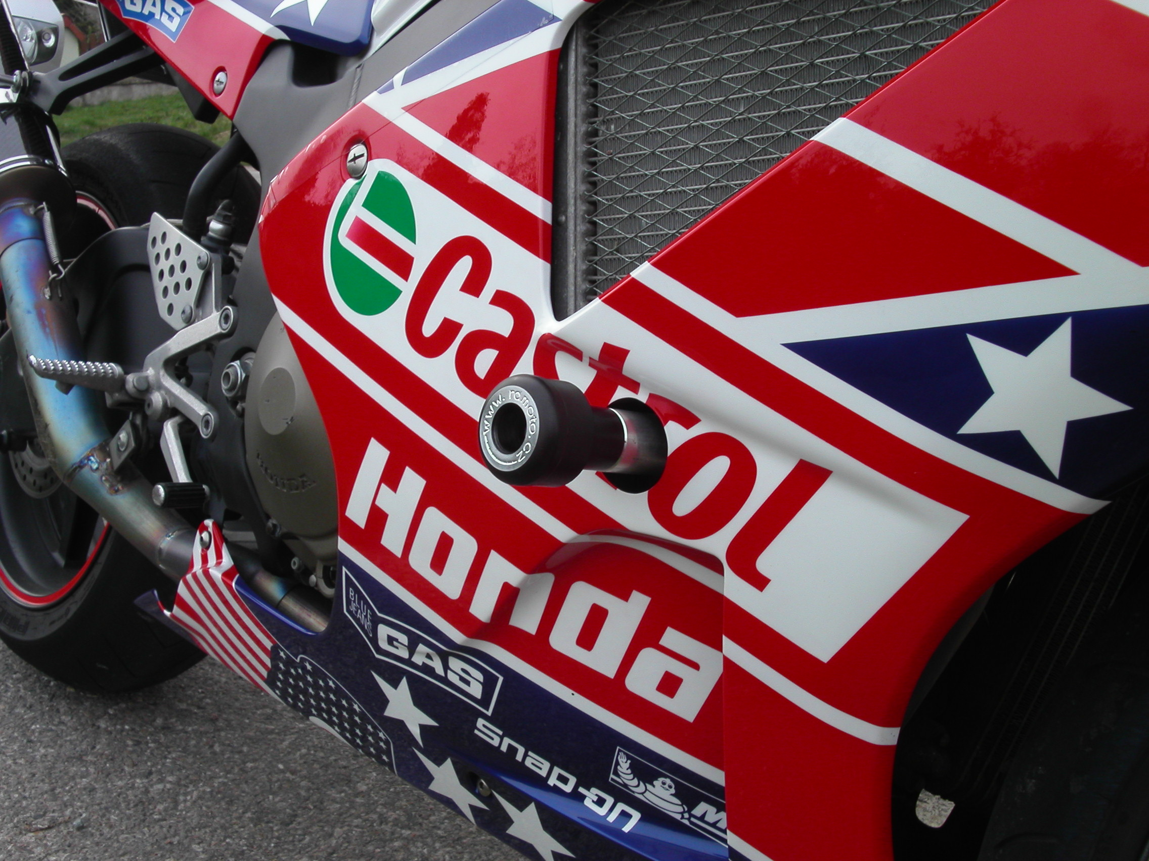
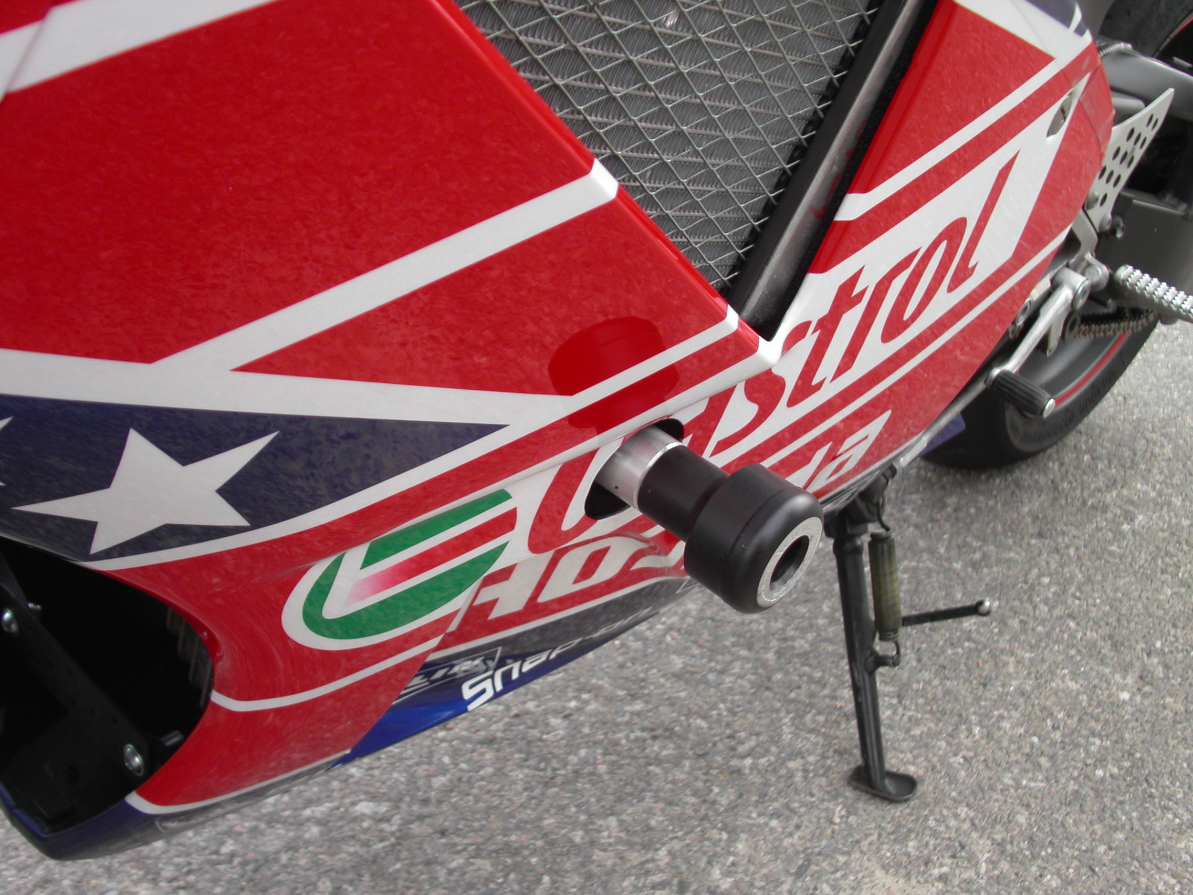
We recommend using medium strenght thread glue during assembly.

