H5S
Honda CBF600 2008-
Honda CB600F Hornet 2007-

Kit for left side: Kit for right side:

ID | Popis | Kat.č. | Počet
1 | Slider SL01 | SL01 | 1
2 | Bolt M6x25 | 877 | 3
3 | Bolt M4x16 | 876 | 2
4 | Bolt M10x20 | 819 | 1
5 | Adapter for slider | DV 317 | 1
6 | Dural. adaptér | 609 | 1
7 | Bolt M12x85x1,25mm | 899 | 1
8 | Bolt M10x65x1,25mm | 945 | 1
9 | dural.cylinder d=12mm | 80 | 1
10 | dural.cylinder d=8mm | 79 | 1
11 | Cover | CapSl. | 1

ID | Popis | Kat.č. | Počet
1 | Slider SL01 | SL01 | 1
2 | Bolt M6x25 | 877 | 3
3 | Bolt M4x16 | 876 | 2
4 | Bolt M10x20 | 819 | 1
5 | Adapter for slider | DV 317 | 1
6 | Dural. cylinder | 610 | 1
7 | Bolt M12x65x1,25mm | 940 | 1
8 | Bolt M10x65x1,25mm | 945 | 1
9 | dural.cylinder d=12mm | 80 | 1
10 | Cover | CapSl. | 1

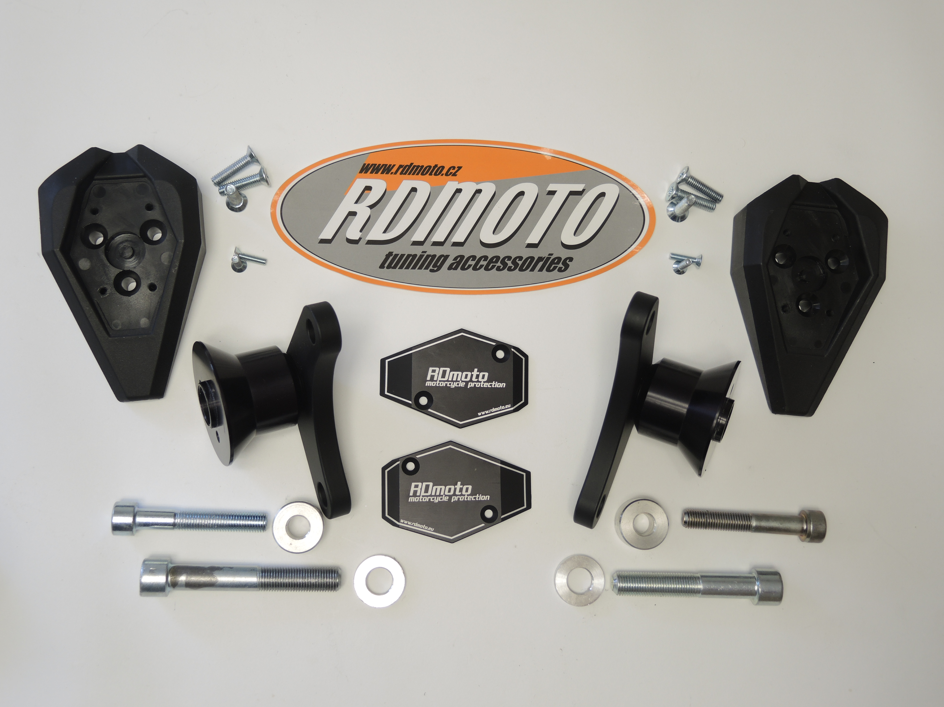
2
1

3
2
3
1

6

6

5

5
8

8
11
9
7
9
10
7

Instruction- left side :

- Take out bolts from frame
- Dural. adapter ID.6 (smaller) mounting on the frame, use bolts ID.7 and ID.8
- Insert between the adapter and frame dural. cylinder ID.9 and ID.10
- Mount adapter for slider ID.5 use bolt M10x20 ID.4
- Mout slider use bolts M6x25 ID.2
- Insert cap into the slider ID.11 and use bolts M4x16 ID.3

Instruction- right side :

- Take out bolts from frame
- Dural. adapter ID.6 mounting on the frame, use bolts ID.7 and ID.8
- Insert between the adapter and frame dural. cylinder ID.9
- Mount adapter for slider ID.5 use bolt M10x20 ID.4
- Mout slider use bolts M6x25 ID.2
- Insert cap into the slider ID.11 and use bolts M4x16 ID.3

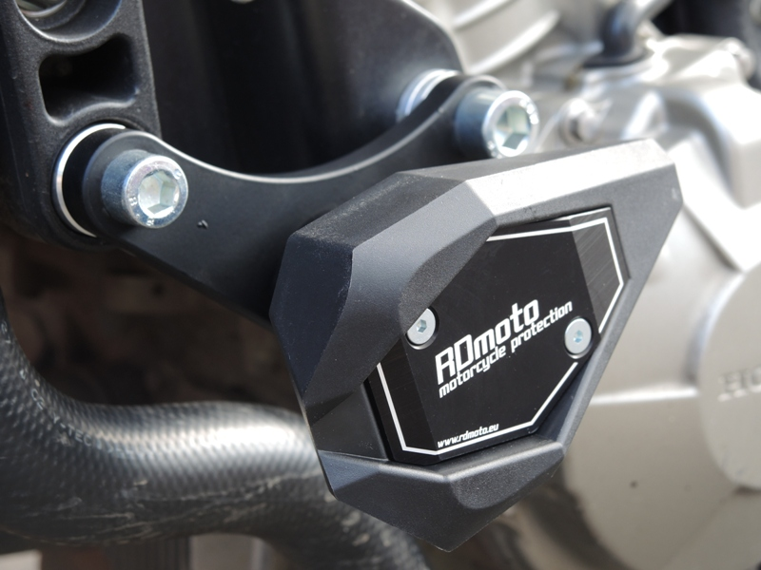
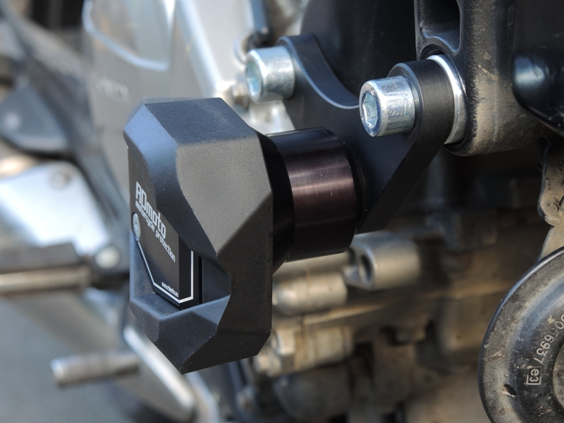
Warning - the threads of the screws is recommended to use premium glue moderate (blue color).

