H5
Honda CBF600 2008-
Honda CB600F Hornet 2007-

Kit for the left side |  |  |  |  | Kit for the right side
No. | Description | Cat.no. | Pcs |  |  | No. | Description | Cat.no. | Pcs
1 | Steel box M10 | X1 | 1 |  |  | 1 | Steel box M10 | X1 | 1
2 | Bolt M12x85x1,25mm | 899 | 1 |  |  | 2 | Bolt M12x65x1,25mm | 940 | 1
3 | Bolt M10x65x1,25mm | 945 | 1 |  |  | 3 | Bolt M10x65x1,25mm | 945 | 1
4 | Bolt M10x35mm | 847 | 1 |  |  | 4 | Bolt M10x35mm | 847 | 1
5 | Dural.cylinder d=12mm | 80 | 1 |  |  | 5 | Dural.cylinder d=12mm | 80 | 1
6 | Dural.cylinder d=8mm | 79 | 1 |  |  | 6 | Duralumin adapter | 610 | 1
7 | Duralumin adapter | 609 | 1

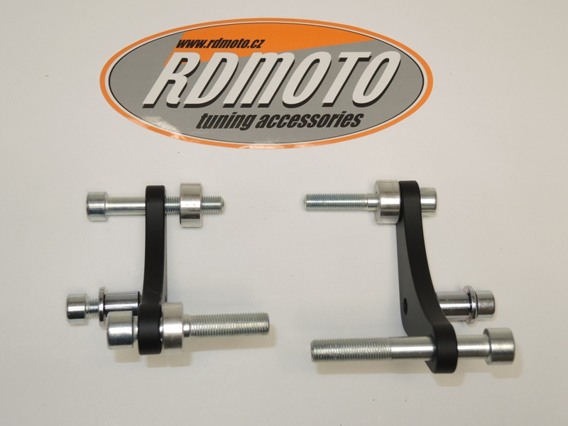

Installation – the left side:

- remove the original bolts
- take the duralumin adapter and give the bolts (No. 2 and No. 3) into the adapter
- the other side of the adapter give the duralumin cylinder (No. 6 and No. 5) on the bolts
- mount the adapter on the frame of the motorcycle, tighten all carefully
- give the steel box (No. 1) together with the bolt (No. 4) into the protector
- all this set mount into the thread on the adapter

Installation – the right side:

- remove the original bolts
- take the duralumin adapter and give the bolts (No. 2 and No. 3) into the adapter
- the other side of the adapter give the duralumin cylinder (No. 5) on the bolts
- mount the adapter on the frame of the motorcycle, tighten all carefully
- give the steel box (No. 1) together with the bolt (No. 4) into the protector
- all this set mount into the thread on the adapter

Warning – we recommend to use safety glue on threads of all bolts (moderate strong – blue colour).
