H65SD
Honda CB 125 R 2019-

Mounting Kit – Left Side: Mounting Kit – Right Side:
ID | Description | Cat.No | Pcs
1 | Steel adapter | 744 | 1
2 | Steel adapter rear L | 745 | 1
3 | Dural. sleeve l=32mm | 1120 | 1
4 | Bolt M10x60x1,25mm | 925 | 1
5 | Bolt M10x25x1,25mm | 1059 | 1
6 | Dural. adapter l=60mm | 14 | 1
7 | Bolt M8x25mm | 815 | 2
8 | Bolt M10x90mm | 880 | 1
9 | Washer M10 flat | 804 | 2
10 | Washer M8 | 800 | 2
11 | SLD adapter | 537 | 1
12 | Spring washerM10 | 801 | 1
ID | Description | Cat.No | Pcs
1 | Steel adapter | 744 | 1
2 | Steel adapter rear P | 746 | 1
3 | Dural. sleeve l=32mm | 1120 | 1
4 | Bolt M10x50x1,25mm | 925 | 1
5 | Bolt M10x25x1,25mm | 1059 | 1
6 | Dural.adapter l=70mm | 15 | 1
7 | Bolt M8x25mm | 815 | 2
8 | Bolt M10x100mm | 885 | 1
9 | Washer M10 flat | 804 | 2
10 | Washer M8 | 800 | 2
11 | SLD adapter | 537 | 1
12 | Spring washerM10 | 801 | 1

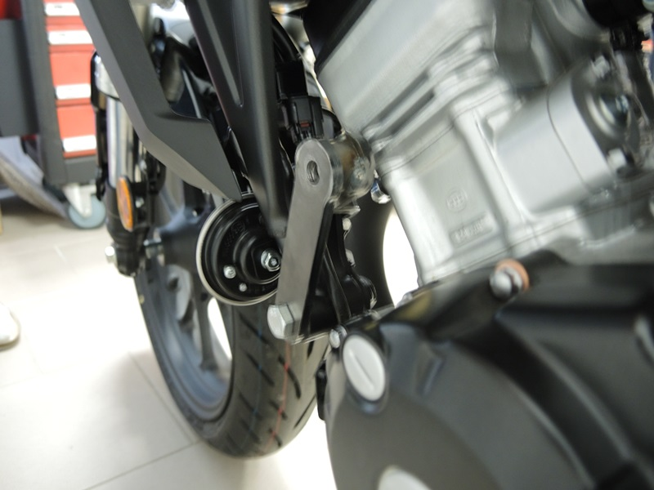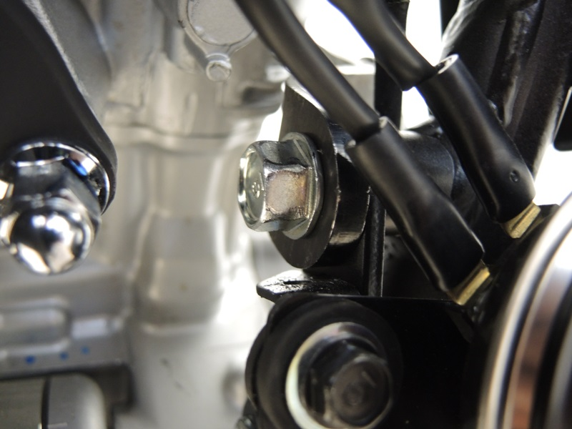
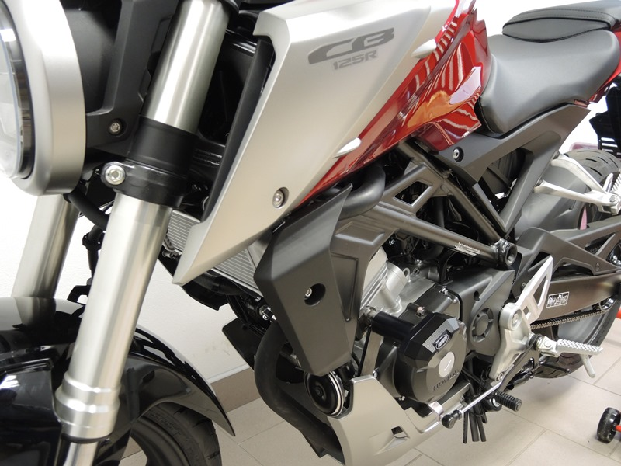
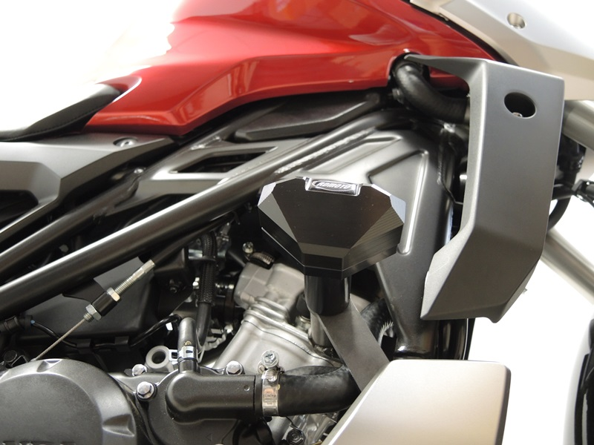

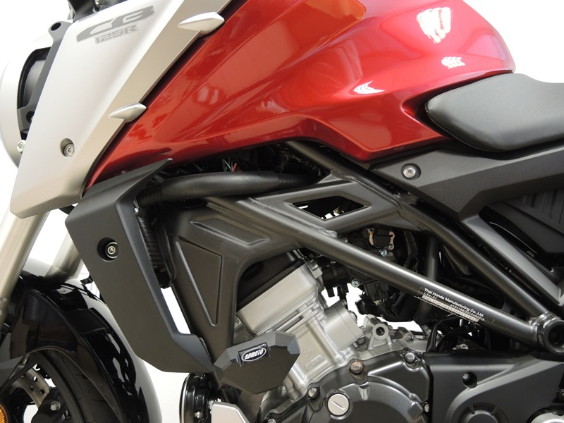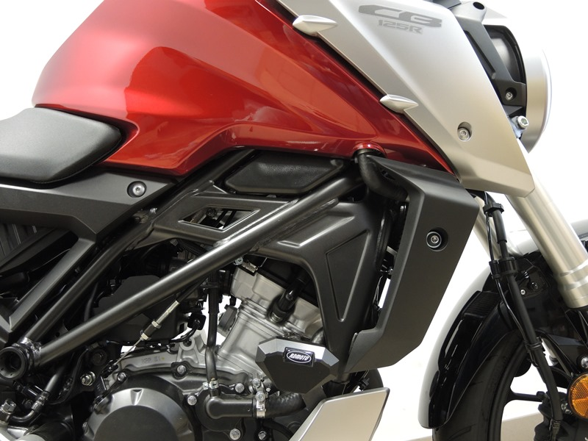

Mounting of the Left Side:
- Remove the original M10 bolts from the outer and inner side of the frame (see. photo).
- Attach the steel adapter ID.2 using the bolt M10 ID.5 and the washer M10 ID.9 from the inside of the motorcycle frame, with the sleeve facing away from the engine. Attach the steel adapter ID1 from the outside, using the bolt M10 ID.4 and the washer M10 ID.9. Insert the sleeve ID.3 into the frame between adapter.
- Install washer M10 ID.12, SLD adapter ID.11 and dural. sleeve ID.6 on the bolt M10 ID.8. Screw this assembly through the outer adapter ID.1 into the sleeve in the adapter ID.
- Attach the slider to the adapter using bolt M8 (ID 7) and the washer M8 ID.10.
- Tighten all the bolts.

Mounting of the Right Side:
- Remove the original M10 bolts from the outer and inner side of the frame (see. photo).
- Attach the steel adapter ID.2 using the bolt M10 ID.5 and the washer M10 ID.9 from the inside of the motorcycle frame, with the sleeve facing away from the engine. Attach the steel adapter ID1 from the outside, using the bolt M10 ID.4 and the washer M10 ID.9. Insert the sleeve ID.3 into the frame between adapter.
- Install washer M10 ID.12, SLD adapter ID.11 and dural. sleeve ID.6 on the bolt M10 ID.8. Screw this assembly through the outer adapter ID.1 into the sleeve in the adapter ID.
- Attach the slider to the adapter using bolt M8 (ID 7) and the washer M8 ID.10.
- Tighten all the bolts.

Warning! We recommend using medium strength thread glue (blue) during assembly

