H65S
Honda CB 125 R 2019-

Mounting Kit – Left Side: Mounting Kit – Right Side:
ID | Description | Cat.No | Pcs
1 | Steel adapter | 744 | 1
2 | Steel adapter rear L | 745 | 1
3 | Dural. sleeve l=32mm | 1120 | 1
4 | Bolt M10x60x1,25mm | 925 | 1
5 | Bolt M10x25x1,25mm | 1059 | 1
6 | Dural. adapter l=70mm | 315 | 1
7 | Bolt M6x25mm | 877 | 3
8 | Bolt M10x45mm | 848 | 1
9 | Washer M10 flat | 804 | 2
10 | Bolt M4x16mm | 876 | 2
ID | Description | Cat.No | Pcs
1 | Steel adapter | 744 | 1
2 | Steel adapter rear P | 746 | 1
3 | Dural. sleeve l=32mm | 1120 | 1
4 | Bolt M10x60x1,25mm | 925 | 1
5 | Bolt M10x25x1,25mm | 1059 | 1
6 | Dural. adapter d=70mm | 315 | 1
7 | Bolt M6x25mm | 877 | 3
8 | Bolt M10x60mm | 850 | 1
9 | Washer M10 flat | 804 | 2
10 | Bolt M4x16mm | 876 | 2
11 | Dural. sleeve l=10mm | DV1 | 1

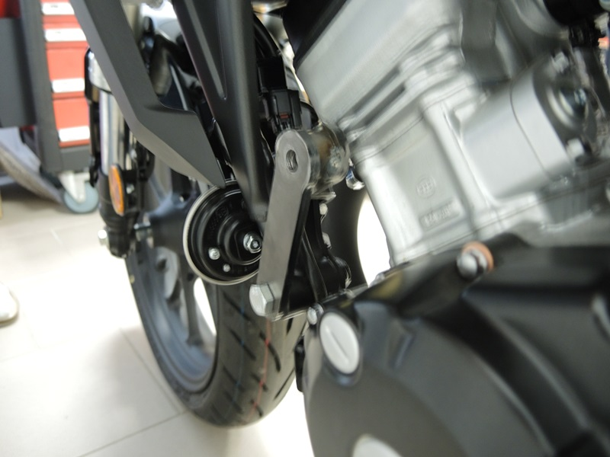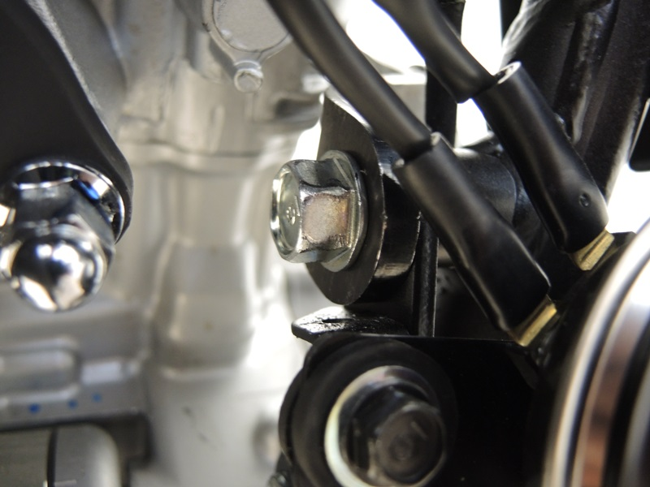

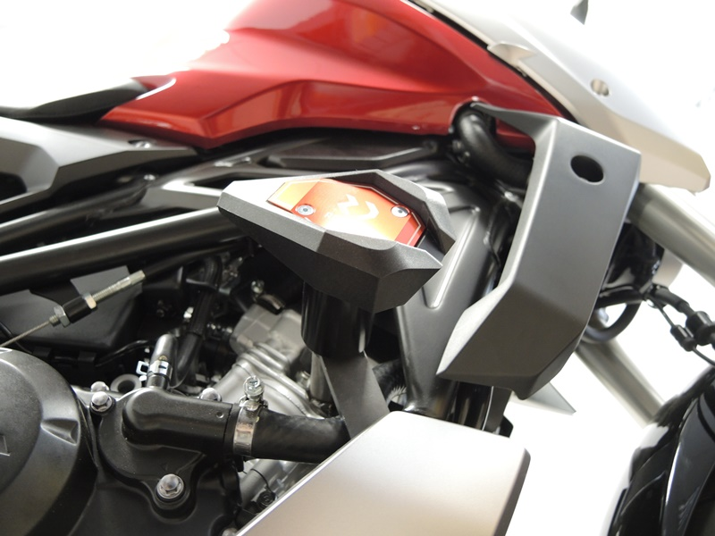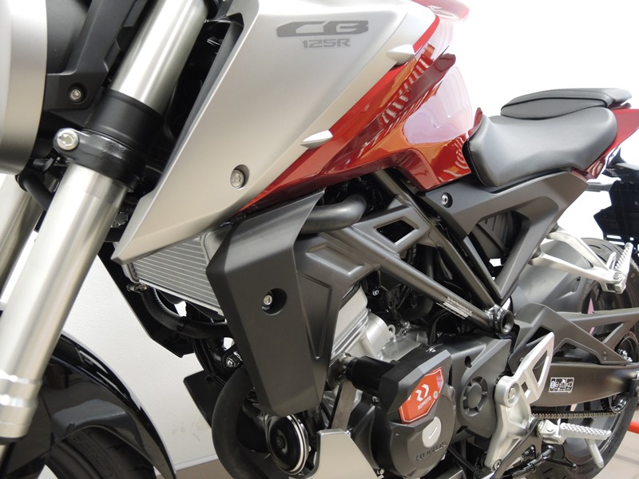

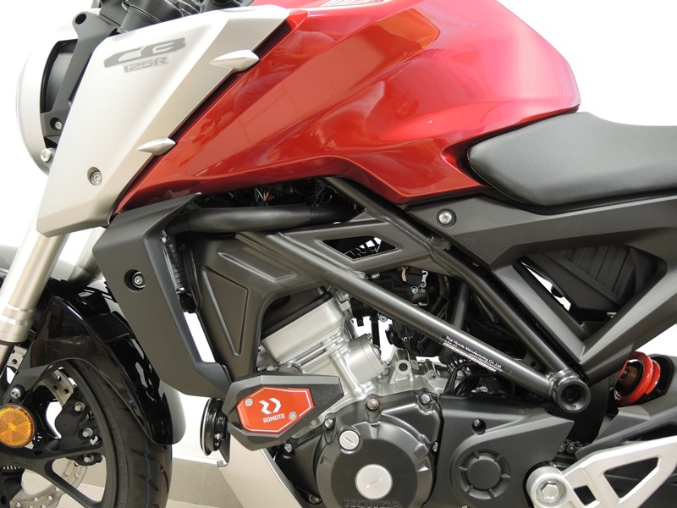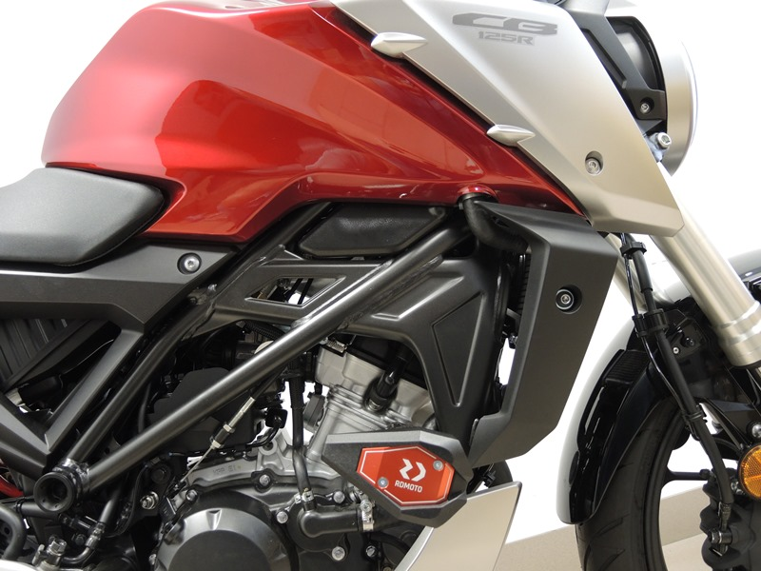

Mounting of the Left Side:

- Remove the original M10 bolts from the outer and inner side of the frame according to the picture below.
- Fasten the steel adapter ID 2 from the inner side of the motorcycle frame with the sleeve facing away from engine using the bolt M10 (ID 5) and washer M10 (ID 9) Attach the steel adapter (ID 1) from the outside using the bolt M10 (ID 4) and washer M10 (ID 9). Insert sleeve (ID 3) into the frame between adapter.
- Install dural. Adapter (ID6) on the bolt M10 (ID8). Screw this assembly through the outer adapter (ID 1) into the sleeve in the adapter (ID 2)
- Attach the slider to the adapter using bolt M6 (ID 7) and the washer using bolts M4 (ID 10)
- Tighten all the bolts.

Mounting of the Right Side:
- Remove the original M10 bolts from the outer and inner side of the frame according to the picture below.
- Fasten the steel adapter ID 2 from the inner side of the motorcycle frame with the sleeve facing away from engine using the bolt M10 (ID 5) and washer M10 (ID 9) Attach the steel adapter (ID 1) from the outside using the bolt M10 (ID 4) and washer M10 (ID 9). Insert sleeve (ID 3) into the frame between adapter.
- Install dural. Adapter (ID6) and sleeve (ID 11) on the bolt M10 (ID8). Screw this assembly through the outer adapter (ID 1) into the sleeve in the adapter (ID 2)
- Attach the slider to the adapter using bolt M6 (ID 7) and the washer using bolts M4 (ID 10)
- Tighten all the bolts.

Warning! We recommend using medium strength thread glue (blue) during assembly.

