H65
Honda CB 125 R 2019-

Mounting Kit Left Side: Mounting Kit Right Side:
ID | Description | Cat.No | Pcs
1 | Steel Adapter | 744 | 1
2 | Steel Adapter – Rear, L | 745 | 1
3 | Dural. spacer d=32mm | 1120 | 1
4 | Bolt M10x60x1,25mm | 925 | 1
5 | Bolt M10x25x1,25mm | 1059 | 1
6 | Dural. spacer d=30mm | DV3 | 1
7 | Protector insertion | X1 | 1
8 | Bolt M10x75mm | 1007 | 1
9 | Washer M10 flat | 804 | 2
ID | Description | Cat.No | Pcs
1 | Steel Adapter | 744 | 1
2 | Steel Adapter – Rear, P | 746 | 1
3 | Dural. spacer d=32mm | 1120 | 1
4 | Bolt M10x60x1,25mm | 925 | 1
5 | Bolt M10x25x1,25mm | 1059 | 1
6 | Dural. spacer d=40mm | DV4 | 1
7 | Protector Insertion | X1 | 1
8 | Bolt M10x85mm | 981 | 1
9 | Washer M10 flat | 804 | 2

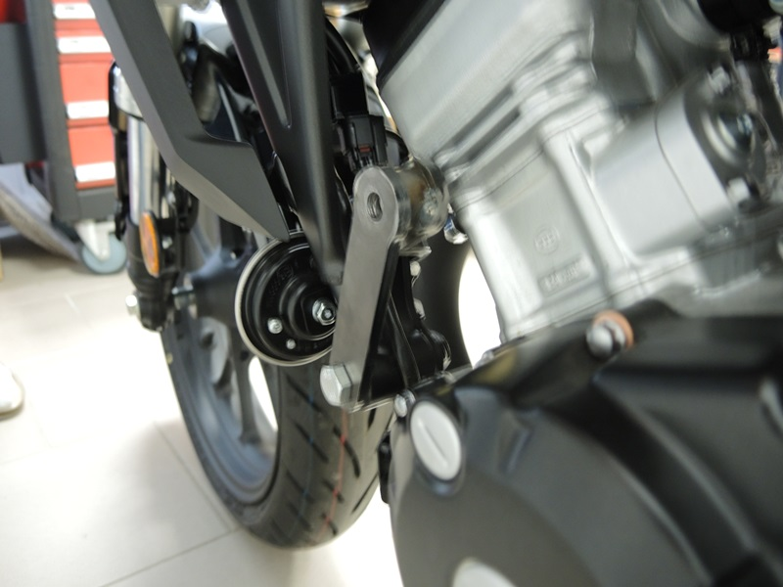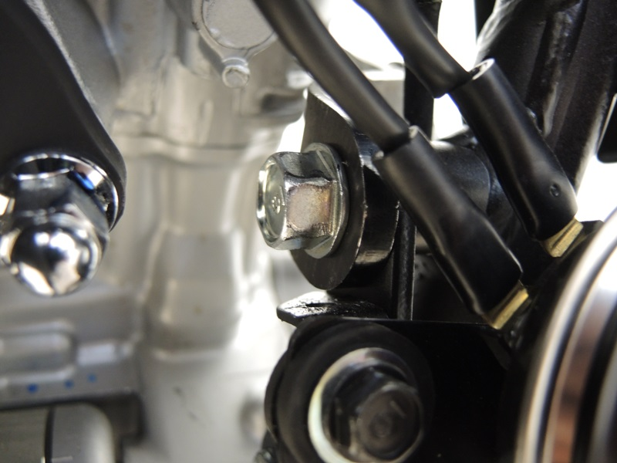
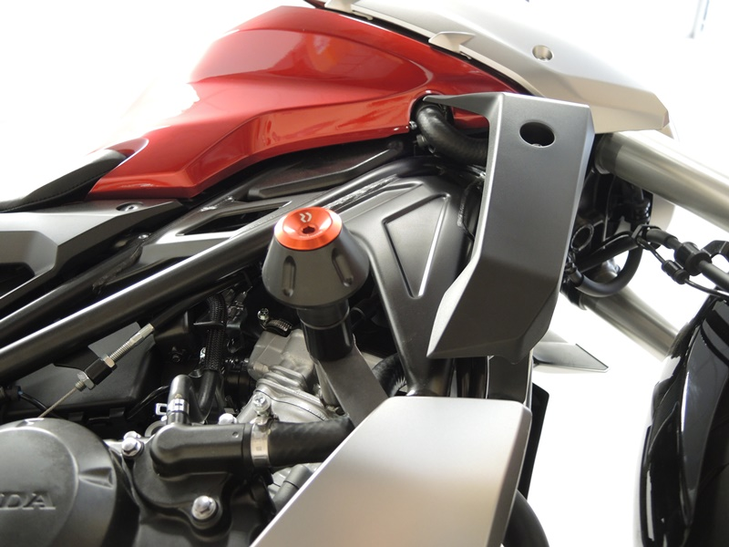
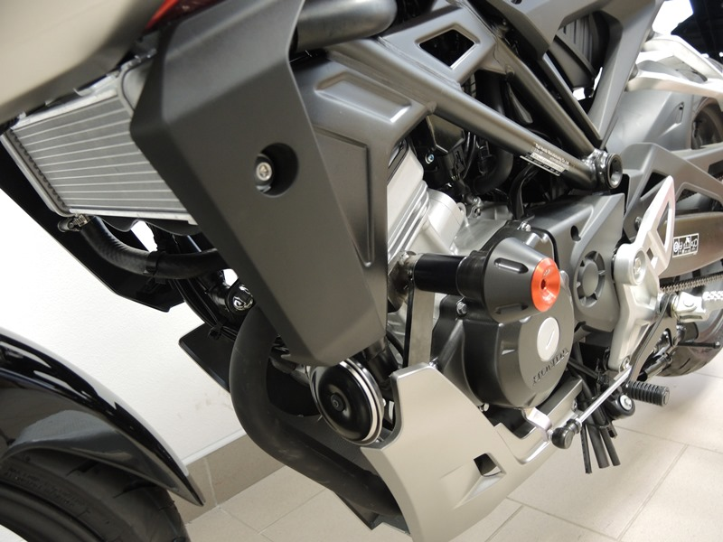

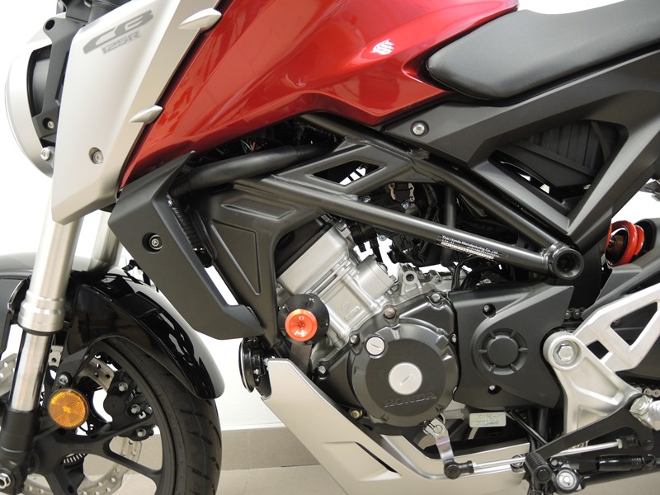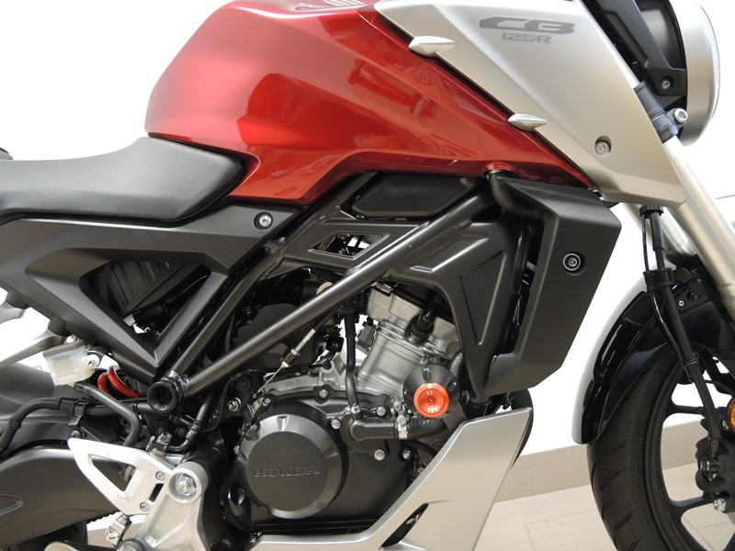

Mounting Instructions Left Side:
- Unscrew the original M10 bolts from both inner and outer side of frame, as shown on photos.
- Attach the steel adapter ID.2 using M10 ID.5 bolt, M10 ID.9 washer from the inside part of motorcycle frame with the spacer in direction away from engine. From the outer side, attach the ID.1 steel adapter using M10 ID.4 bolt and M10 ID.9 washer and put the ID.3 spacer into the frame in between.
- Take the M10 ID.8 bolt and equip it with ID.7 insertion, ID.3 spacer and a protector and then mount this assembly into spacer on adapter ID.2 through the outer adapter ID.1.
- Tighten all bolts now.

Mounting Instructions Right Side:
- Unscrew the original M10 bolts from both inner and outer side of frame, as shown on photos.
- Attach the steel adapter ID.2 using M10 ID.5 bolt, M10 ID.9 washer from the inside part of motorcycle frame with the spacer in direction away from engine. From the outer side, attach the ID.1 steel adapter using M10 ID.4 bolt and M10 ID.9 washer and put the ID.3 spacer into the frame in between.
- Take the M10 ID.8 bolt and equip it with ID.7 insertion, ID.3 spacer and a protector and then mount this assembly into spacer on adapter ID.2 through the outer adapter ID.1.
- Tighten all bolts now.

Note: We recommend using medium strenght thread glue (blue color) during assembly.

