H6SDM
Honda CBF1000 2006-2009

Kit for the left side |  |  |  |  | Kit for the right side
No. | Description | Cat.N | Qt |  |  | No. | Description | Cat.N | Qt
1 | Bracket for SLDM | 537/B | 1 |  |  | 1 | Bracket for SLDM | 537/B | 1
2 | Bolt M12x115x1,25mm | 918 | 1 |  |  | 2 | Bolt M12x105x1,25mm | 912 | 1
3 | Dural.adapter d=30mm | 171 | 1 |  |  | 3 | Dural.adapter d=30mm | 171 | 1
4 | Bolt M6x20 | 1024 | 2 |  |  | 4 | Bolt M6x20 | 1024 | 2
5 | Washer M6 | 1023 | 2 |  |  | 5 | Washer M6 | 1023 | 2

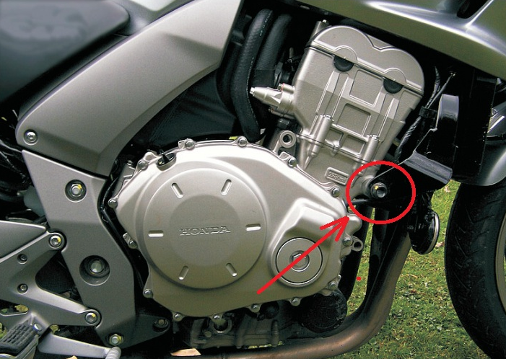
Installation:

- Installation of the left and right protector make in gripping about the attached photo.
- Bolt No.2 insert thru the bracket for SLD No.1 and under the bracket put duralumin adapter No.3.
- This kit mounted on the frame, for gripping sliders use bolt M8x25 and washer from back side.

Warning – we recommend to use safety glue on threads of all bolts (moderate strong – blue colour).

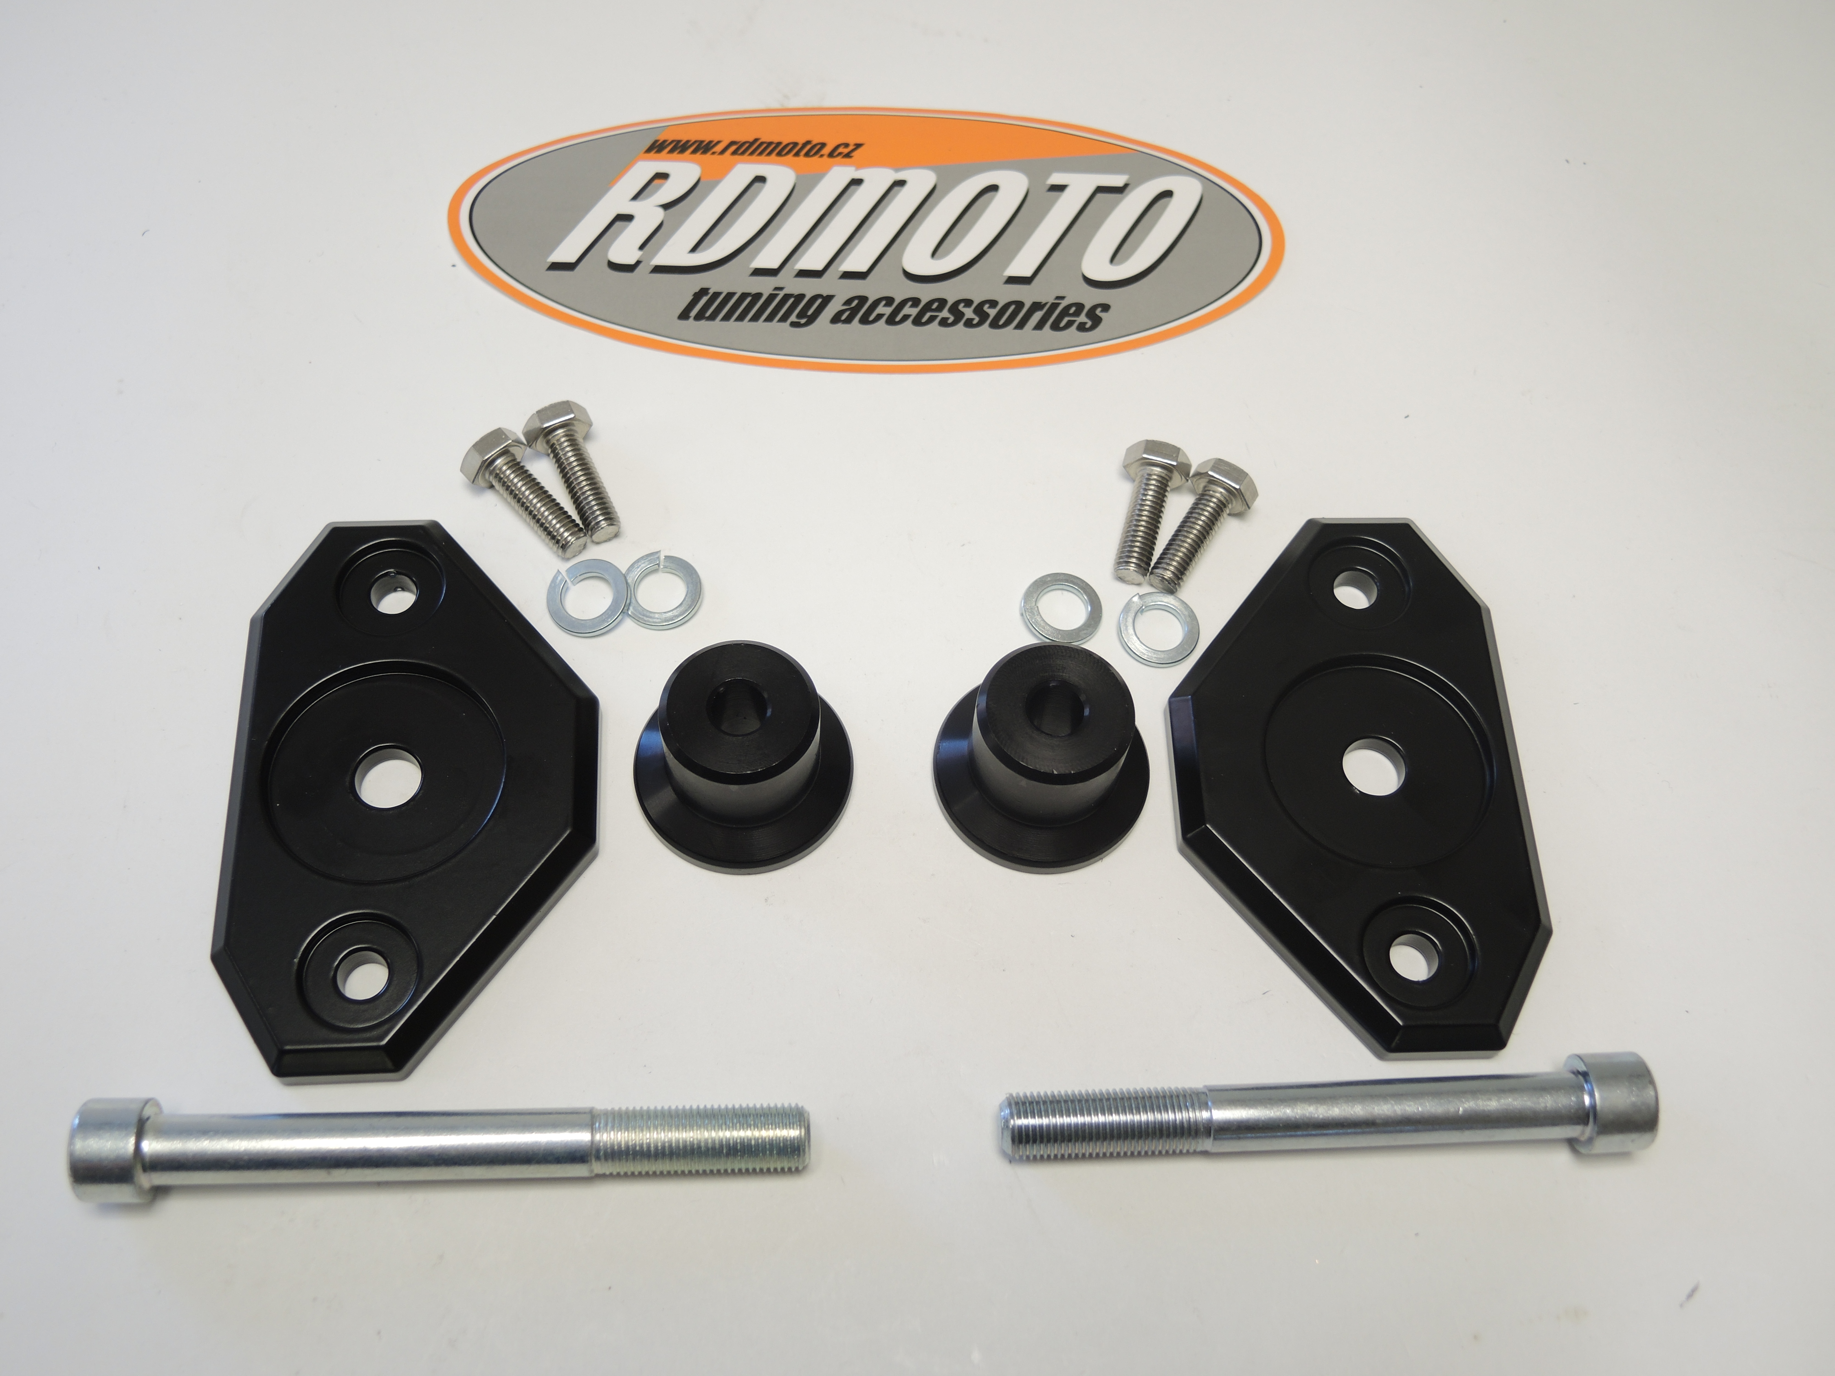

1
4
5
3
3
5
4
1
2
2

