H7S
Honda CBR600RR 2007-2008

Kit for left side: |  |  |  |  | Kit for right side:
ID. | Description | Cat.No | Qty |  |  | ID. | Description | Cat.No | Qty
1 | Steel adapter | 513 | 1 |  |  | 1 | Steel adapter | 512 | 1
2 | dural.cylinder=10mm | 126 | 1 |  |  | 2 | dural.cylinder=10mm | 126 | 1
3 | Adapter for slider | 317 | 1 |  |  | 3 | Adapter for slider | 317 | 1
4 | bolt M10x25mm | 868 | 1 |  |  | 4 | bolt M10x25mm | 868 | 1
5 | bolt M6x25mm | 877 | 3 |  |  | 5 | bolt M6x25mm | 877 | 3
6 | bolt M4x16mm | 876 | 2 |  |  | 6 | bolt M4x16mm | 876 | 2
7 | washer M10 –spring | 801 | 1 |  |  | 7 | washer M10 –spring | 801 | 1
8 | slider SL01 | SL01 | 1 |  |  | 8 | slider SL01 | SL01 | 1
9 | cap SL01 | cap | 1 |  |  | 9 | cap SL01 | capSL. | 1
10 | tape 3M |  | 1 |  |  | 10 | tape 3M |  | 1

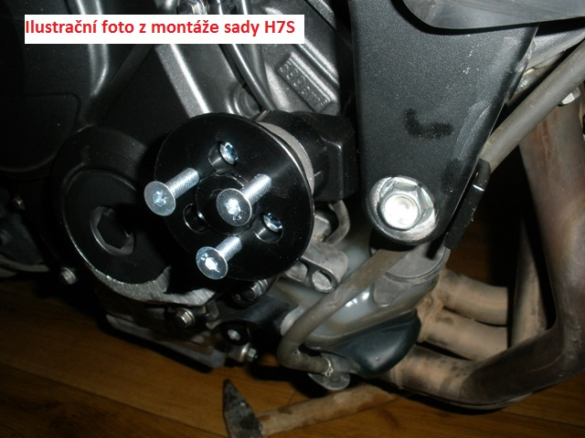

Instruction to assembly:
- Take out fairng.
- The first maket he right side.
- Dismantle bolt from frame.
- Take out original cylinder between the frame and engine.
- Take the steel adapter and insert it between the frame and engine. Stick 3M tape on frame.
- Change the original cylinder for dural. cylinder ID.2
- Use the original bolt and tighten it.
- Mount dural. adapter for slider on the steel bracket and use the bolt M10x25 and washer M10.
- Mount slider SL01 on the dural.adapter, use bolts M6x25 and insert cover into the slider, use bolts M4x16
- Instruction for left side is same.

We recommend use the glue of all threads-medium strong.

