H8S
Honda CBR600F 2000-

Kit for left side: |  |  |  |  | Kit for right side:
ID. | Description | Cat.N | Qt |  |  | ID. | Description |  | Cat.N |  | Qt
1 | Dural. adapter for SL01 | 313 | 1 |  |  | 1 | Dural. adapter for SL01 |  | 313 |  | 1
2 | Bolt M10x80x1,25mm | 920 | 1 |  |  | 2 | Bolt M10x100x1,25mm |  | 892 |  | 1
3 | dural. spacer d=21mm | 30 | 1 |  |  | 3 | dural. spacer d=18mm |  | 29 |  | 1
4 | Bolt M8x25mm | 832 | 2 |  |  | 4 | Bolt M8x25mm |  | 832 |  | 2
5 | Poly nut d=20mm | X6 | 2 |  |  | 5 | Poly nut d=20mm |  | X6 |  | 2
6 | Washer M10 | 801 | 1 |  |  | 6 | Washer M10 |  | 801 |  | 1
7 | Dura. brcaket | 508 | 1 |  |  | 7 | Dural. bracket |  | 509 |  | 1
8 | Tape 3M | ------ | 1 |  |  | 8 | páska 3M |  | ------- |  | 1
9 | Bolt M10x40 | 854 | 1 |  |  | 9 |  | Bolt M10x40 |  | 854 |  | 1
10 | Bolt M6x25 | 877 | 3 |  |  | 10 |  | Bolt M6x25 |  | 877 |  | 3
11 | Bolt M4x16 | 876 | 2 |  |  | 11 |  | Bolt M4x16 |  | 876 |  | 2
12 | Nut M10 | 810 | 1 |  |  | 12 |  | Nut M10 |  | 810 |  | 1
13 | Washer M10 | 804 | 1 |  |  | 13 |  | Washer M10 |  | 804 |  | 1
Instr. To assembly left side :

- Take out fairing and bolt M10 from frame.
- Assembly together adapter ID.7. Mounting poly nuts ID.5 use bolts ID. 4. Stick 3M tape from back side on the adapter.
- Put washer ID.6 on bolt ID.2. Into the frame insert dural. spacer ID.3. Place bolt into the adapter and tighten it on motorcycl frame.
- Put fairing back on the bike.
- Assembly adapter ID.1 by bolt ID.9. Place washer ID.13 and tighten nut ID.12 from back side
- Place slider and make assembly by bolts ID.10 place cover use bolts ID.11

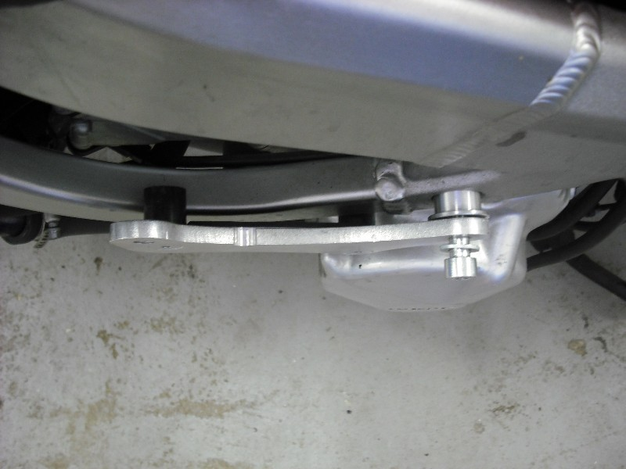

Instr. To assembly right side :

- Take out fairing and bolt M10 from frame.
- Assembly together adapter ID.7. Mounting poly nuts ID.5 use bolts ID. 4. Stick 3M tape from back side on the adapter.
- Put washer ID.6 on bolt ID.2. Into the frame insert dural. spacer ID.3. Place bolt into the adapter and tighten it on motorcycl frame.
- Put fairing back on the bike.
- Assembly adapter ID.1 by bolt ID.9. . Place washer ID.13 and tighten nut ID.12 from back side
- Place slider and make assembly by bolts ID.10 place cover use bolts ID.11

We recommend to use medium strong glue on the bolt threads.
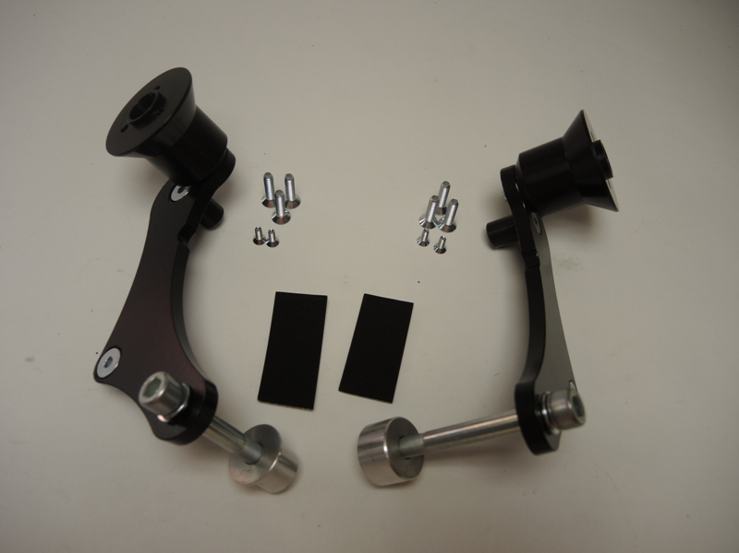
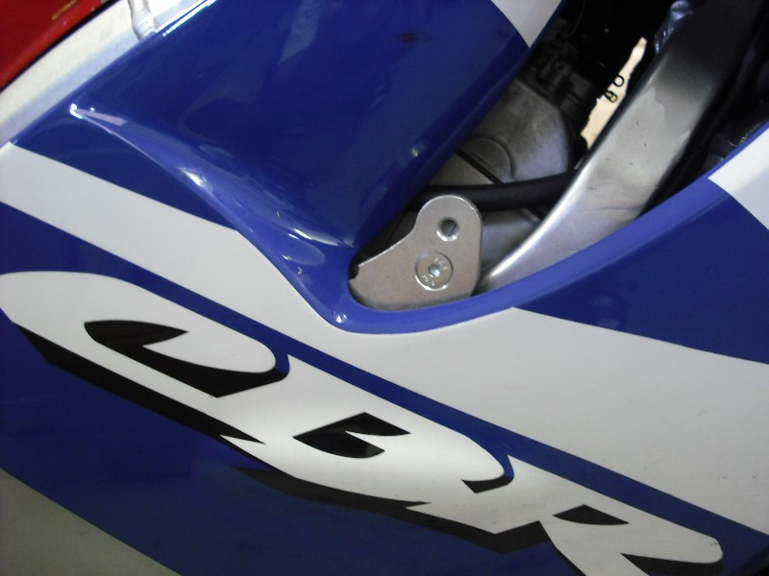
9
1
8
10,11
10,11
6
3
2
9
4
1
7
6
2
3
5
5
4
4
5
4

