H8
Honda CBR600F 2000-

Kit for the left side |  |  |  |  | Kit for the right side
No. | Description | Cat.No | Pcs |  |  | No. | Description | Cat.No | Pcs
1 | Steel box M10 | X1 | 1 |  |  | 1 | Steel box M10 | X1 | 1
2 | Bolt M10x80x1,25mm | 920 | 1 |  |  | 2 | Bolt M10x100x1,25mm | 892 | 1
3 | Dural. cylinder d=21mm | 30 | 1 |  |  | 3 | Dural. cylinder d=18mm | 29 | 1
4 | Dural. cylinder d=20mm | 2 | 1 |  |  | 4 | Dural. cylinder d=20mm | 2 | 1
5 | Bolt M10x 65 mm | 943 | 1 |  |  | 5 | Bolt M10x65 mm | 943 | 1
6 | Bolt M8x25mm | 832 | 2 |  |  | 6 | Bolt M8x25mm | 832 | 2
7 | Poly nut d=20mm | X6 | 2 |  |  | 7 | Poly nut d=20mm | X6 | 2
8 | Pad M10 (spring) | 801 | 1 |  |  | 8 | Pad M10 (spring) | 801 | 1
9 | Duralumin adapter | 508 | 1 |  |  | 9 | Duralumin adapter | 509 | 1
10 | Tape 3M |  | 1 |  |  | 10 | Tape 3M |  | 1
11 | Washer M10 | 804 | 1 |  |  | 11 | Washer M10 | 804 | 1
12 | Lock Nut M10 | 810 | 1 |  |  | 12 | Lock Nut M10 | 810 | 1
 | 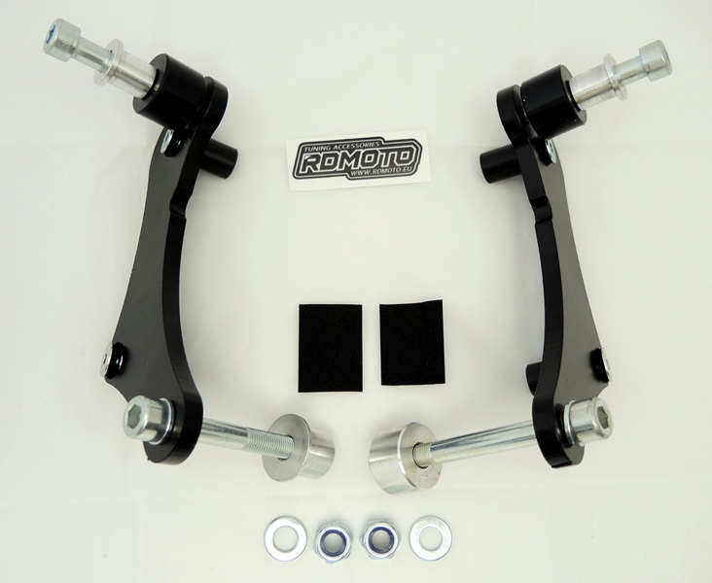
Installation – the left side:

- remove the original side plastic and bolt M10 in frame of the motorcycle
- compile adapter (No. 9) together, use bolts (No. 6) for gripping of poly nut (No. 7)
- stick on reverse side of adapter tape 3M (No. 10)
- put duralumin cylinder (No. 3) under adapter, use the bolt (No. 2) with pad (No. 8) and screw up adapter to frame of the motorcycle
- check all and then you can mount the original plastic side back
- give steel box (No. 1) in protector together with bolt (No. 5), then give duralumin cylinder (No. 4) under protector, the cyclinder give on bolt too.
- all this set mount to thread on adapter. Place washer frm back side on the bolt and tighten it by nut note.12

Warning – we recommend to use safety glue on threads of all bolts (moderate strong – blue colour).

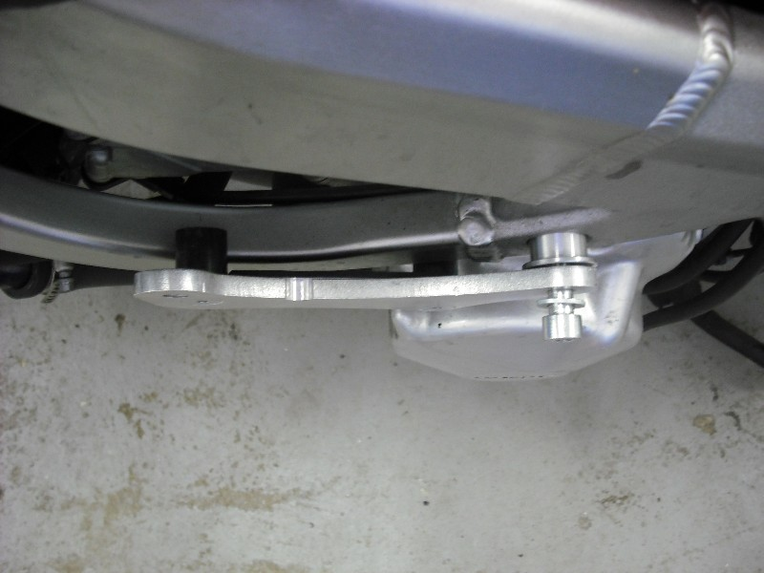

Installation – the right side:

- remove the original plastic side and bolt M10 in frame of the motorcycle
- compile adapter (No. 9) together, use bolts (No. 6) for gripping of poly nut (No. 7)
- stick on reverse side of adapter tape 3M (No. 10)
- put duralumin cylinder (No. 3) under adapter, use the bolt (No. 2) with pad (No. 8) and screw up adapter to frame of the motorcycle
- check all and then you can mount the original plastic side back
- give steel box (No. 1) in protector together with bolt (No. 5), then give duralumin cylinder (No. 4) under protector, the cyclinder give on bolt too.
- all this set mount to thread on adapter. Place washer frm back side on the bolt and tighten it by nut note.12

Warning – we recommend to use safety glue on threads of all bolts (moderate strong – blue colour).

