H9*
Honda VFR 750F

Fitting kit left side: Fitting kit right side:
ID | Description | Cat.n | QT
1 | Steel box | X1 | 1
2 | Dural.spacer l=40mm | 4 | 1
3 | Bolt M10x70 | 851 | 1
4 | Dural.spacer l=5mm | 168 | 1
5 | Bolt M10x85x1,25 | 934 | 1
6 | Bolt M10x90x1,25 | 890 | 1
7 | Washer M10 | 804 | 2
8 | Steel adapter | 514 | 1
ID | Description | Cat.n | QT
1 | Steel box | X1 | 1
2 | Dural.spacer l=40mm | 4 | 1
3 | Bolt M10x70 | 851 | 1
4 | Bolt M10x70x1,25 | 898 | 1
5 | Bolt M10x90x1,25 | 890 | 1
7 | Washer M10 | 804 | 2
8 | Steel adapter | 514 | 1

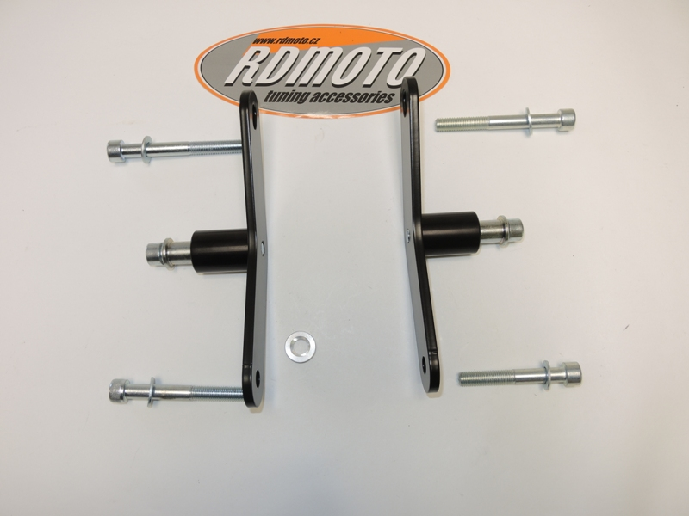
7
7

1
1

3
3

2
4
2

7
7

*You will have to drill the hole in the fairing during installation. It is therefore necessary intervention in the original cowl!

Warning: We recommend use the glue of all threads. Medium strong.

