K11SD
Kawasaki Z750 2007-2011

Kit for the left side |  |  |  | Kit for the right side
ID | Description | Cat.no. | Pcs |  |  | ID | Description | Cat.no. | Pcs
2 | SLD adapter | 537 | 1 |  |  | 2 | SLD adapter | 537 | 1
3 | Bolt M8x60mm | 838 | 2 |  |  | 3 | Bolt M8x60mm | 838 | 2
4 | Dural. cylinder 14mm | 18 | 2 |  |  | 4 | Dural. cylinder 14mm | 18 | 2
5 | Dural. adapter | 547 | 1 |  |  | 5 | Dural. adapter | 547 | 1
6 | Plastic cover | X5 | 2 |  |  | 6 | Plastic cover | X5 | 2
7 | 3M tape |  | 1 |  |  | 7 | 3M tape |  | 1
8 | Dural. cylinder 30mm | 11 | 1 |  |  | 8 | Dural. cylinder 15mm | 9 | 1
9 | Bolt M8 | 815 | 2 |  |  | 9 | Bolt M8 | 815 | 2
10 | Washer M8 (stringed) | 800 | 2 |  |  | 10 | Washer M8 (stringed) | 800 | 2
11 | Bolt M10x60 | 850 | 1 |  |  | 11 | Bolt M10x40 | 854 | 1
Instructions:

- Remove original bolt M8 from the frame of motorcycle.
- Mount dural. adapter (ID5) and dural cylinder (ID4) using bolts M8 (ID3) on the frame of motorcycle.
- Cover bolts with covers ID6.
- Mount SLD adapter ID2 and dural. cylinder ID8 on the dural. adapter using bolt ID11.
- In the end mount slider using bolts ID9 and washers ID10.

We recommend to use the glue on all threads (medium strong).

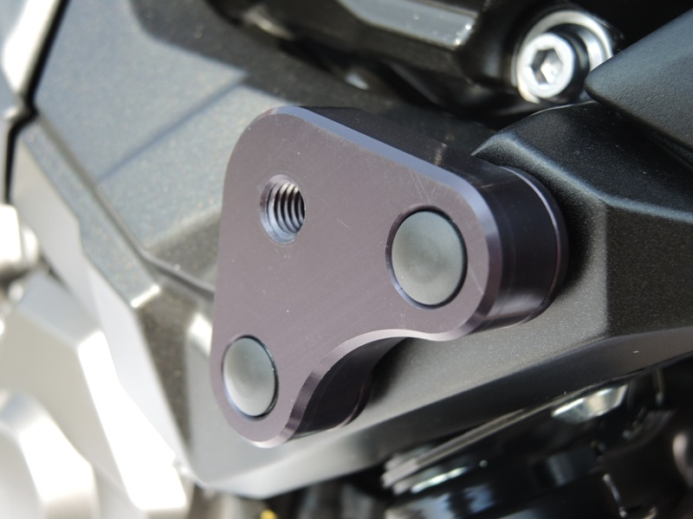
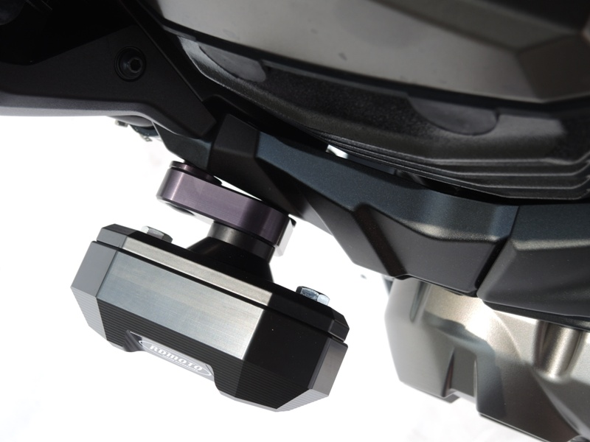
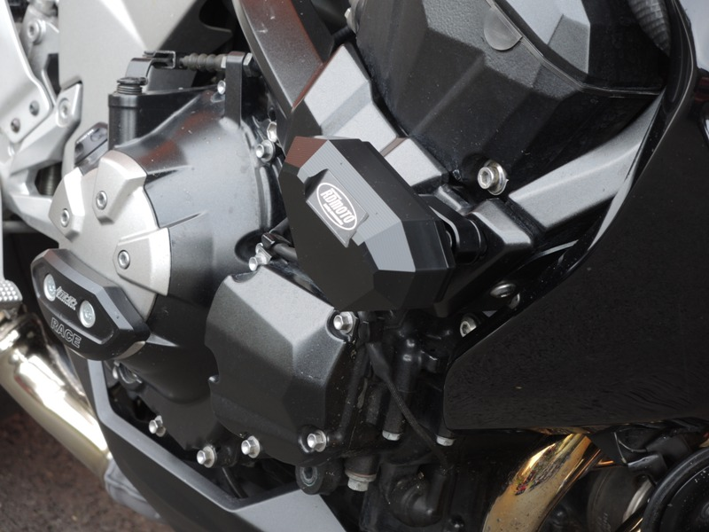

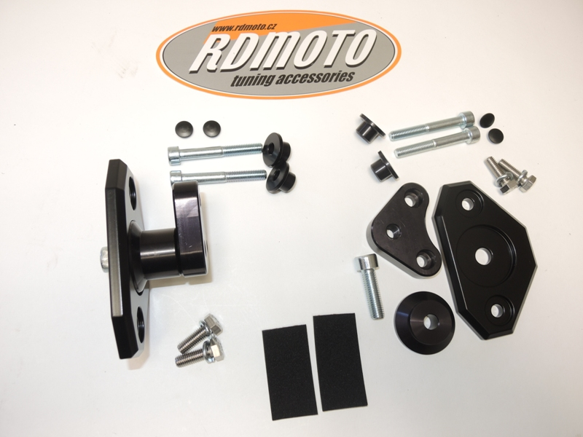
1
1
8
8
4

