K11S
Kawasaki Z750 2007-2012

Fitting kit left side: Fitting kit right side:
ID | Description | Cat.N | Qty
1 | Dural.adapter SL01 | 313 | 1
2 | Bolt M10x30mm | 882 | 1
3 | Bolt M6x25 | 877 | 3
4 | Bolt M4x16 | 876 | 2
5 | Bolt M8x60mm | 838 | 2
6 | Dural.cylinder d=14mm | 18 | 2
7 | Dural.adapter | 547 | 1
8 | Washer spring M10 | 801 | 1
9 | Plastic cap | X5 | 2
10 | 3M tape |  | 1
ID | Description | Cat.N | Qty
1 | Dural.adapter SL01 | 292 | 1
2 | Bolt M10x35mm | 847 | 1
3 | Bolt M6x25 | 877 | 3
4 | Bolt M4x16 | 876 | 2
5 | Bolt M8x60mm | 838 | 2
6 | Dural.cylinder d=14mm | 18 | 2
7 | Dural.adapter | 547 | 1
8 | Plastic cap | X5 | 2
9 | 3M tape |  | 1
10 | Washeer spring M10 | 801 | 1

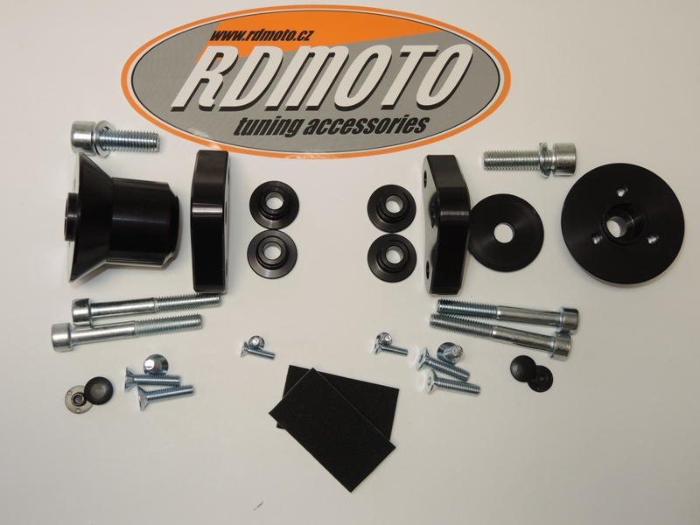

8
10
2
7
7
2
6
1

1

5

5
6

8
4

3
4
3
9
10
9

Instruction to assembly left side:
- Take out original bolts from frame M8.
- Mounting dural.adapter ID.7 on frame. Use bolts ID.5 and into the frame put dural.cylinders ID.6.
- You can stick 3M tape under the dural. adapter ID.7.
- Put plastic cover into the bolts ID.9.
- Grip dural.adapter ID1 on the bike. Use bolt ID.2 and washer ID.8
- Mounted slider on the adapter, use bolts ID.3.
- Insert cover into the slider, use bolts ID.4.

Instruction to assembly right side:
- Take out original bolts from frame M8.
- Mounting dural.adapter ID.7 on frame. Use bolts ID.5 and into the frame put dural.cylinders ID.6.
- You can stick 3M tape under the dural. adapter ID.6.
- Put plastic cover into the bolts ID.8.
- Grip dural.adapter ID.1 on the bike Use bolt ID.2 and washer ID.10.
- Mounted slider on the adapter, use bolts ID.3.
- Insert cover into the slider, use bolts ID.4.

Warning: We recommend use the glue of all threads. Medium strong.
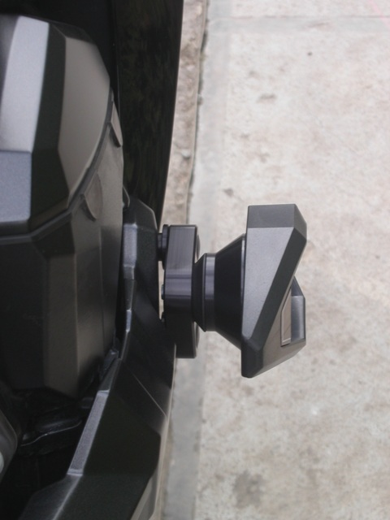
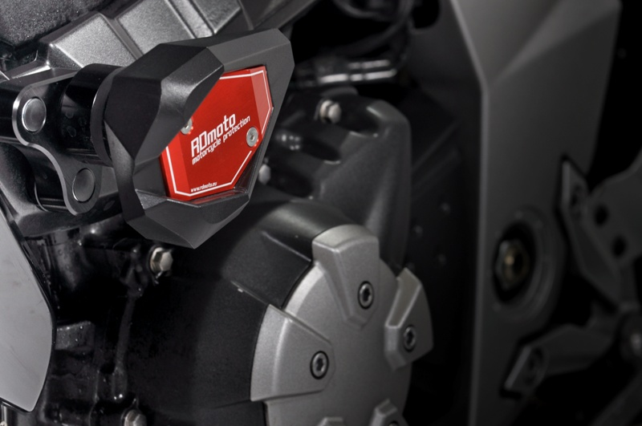
Foto staršího typu uchycení slideru.

