K12
Kawasaki ZX-10R 2006-2007

Fitting kit left: Fitting kit right:
ID | Description | Cat.No | Qty
1 | Steel box M10 | X1 | 1
2 | Steel adapter | 554 | 1
3 | Bolt M10X70 | 851 | 1
4 | Bolt M10x70x1,25 | 898 | 1
5 | Dural.adapter d=30 | 11 | 1
6 | Dural.cylinder d=14 | 114 | 1
7 | Washer M10 spring | 801 | 1
8 | Tape 3M |  | 1
ID | Description | Cat.N | QTY
1 | Steel box M10 | X1 | 1
2 | Steel adapter | 553 | 1
3 | Bolt M10x70 | 851 | 1
4 | Bolt M10x80x1,25 | 920 | 1
5 | Dural.adapter d=30 | 11 | 1
6 | Washer M10 spring | 801 | 1
7 | Tape 3M |  | 1

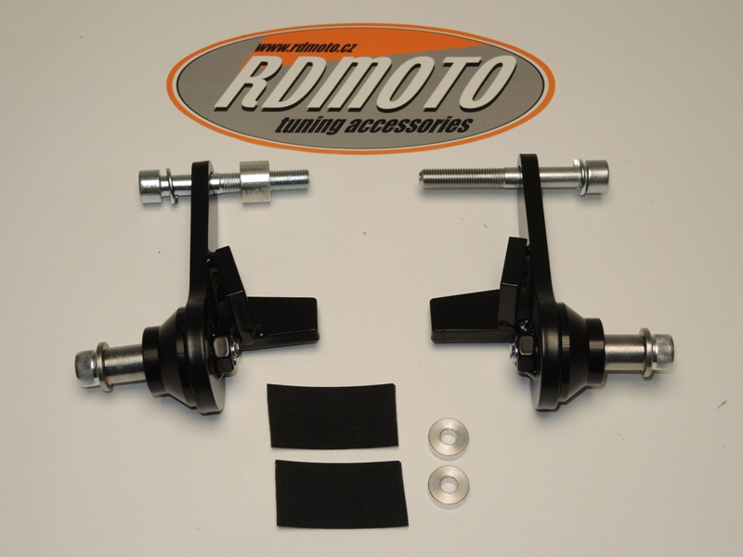
Pad for expansion bottle.
ID | Description | Cat.N | QTY
9  4,7  2 | Dural.cylinder d=6  6 | 115  2  4,6 | 2
5
5
3
1
9
7,8
3
1
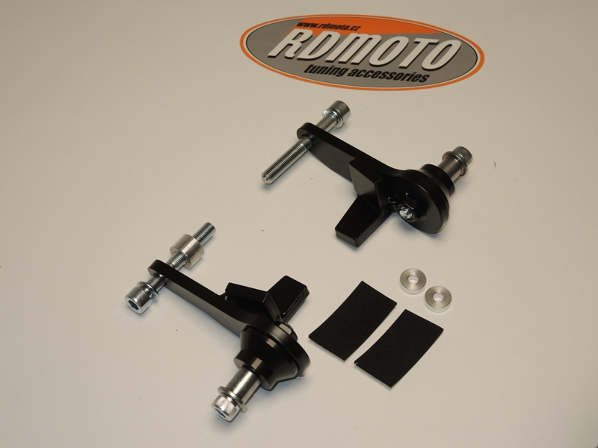
Assembly make here:

Insert pad under the expansion bottle.

Assembly left side:
- Take off fairing and bolt from frame M10.
- On the adapter ID.2 stick 3M tape in point where is adapter touching with frame.
- Through the adapter insert bolt with pad ID.4 and ID.7 Put dural.cylinder ID.6 on bolt from back side. Between the adapter and frame.
- This kit mounted on the frame.
- Into the protector insert steel box ID.1. Under the protector put dural.adapter. ID.5. This kit mounted on the steel adapter. Use bolt ID.3
- Put fairing back.

Assembly right side:
- Take off fairing and bolt from frame M10.
- On the adapter ID.2 stick 3M tape in point where is adapter touching with frame.
- Through the adapter insert bolt with pad ID.4 and ID.6.
- This kit mounted on the frame.
- Into the protector insert steel box ID.1. Under the protector put dural.adapter. ID.5. This kit mounted on the steel adapter. Use bolt ID.3
- Put fairing back.

Warning: We recommend use the glue of all threads. Medium strong.

