K13
Kawasaki Z1000 2007-2009

Kit for the left side | Kit for the right side

No. | Description | Cat.no. | Pcs |  | No. | Description |  | Cat.no. | Pcs
1 | Steel box M10 | X1 | 1 |  | 1 | Steel box M10 |  | X1 | 1
2 | Bolt M10x50mm | 849 | 1 |  | 2 | Bolt M10x40mm |  | 854 | 1
3 | Bolt M8x60mm | 838 | 2 |  | 3 | Bolt M8x60mm |  | 838 | 2
4 | AL.spacer d=14mm | 18 | 2 |  | 4 | Al. spacer d=14 |  | 18 | 2
5 | Duralumin adapter | 547 | 1 |  | 5 | Duralumin adapter |  | 547 | 1
6 | Plastic cover - black | X5 | 2 |  | 6 | Plastic cover - black |  | X5 | 2
7 | 3M tape |  | 1 |  | 7 | 3M tape |  |  | 1
8 | Duralumin cylinder d=10 | 1 | 1
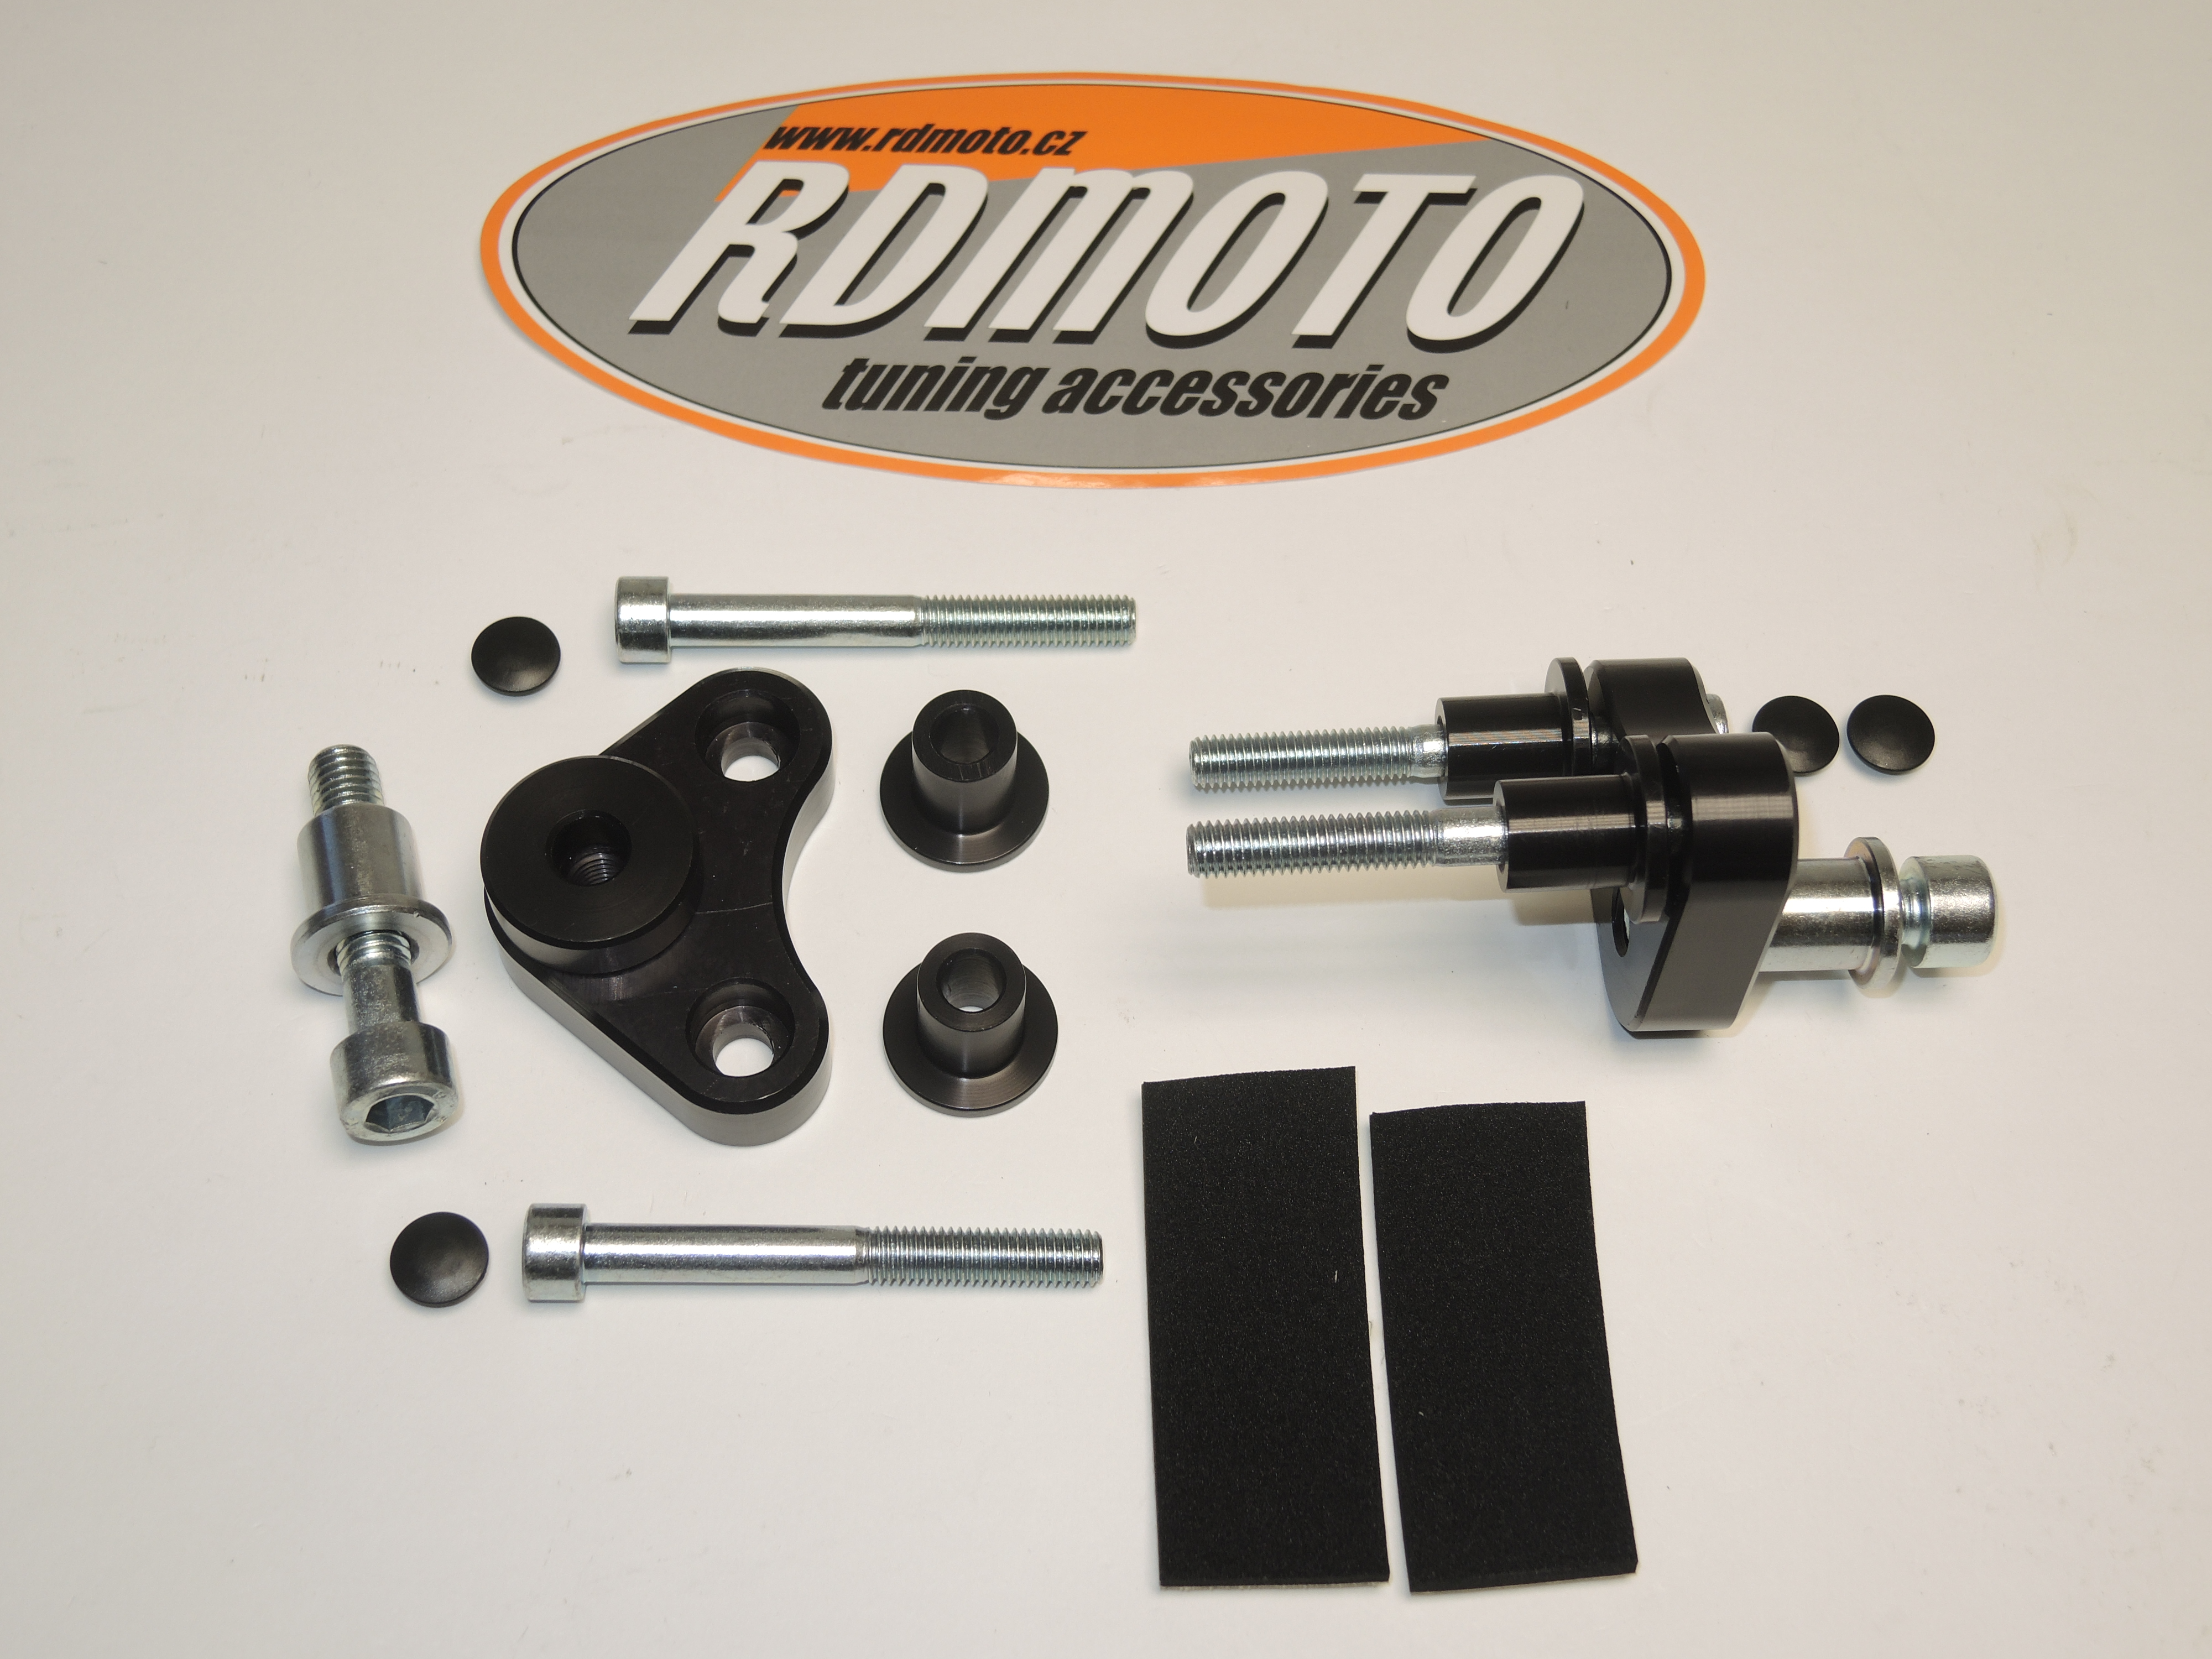

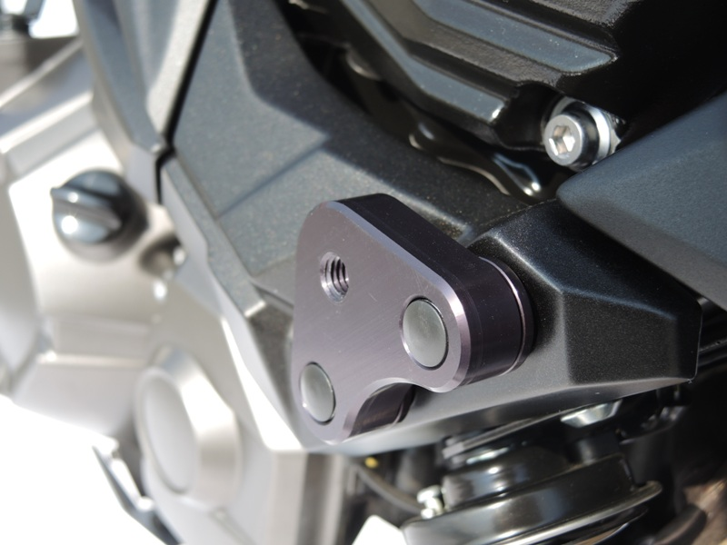

Installation – the left side:

- remove the original bolts M8
- use the bolts (No. 3) for mounting of the duralumin adapter (No. 5), during the installation give the duralumin cylinders (No. 4) on the bolts
- give the plastic covers (No. 6) on the heads of the bolts
- mount the adapter on the frame of the motorcycle, tighten all carefully
- give the steel box (No. 1) together with the bolt (No. 2) into the protector between the protector and adapter insert cylinder (No.8)
- all this set mount into the thread on the adapter
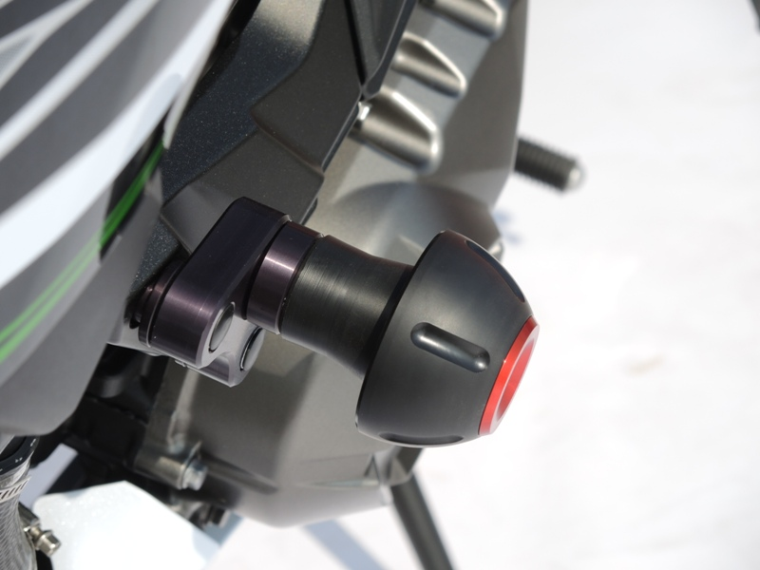
Installation – the right side:

- remove the original bolts M8
- use the bolts (No. 3) for mounting of the duralumin adapter (No. 5), during the installation give the duralumin cylinders (No. 4) on the bolts
- give the plastic covers (No. 6) on the heads of the bolts
- mount the adapter on the frame of the motorcycle, tighten all carefully
- give the steel box (No. 1) together with the bolt (No. 2) into the protector
- this side is without duralumin cylinder
- all this set mount into the thread on the adapter

Warning – we recommend to use safety glue on threads of all bolts (moderate strong – blue colour).

