K14
Kawasaki ZZR1400 2006-

Kit for the left side |  |  |  |  | Kit for the right side
No. | Description | Cat.No. | Pcs |  |  | No. | Description | Cat.No. | Pcs
1 | Steel box M12 | X2 | 1 |  |  | 1 | Steel box M12 | X2 | 1
2 | Bolt M10x65x1,25mm | 945 | 1 |  |  | 2 | Bolt M10x55x1,25mm | 915 | 1
3 | Dural. cylinder d=12mm | 169 | 1 |  |  | 3 | Dural. cylinder d=5mm | 297 | 1
4 | Bolt M8x30mm | 834 | 1 |  |  | 4 | Bolt M8x30mm | 834 | 1
5 | Bolt M12x110mm | 946 | 1 |  |  | 5 | Bolt M12x110mm | 946 | 1
6 | Duralumin adapter | 605 | 1 |  |  | 6 | Duralumin adapter | 606 | 1
7 | Dural.cylinder d=70mm | 296 | 1 |  |  | 7 | Dural.cylinder d=70mm | 296 | 1

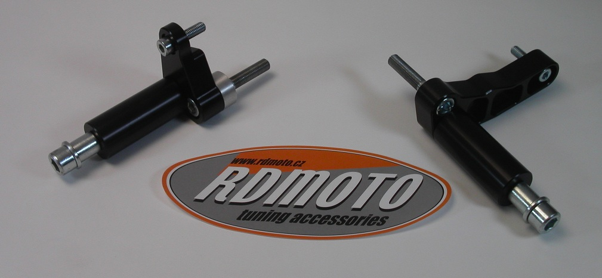

Installation – the left side:

- remove the original side plastic
- take duralumin adapter (No. 6), give the bolt (No. 4) and the bolt (No. 2), give the distance duralumin cylinder (No. 3) on the bolt M10 from the other side
- mount this prepared adapter on the frame of motorcycle and tighten.
- mount the original plastics back.
- give the steel box (No. 1) together with the bolt (No. 5) and with the pad (No. 7) in the protector
- all this set mount to thread on adapter

Warning – we recommend to use safety glue on threads of all bolts (moderate strong – blue colour).

Installation – the right side:

- remove the original side plastic
- take duralumin adapter (No. 6), give the bolt (No. 4) and the bolt (No. 2), give the distance duralumin cylinder (No. 3) on the bolt M8 from the other side
- mount this prepared adapter on the frame of motorcycle and tighten.
- mount the original plastics back.
- give the steel box (No. 1) together with the bolt (No. 5) and with the pad (No. 7) in the protector
- all this set mount to thread on adapter

Warning – we recommend to use safety glue on threads of all bolts (moderate strong – blue colour).

