K15SD
Kawasaki ZX-10R 2008-2010

Kit for the left side |  |  |  |  | Kit for the right side
ID | Description | Cat.no. | Pcs |  |  | ID | Description | Cat.no. | Pcs
1 | Steel adapter | 555 | 1 |  |  | 1 | Steel adapter | 556 | 1
2 | SLD adapter | 537 | 1 |  |  | 2 | SLD adapter | 537 | 1
3 | Bolt M10x50x1,25 mm | 921 | 1 |  |  | 3 | Bolt M10x50x1,25 mm | 921 | 1
4 | Bolt M10x90 mm | 880 | 1 |  |  | 4 | Bolt M10x50 mm | 849 | 1
5 | Washer M10 (stringed) | 801 | 1 |  |  | 5 | Washer M10 (stringed) | 801 | 1
6 | Washer M10 (flat) | 804 | 1 |  |  | 6 | Washer M10 (flat) | 804 | 1
7 | Dural. cylinder d=10mm | 113 | 1 |  |  | 7 | Dural. cylinder d=4mm | 112 | 1
8 | Dural. cylinder d=60mm | 14 | 1 |  |  | 8 | Dural. cylinder d=40mm | 12 | 1
- | Rod AL16(M10)x410x30x30 |  | 1 |  |  | 9 | Bolt M10x30mm | 846 | 1
10 | Tape 3M |  |  |  |  | 10 | Tape 3M
11 | Bolt M8x25 | 815 | 2 |  |  | 11 | Bolt M8x25 | 815 | 2
12 | Washer M8 | 800 | 2 |  |  | 12 | Washer M8 | 800 | 2

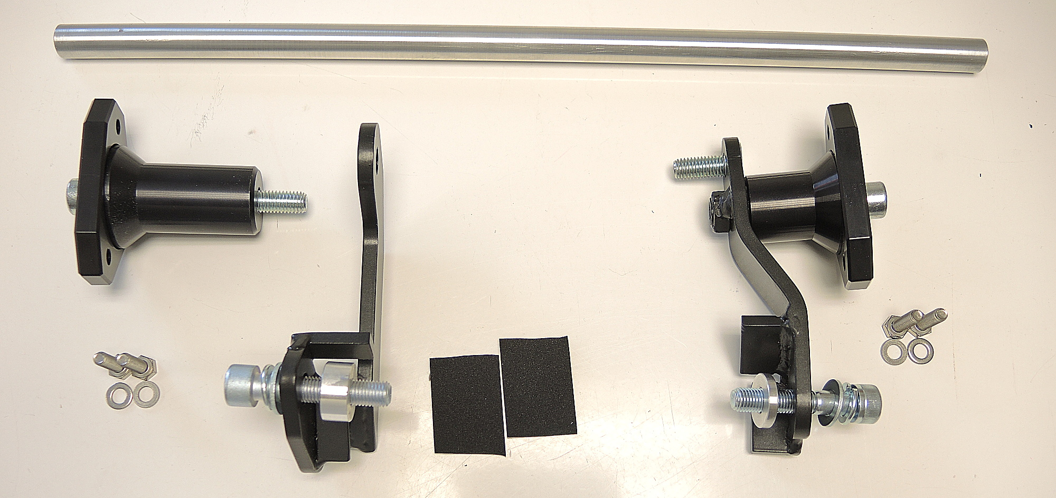

8
2
2

9
4
4
8
1
1
11+12

3+5+6
3+5+6
7
7
11+12
10

Instructions:

- Remove fairing of motorcycle.
- Remove original bolts M10 from the frame of motorcycle.
- Stick 3M tape on the frame of motorcycle.
- Fit steel adapter (ID1) on the left side using bolt (ID3). Place washers (ID5 and ID6) and cylinder (ID7) on the bolt.
- Fit steel adapter on the right side (ID1) using bolt (ID3). Place washers (ID5 and ID6) and cylinder (ID7) on the bolt.
- Fit connecting rod on the right side adapter using bolt (ID9).
- Fit kit for the left side protector. Put adapter (ID2) and cylinder ID8 on the bolt ID4. Mount this kit into thread of connecting rod.
- Now fit kit for the right side protector. Put SLDM adapter (ID2) and cylinder ID8 on the bolt ID4. Mount this kit into the thread of steel adapter ID1.
- In the end fit protectors using two bolts M6 and washers M6 (ID11 and ID12).

We recommend to use the glue on all threads (medium strong).
