K15S
Kawasaki ZX-10R 2008-2010

Kit for the left side |  |  |  |  | Kit for the right side
No. | Description | Cat.no. | Pcs |  |  | No. | Description | Cat.no. | Pcs
1 | Slider RDmoto | SL | 1 |  |  | 1 | Slider RDmoto | SL | 1
2 | Cover | SLcap.. | 1 |  |  | 2 | Cover | SLcap.. | 1
3 | Adapter moto | DV-315 | 1 |  |  | 3 | Adapter moto | DV-317 | 1
4 | Bolt M6x25 | 877 | 3 |  |  | 4 | Bolt M6x25 | 877 | 3
5 | Bolt M4x16 | 876 | 2 |  |  | 5 | Bolt M4x16 | 876 | 2
6 | Steel adapter | 555 | 1 |  |  | 6 | Steel adapter | 556 | 1
7 | Bolt M10x50x1,25mm | 921 | 1 |  |  | 7 | Bolt M10x50x1,25mm | 921 | 1
8 | Bolt M10x50mm | 849 | 1 |  |  | 8 | Bolt M10x30mm | 882 | 1
9 | Washer M10 (spring) | 801 | 1 |  |  | 9 | Washer M10 (spring) | 801 | 1
10 | Dural. cylinder d=10mm | 113 | 1 |  |  | 10 | Dural. cylinder d=4mm | 112 | 1
11.1 | Steel rod M10x415x30x30 | AL16 | 1 |  |  | 11.2 | Bolt M10x30mm (cone) | 846 | 1
12 | Tape 3M |  |  |  |  | 12 | Tape 3M

Installation:

- Remove fairing of motorcycle.
- Remove original bolts M10 from the frame.
- Stick 3M tape on the frames on both sides according to the picture.
- Use bolt M10 (ID7) for tightening rear part of steel adapter ID6. Place washers ID9 and cylinders ID10 on the bolt.
- Prepare steel rod ID11.1 and place it between adapters into front threads of adapters.
- Fit steel rod using cone bolt ID11.2 on the right side.
- On the left prepare bolt ID8. Insert this bolt into adapter ID3 and mount this kit through front thread into the steel rod.
- Now fit right side adapter ID3 using bolt ID8.
- Mount slider on the adapter using three bolts M6.
- In the end mount coloured cover using two bolts M4.

Warning – we recommend to use safety glue on threads of all bolts (moderate strong – blue colour).

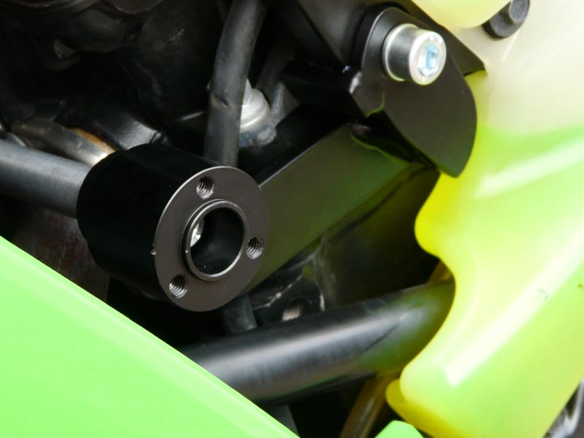
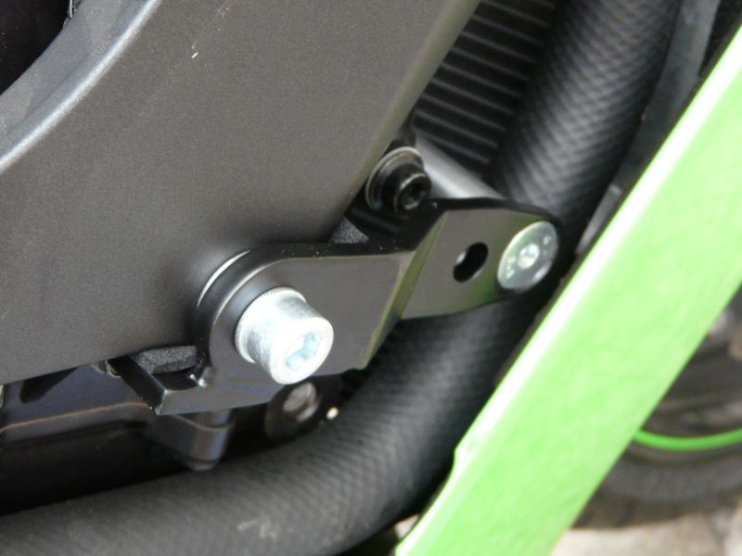
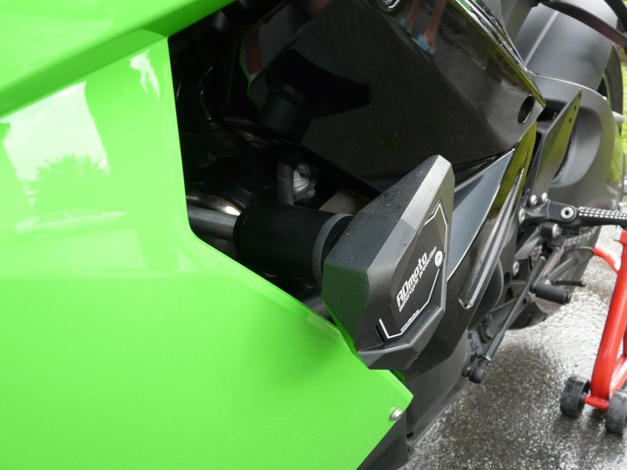
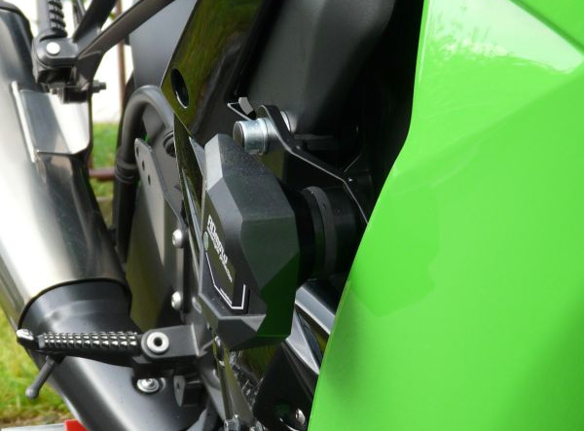
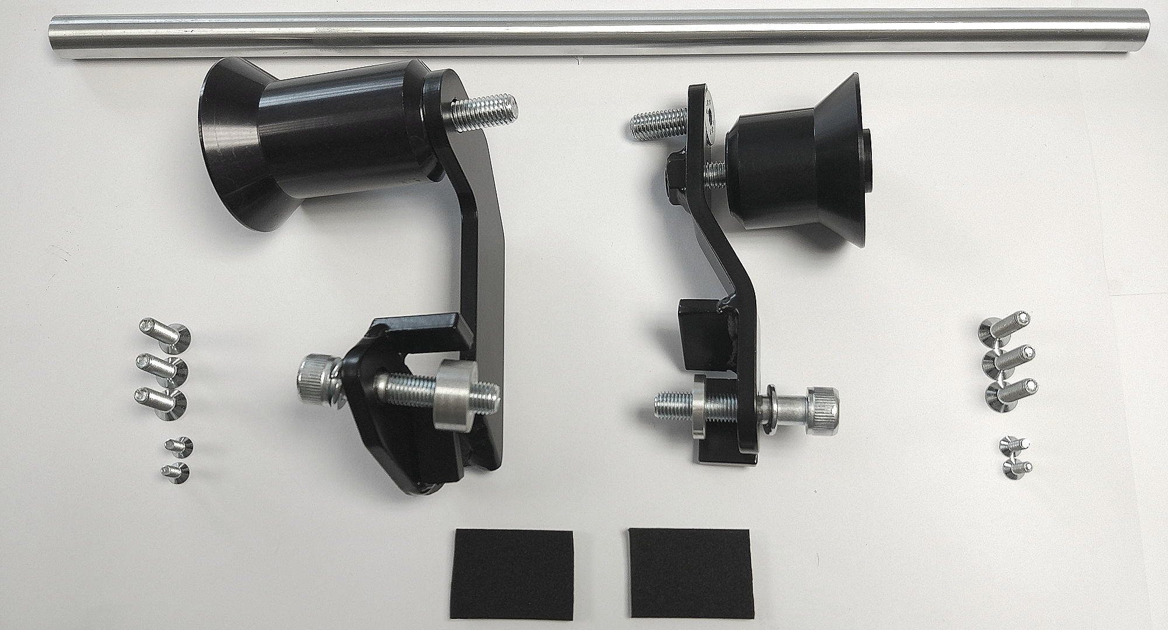
ID3+8
ID3+8
ID7+9+10
ID7+9+10

