K15
Kawasaki ZX-10R 2008-2010

Kit for the left side |  |  |  |  | Kit for the right side
ID | Description | Cat.no. | Pcs |  |  | ID | Description | Cat.no. | Pcs
1 | Steel adaper | 555 | 1 |  |  | 1 | Steel adapter | 556 | 1
2 | Steel insert | X1 | 1 |  |  | 2 | Steel insert | X1 | 1
3 | Bolt M10x50x1,25mm | 921 | 1 |  |  | 3 | Bolt M10x50x1,25mm | 921 | 1
4 | Bolt M10x80mm | 852 | 1 |  |  | 4 | Bolt M10x50mm | 849 | 1
5 | Washer M10 (pérová) | 801 | 1 |  |  | 5 | Washer M10 (pérová) | 801 | 1
6 | Washer M10 (plochá) | 804 | 1 |  |  | 6 | Washer M10 (plochá) | 804 | 1
7 | Dural cylinder - 10mm | 113 | 1 |  |  | 7 | Dural cylinder - 4mm | 112 | 1
8 | Dural cylinder - 30mm | 3 | 1 |  |  | 8 | Dural cylinder - 10mm | 1 | 1
- | Dural. rod AL16(M10)x410x30x30 |  | 1 |  |  | 9 | Bolt M10x30mm | 846 | 1
10 | Tape 3M |  |  |  |  | 10 | Tape 3M

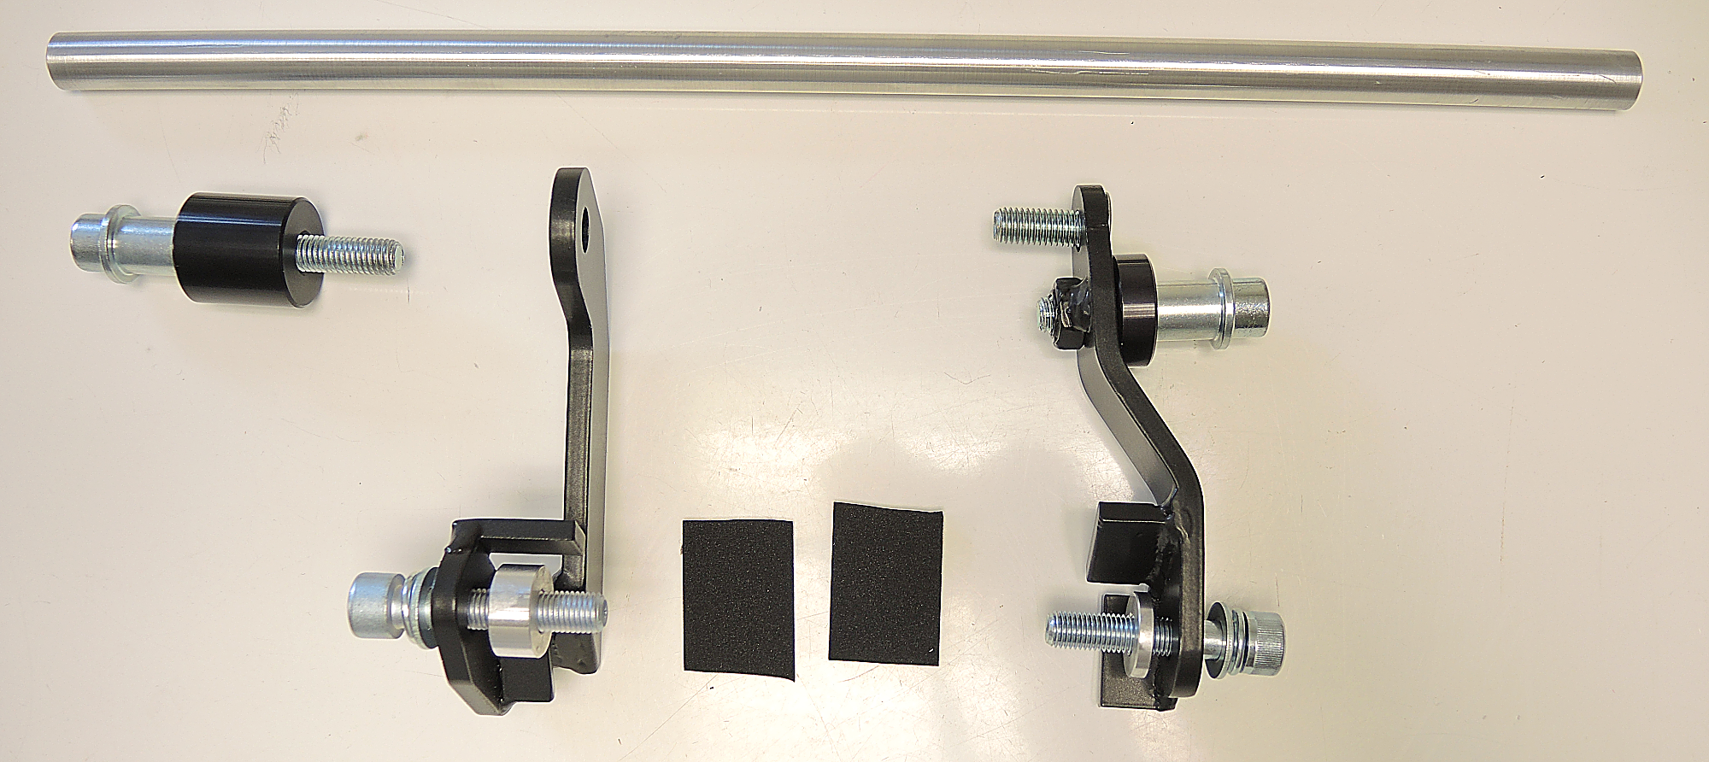

2
8

9
4
4
8
1
1
2

3+5+6
3+5+6
10
7
7

Instructions:

- Remove fairing of motorcycle.
- Remove original bolts M10 from the frame of motorcycle.
- Stick 3M tape on the frame of motorcycle.
- Fit steel adapter (ID1) on the left side using bolt (ID3). Place washers (ID5 and ID6) and cylinder (ID7) on the bolt.
- Fit steel adapter on the right side (ID1) using bolt (ID3). Place washers (ID5 and ID6) and cylinder (ID7) on the bolt.
- Fit connecting rod on the right side adapter using bolt (ID9).
- Now fit left side protector. Insert steel insert (ID2) and bolt ID4 into the protector and put bolt trough cylinder ID8. Mount this kit into the thread of connecting rod.
- In the end fit right side protector. Insert steel insert (ID2) and bolt ID4 into the protector and put bolt trough cylinder ID8. Mount this kit into the thread of connecting rod.

We recommend to use the glue on all threads (medium strong).
