K16SD
Kawasaki Versys 650 2006-

LEFT SIDE KIT |  |  |  |  |  | RIGHT SIDE KIT
ID |  | Description | Cat.no. | Pcs |  |  | ID | Description | Cat.no. | Pcs
1 |  | Adapter SLD | 537 | 1 |  |  | 1 | Adapter SLD | 537 | 1
2 |  | Nut M8 | 813 | 1 |  |  | 2 | Nut M8 | 813 | 2
3 |  | Washer M8 | 802 | 1 |  |  | 3 | Washer M8 | 802 | 2
4 |  | Dural. cylinder 50mm | 209 | 1 |  |  | 4 | Dural.váleček d=30m | 170 | 1
5 |  | Bolt M12x100 | 986 | 1 |  |  | 5 | Bolt M12x80 | 956 | 1
6 |  | Dural adapter | 544 | 1 |  |  | 6 | Dural. adapter | 543 | 1
7 |  | Bolt M10x100x1,25mm | 892 | 1 |  |  | 7 | Bolt M10x110x1,25mm | 928 | 1
8 |  | Bolt M8x40mm | 828 | 1 |  |  | 8 | Bolt M8x40 | 828 | 2
9 |  | Dural. cylinder 41mm | 36 | 1 |  |  | 9 | dural. cylinder 61mm | 37 | 1
10 |  | Dural. SLD adapter 15mm | DV149 | 1 |  |  | 10 | Dural. SLD adapter | DV149 | 1
11 |  | Bolt M8x25 | 815 | 2 |  |  | 11 | Bolt M8x25 | 815 | 2
12 |  | Washer M8 | 800 | 2 |  |  | 12 | Washer M8 | 800 | 2
13 |  | Dural. rod AL20(M12)x314x30x30 |  | 1

INSTRUCTIONS

- Remove side fairing and unbolt bolts M10 and M8.
- Fit dural adapter ID6 on the left side using bolt ID7 and ID8, use safety nut ID2 and washer ID3.
- Insert dural. cylinder ID9 between frame and motorcycle.
- Fit steel adapter ID6 on the right side using bolt ID7 and ID8, use nut ID2 and washer ID3.
- Insert dural. cylinder ID9 between frame and motorcycle.
- Put bolt ID5 through adapter ID1, insert adapter ID10 and cylinder ID4 under steel adapter.
- Mount this kit into dural. rod ID13. Place this rod before engine, between adapters for protectors.
- Fit SLD adapter ID1 and adapter ID10 and cylinder ID4 using bolt ID5 into dural rod ID13.
- Fit slider using three bolts ID11.
- Fit cover using two bolts ID12.

We recommend to use safety glue on all threads.

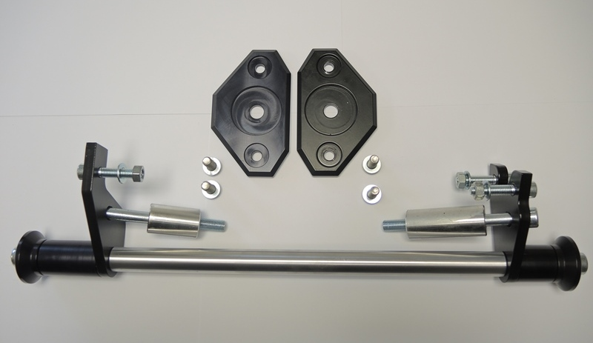

1
1

6
6
2,3
8
2,3
8
9
9

7
5
7
5

4
4
10
10

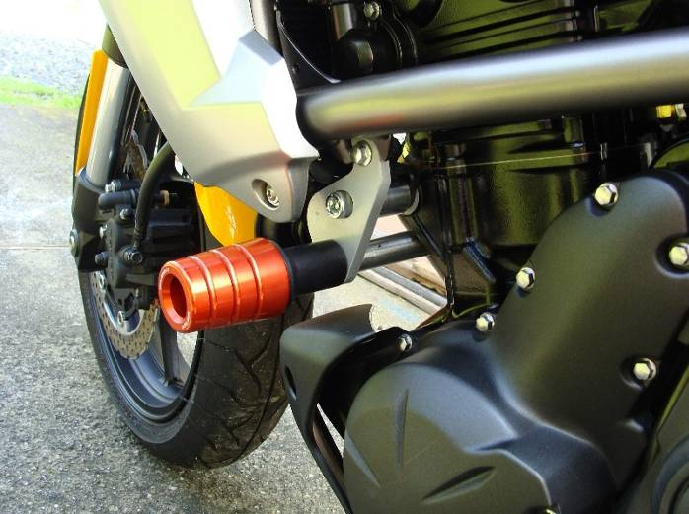
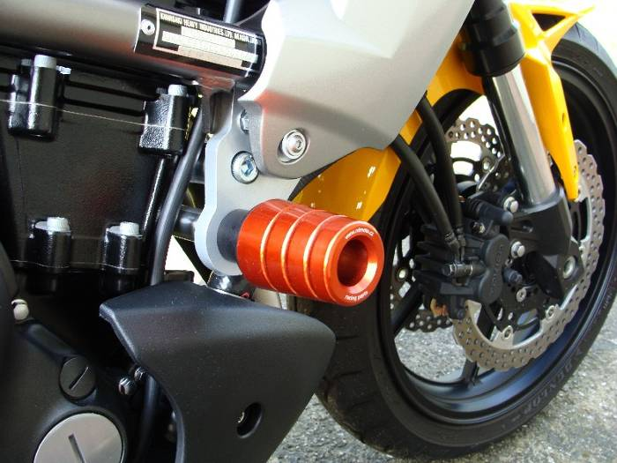
Old type of protector

