K16
Kawasaki Versys 650 2006-

Kit for left side: |  |  |  |  | Kit for right side:
ID | Description | Cat.N | Qt. |  | ID | Description | Cat.N | Qt.
1 | Steel box | X2 | 1 |  | 1 | Steel box | X2 | 1
2 | Nut M8 | 813 | 1 |  | 2 | Nut M8 | 813 | 2
3 | Washer M8 | 802 | 1 |  | 3 | Washer M8 | 802 | 2
4 | Alu. spacer d=50mm | 209 | 1 |  | 4 | Alu. spacer d=30mm | 170 | 1
5 | Bolt M12x100 | 986 | 1 |  | 5 | Bolt M12x80 | 956 | 1
6 | Alu. adapter | 544 | 1 |  | 6 | Alu.adapter | 543 | 1
7 | Bolt M10x100x1,25mm | 892 | 1 |  | 7 | Bolt M10x110x1,25mm | 928 | 1
8 | Bolt M8x40mm | 828 | 1 |  | 8 | Bolt M8x40 | 828 | 2
9 | Alu. spacer d=41mm | 36 | 1 |  | 9 | Alu. spacer d=61mm | 37 | 1
10 | Alu. connection bar AL20(M12)x314x30x30 |  | 1
Assembly:

- Dismantle original bolts M8 and M10 from frame and plastic covers.
- Tighten alu. adapter ID.6 on the left side. Make assembly by bolt M10x100 ID.7 and bolt M8x40 ID.8, use nut M8 ID.2 and washer ID.3 for tightening.
- Place spacer d=41mm ID.9 between frame and adapter.
- Tighten alu. adapter ID.6 on the right side. Make assembly by bolt M10x110 ID.7 and bolt M8x40 ID.8, use nut M8 ID.2 and washer ID.3 for tightening
- Place spacer ID.9 d=61mm between frame and alu. adapter.
- Insert steel box ID.1 into the cash protector on the left side.
- Bolt M12x100 ID.5 inside protector, under the protector place alu. spacer d=50mm ID.4.
- This kit assembly into the alu. connection bar ID.10 with threads M12. This alu.bar is infant of the engine. Insert steel box ID.1 into the cash protector on the right side.
- Bolt M12x80 ID.5 inside protector, under the protector place alu. spacer. váleček ID4. This kit assembly into the alu. connection bar ID.10 with threads M12.
- Put fairings back to the bike.

Warning - on the threads of the screws we recommend using premium adhesive moderate (blue).

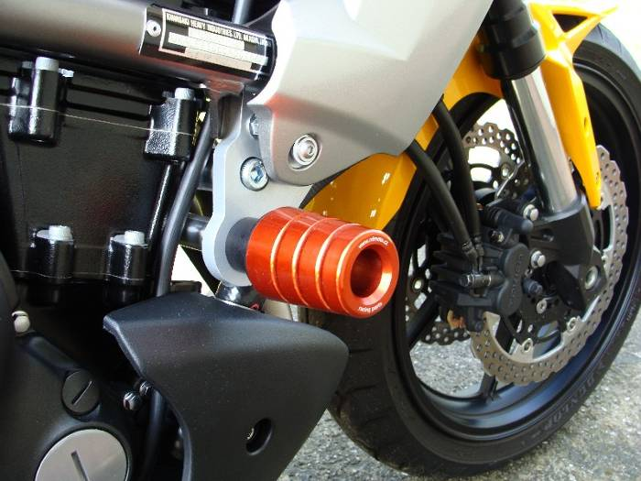
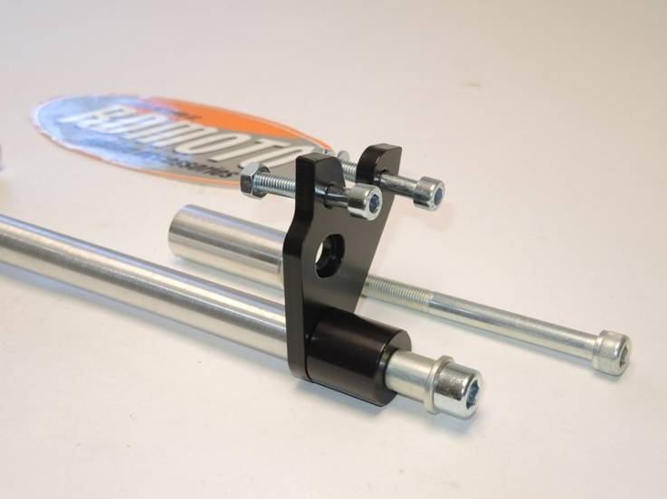
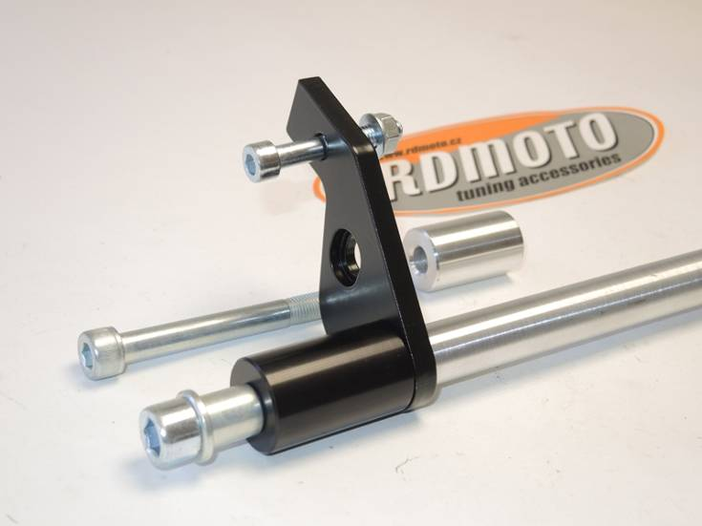
8
6
7
7
9
2,3
2,3
6
8
10
9
5
1
4
10
4
1
5

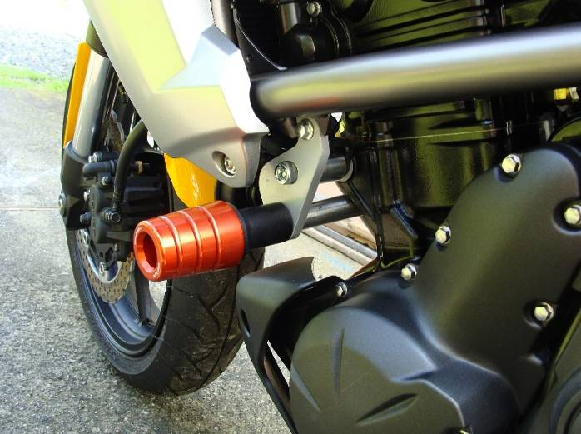

Ilustration photos older model of protectors.

