K19
Kawasaki ZX-9R 1998-1999
Kit for the left side |  |  |  |  | Kit for the right side
ID. | Description | Cat.no. | pcs |  |  | ID. | Description | Cat.no. | pcs
1 | Steel insert M10 | X1 | 1 |  |  | 1 | Steel insert M10 | X1 | 1
2 | Bolt M10x80x1,25mm | 920 | 1 |  |  | 2 | bolt M10x100x1,25mm | 892 | 1
3 | dural. cylinder - 60mm | 6 | 1 |  |  | 3 | dural. cylinder d=40mm | 4 | 1
4 | bolt M10x110mm | 879 | 1 |  |  | 4 | bolt M10x90mm | 880 | 1
5 | washer M10 (flat) | 804 | 2 |  |  | 5 | bolt M8x45mm | 964 | 1
6 | Steel adapter | 534 | 1 |  |  | 6 | washer M8 (flat) | 802 | 2
- | AL16(M10)x392x30x30 |  | 1 |  |  | 7 | washer M10 (flat) | 804 | 1
8 | washer (flat) M6 | 947 | 4 |  |  | 8 | Steel adapter | 535 | 1
9 | 3M tape |  | 1 |  |  | 9 | Dural cylinder d=14mm | 1211 | 1
 |  |  |  |  |  | 10 | Nut M8 | 809 | 1
 |  |  |  |  |  | 11 | 3M tape |  | 1
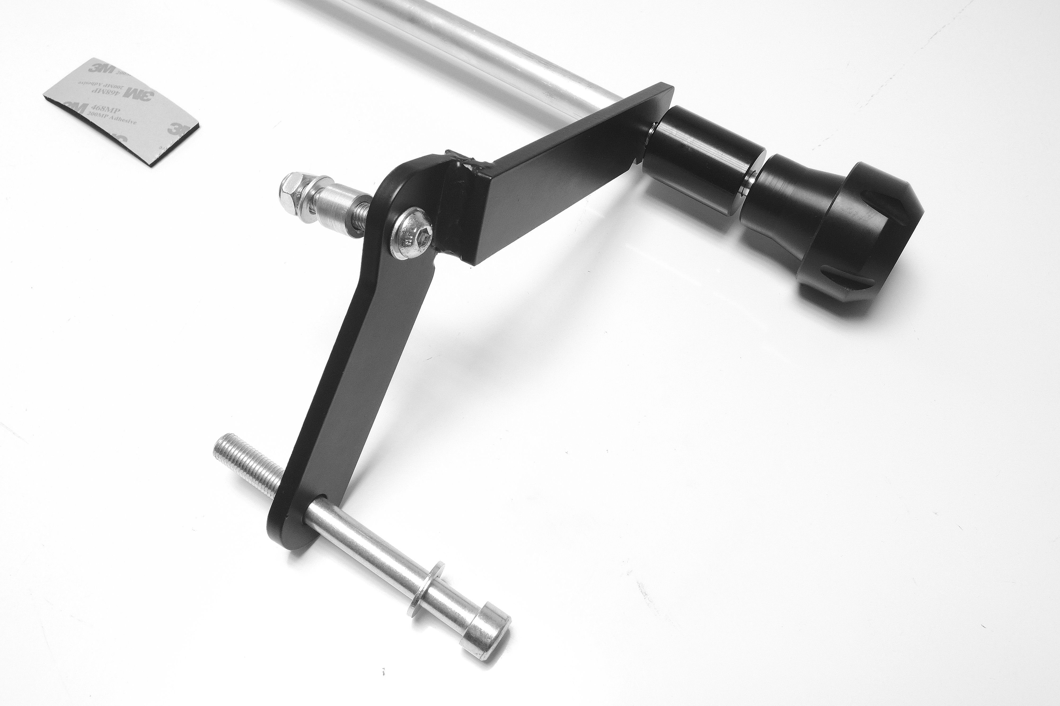
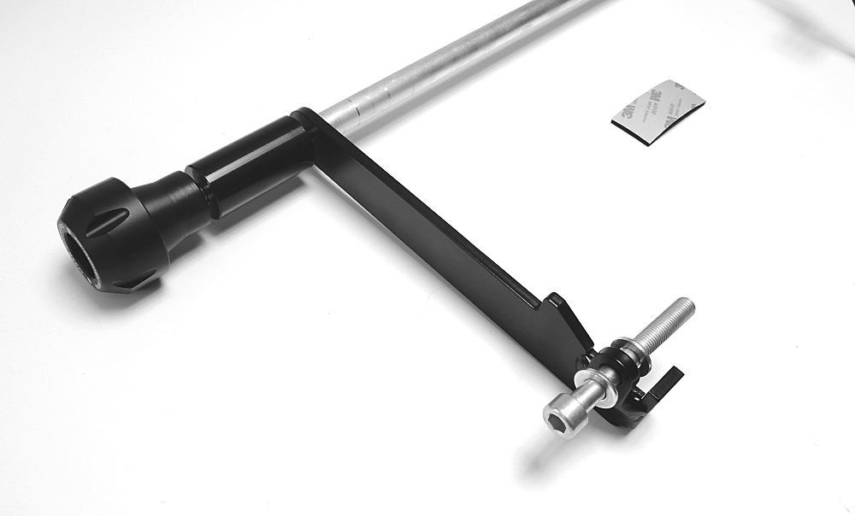
picture 1
picture 2

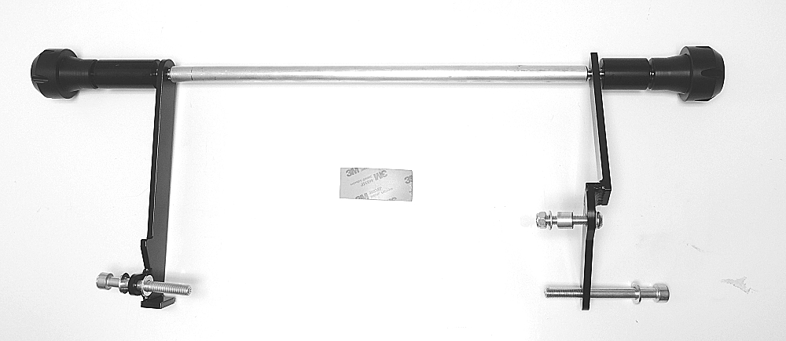
bolt M10x110 > insert X1 > cylinder (60mm) > adapter > rod
bolt M10x90 > insert X1 > cylinder (40mm) > adapter > rod

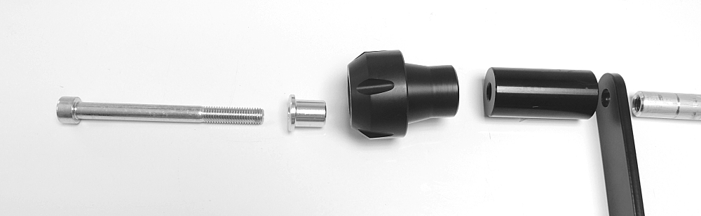
bolt M10x80 > washer M10 > steel adapter > washer M10
bolt M10x100 > washer M10 > steel adapter
bolt M8x45 > washer M8 > steel adpater> cylinder (14mm) > washer M8 > nut M8
picture 3
3
picture 4

Installation:

- Remove fairing of motorcycle from both sides.
- Remove original M10 bolts.
- During the installation don’t forget to place 3M tape and all washers according to the pictures.
- Using two M10 bolts (ID2) fit steel adapter from both sides. Place all washers according to the picture 1, 2 and 3.
- Fit right side adapter also using M8 bolt according to the picture 2. Place two M8 washers and dural cylinder (14mm) between engine and steel adapter. Tighten this bolt using M8 nut.
- Now prepare protectors sets in order according to the picture 4 (Bolt (M10x110 on the left and M10x90 on the right) > steel insert > protector > cylinder (60mm on the left and 40mm on the right).
- Insert steel rod between steel adapters and thighten it using prepared protectors sets.

We recommended to use the glue on all threads (medium strong).

