6

**K1**

**Kawasaki ER-5**

|  |  |  |  |
| --- | --- | --- | --- |
| **ID.** | **Description** | **Cat.N** | **Qt** |
| 1 | Connect bar M10x(1,25)x420x30x30 |  | 1 |
| 2 | Steel box | X1 | 2 |
| 3 | Nuts M10x1,25 | X11 | 2 |
| 4 | Alu spacer d=60 | 51 | 2 |

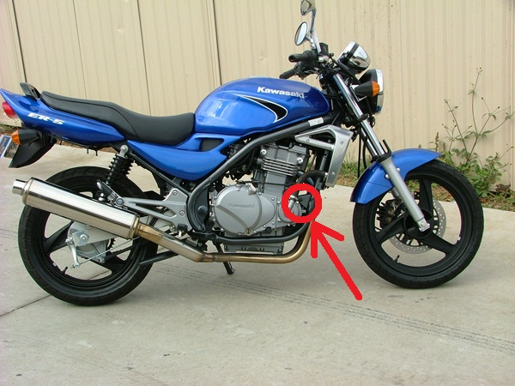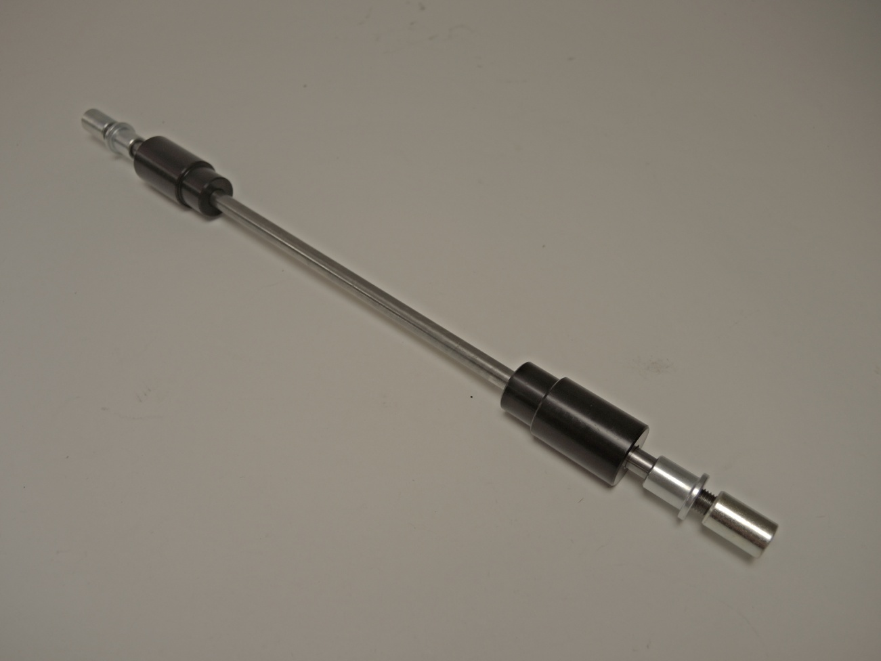  
Mounting make to the position by following the attached photo. Remove the original screw. To the hole insert a stainless steel rod, on both sides attach a dural distance rollers. Put protectors and by nuts M10 tighten.

3

2

4

1

4

2

3