K23SD
Kawasaki ER-6N 2009-2011

LEFT SIDE KIT |  |  |  |  | RIGHT SIDE KIT
ID | Description | Cat.no. | Pcs |  |  | ID | Description | Cat.no. | Pcs
1 | Adapter SLD | 537 | 1 |  |  | 1 | Adapter SLD | 537 | 1
2 | Bolt M10x130x1,25mm | 905 | 1 |  |  | 2 | Bolt M10x120x1,25mm | 895 | 1
3 | Bolt M8x60mm | 838 | 1 |  |  | 3 | Bolt M8x40mm | 835 | 2
4 | Bolt M10x60mm | 850 | 1 |  |  | 4 | Bolt M10x70mm | 851 | 1
5 | Dural. cylinder 40mm | DV12 | 1 |  |  | 5 | Dural. cylinder 50mm | DV13 | 1
6 | Dural. cylinder 63mm | 118 | 1 |  |  | 6 | Dural. cylinder 4,5mm | 116 | 1
7 | Dural. cylinder 22mm | 117 | 1 |  |  | 7 | Dural. adapter | 527 | 1
8 | Dural. adapter | 528 | 1 |  |  | 8 | Washer M10 (flat) | 804 | 1
9 | Washer M10 (flat) | 804 | 1 |  |  | 9 | Bolt M8x25 | 815 | 2
10 | Bolt M8x25 | 815 | 2 |  |  | 10 | Washer M8 | 800 | 2
11 | Washer M8 | 800 | 2

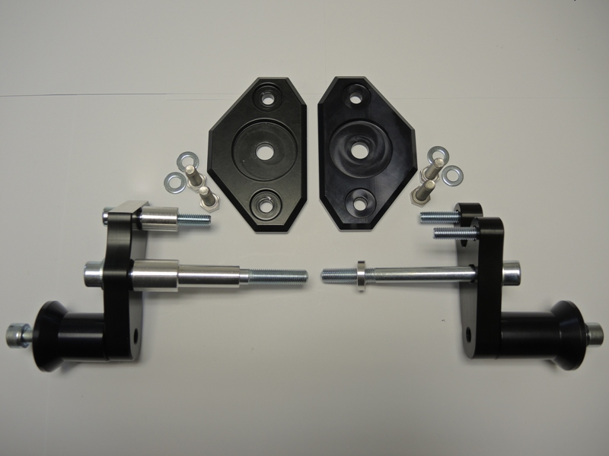

LEFT SIDE INSTRUCTIONS

- Dismantle side fairing and bolts from the frame.
- Assembly fitting kit according to the picture above (page 1).
- Fit this kit into the frame of motorcycle.
- Fit SLD adapter ID1 and dural cylinder ID5 into the fitting kit using bolt ID4.
- Fit slider using bolts ID10 and washers ID11.

We recommend to use safety glue on all threads (medium strong).

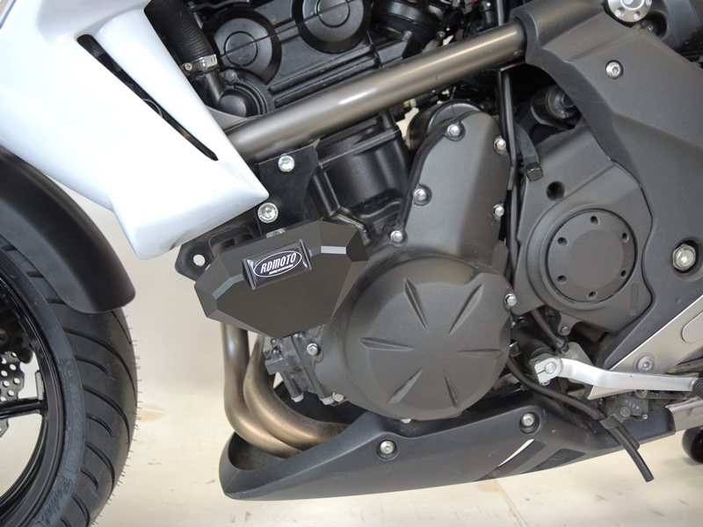

RIGHT SIDE INSTRUCTIONS

- Dismantle side fairing and bolts from the frame.
- Assembly fitting kit according to the picture above (page 1).
- Fit this kit into the frame of motorcycle.
- Fit SLD adapter ID1 and dural cylinder ID5 into the fitting kit using bolt ID4.
- Fit slider using bolts ID9 and washers ID10.

We recommend to use safety glue on all threads (medium strong).

