K23S
Kawasaki ER-6N 2009-2011

Kit for the left side |  |  |  |  | Kit for the right side
No. | Description | Cat.no. | Pcs |  |  | No. | Description | Cat.no. | Pcs
1 | Slider RDmoto | SL | 1 |  |  | 1 | Slider RDmoto | SL | 1
2 | Cover | SLcap.. | 1 |  |  | 2 | Cover | SLcap.. | 1
3 | Slider adapter | DV-316 | 1 |  |  | 3 | Slider adapter | DV-318 | 1
4 | Bolt M6x25 | 877 | 3 |  |  | 4 | Bolt M6x25 | 877 | 3
5 | Bolt M4x16 | 876 | 2 |  |  | 5 | Bolt M4x16 | 876 | 2
6 | Bolt M10x130x1,25mm | 905 | 1 |  |  | 6 | Bolt M10x120x1,25mm | 895 | 1
7 | Bolt M8x60mm | 838 | 1 |  |  | 7 | Bolt M8x40mm | 835 | 2
8 | Bolt M10x25mm | 868 | 1 |  |  | 8 | Bolt M10x25mm | 868 | 1
9 | Dural. cylinder d=63mm | 118 | 1 |  |  | 9 | Dural. cylinder d=4,5mm | 116 | 1
10 | Dural. cylinder d=22mm | 117 | 1 |  |  | 10 | Duralumin adapter | 527 | 1
11 | Duralumin adapter | 528 | 1 |  |  | 11 | Washer M10 (plane) | 804 | 1
12 | Washer M10 (plane) | 804 | 1

Installation – left side:

- Remove fairing and bolts from the frame of motorcycle.
- Insert bolts (ID6 and ID7) into Dural adpater (ID11). Do not forget to place washer (ID12) under bolt (ID6).
- Put cylinders (ID9 and ID10) on the bolts.
- Fit this kit on the frame of motorcycle. Tighten all bolts.
- Put fairing back on the motorcycle.
- Fit slider adapter (ID3) on the dural adapter using bolt (ID8).
- Fit slider (ID1) on the slider adapter (ID3) using three bolts (ID4)
- In the end fit coloured cove using two bolts (ID5).

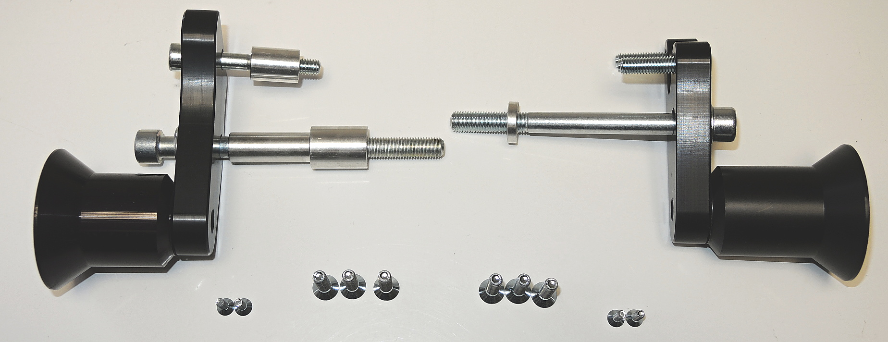
Warning – we recommend to use safety glue on threads of all bolts (moderate strong – blue colour).

22 mm
ID7
ID7
4,5 mm

ID11
63 mm
ID6

ID11
ID3+ID8

ID5
ID4
ILLUSTRATIVE PHOTO
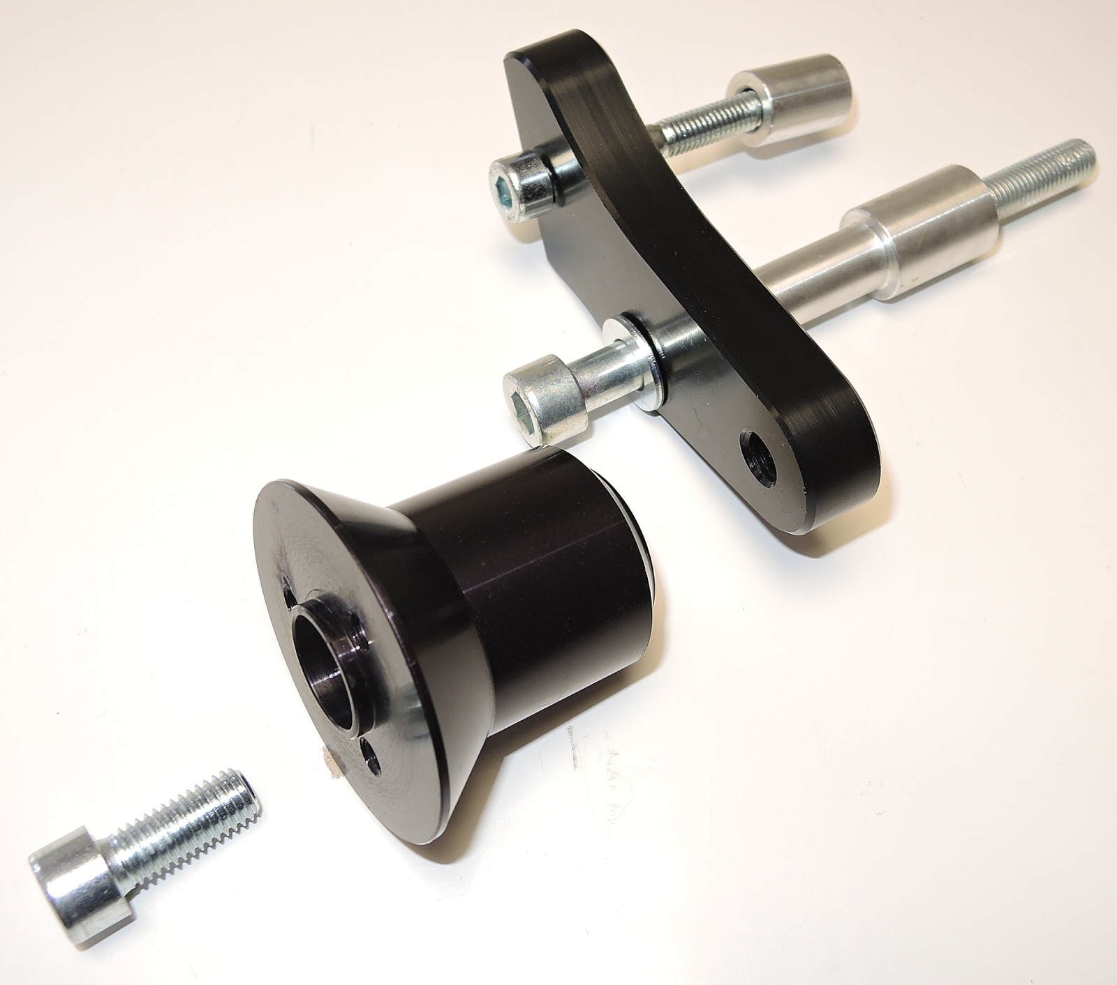

Installation – right side:

- Remove fairing and bolts from the frame of motorcycle.
- Insert bolts (ID6 and ID7) into Dural adpater (ID10). Do not forget to place washer (ID11) under bolt (ID6).
- Put cylinder (ID9) on the bolt M10.
- Fit this kit on the frame of motorcycle. Tighten all bolts.
- Put fairing back on the motorcycle.
- Fit slider adapter (ID3) on the dural adapter using bolt (ID8).
- Fit slider (ID1) on the slider adapter (ID3) using three bolts M6 (ID4)
- In the end fit coloured cover using two bolts M4 (ID5).

Warning – we recommend to use safety glue on threads of all bolts (moderate strong – blue colour).

ILLUSTRATIVE PHOTO

