K23
Kawasaki ER-6N 2009-2011

Kit for the left side |  |  |  |  | Kit for the right side
No. | Description | Cat.no. | Pcs |  |  | No. | Description | Cat.no. | Pcs
1 | Steel box M10 | X1 | 1 |  |  | 1 | Steel box M10 | X1 | 1
2 | Bolt M10x130x1,25mm | 905 | 1 |  |  | 2 | Bolt M10x120x1,25mm | 895 | 1
3 | Bolt M8x60mm | 838 | 1 |  |  | 3 | Bolt M8x40mm | 835 | 2
4 | Bolt M10x60mm | 850 | 1 |  |  | 4 | Bolt M10x70mm | 851 | 1
5 | Dural. cylinder d=20mm | 2 | 1 |  |  | 5 | Dural. cylinder d=30mm | 3 | 1
6 | Dural. cylinder d=63mm | 118 | 1 |  |  | 6 | Dural. cylinder d=4,5mm | 116 | 1
7 | Dural. cylinder d=22mm | 117 | 1 |  |  | 7 | Duralumin adapter | 527 | 1
8 | Duralumin adapter | 528 | 1 |  |  | 8 | Pad M10 (plane) | 804 | 1
9 | Pad M10 (plane) | 804 | 1

Installation – the left side:

- remove the original side plastic and bolts in the place of installation
- give bolts (No. 2 and No. 3) into the duralumin adapter, don’t forget to give the pad (No. 9) under the head of the bolt (No. 2)
- give the duralumin cylinder (No. 6 and No. 7) on bolts the other side of adapter
- this prepared adapter mount on the frame of motorcycle and tighten all properly
- mount the original side plastic back
- use the bolt (No. 4), give steel box (No. 1) and the crash protectors on this bolt, give the duralumin cylinder (No. 5) on the bolt under the protector
- all this set mount on duralumin adapter

Warning – we recommend to use safety glue on threads of all bolts (moderate strong – blue colour).

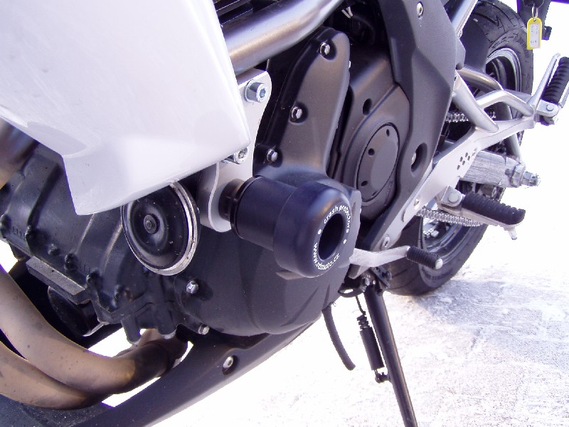

Installation – the right side:

- remove the original side plastic and bolts in the place of installation
- give bolts (No. 2 and No. 3) into the duralumin adapter, don’t forget to give the pad (No. 8) under the head of the bolt (No. 2)
- give the duralumin cylinder (No. 6) on bolts M10 the other side of adapter
- this prepared adapter mount on the frame of motorcycle and tighten all properly
- mount the original side plastic back
- use the bolt (No. 4), give steel box (No. 1) and the crash protectors on this bolt, give the duralumin cylinder (No. 5) on the bolt under the protector
- all this set mount on duralumin adapter

Warning – we recommend to use safety glue on threads of all bolts (moderate strong – blue colour).

