K24SDM
Kawasaki ER-6F 2009-2011

Mounting Kit Left Side: Mounting Kit Right Side:
ID | Description | Cat. No. | Pcs.
1 | Alu. Roller d=60mm | DV14 | 1
2 | Dural. Adapter SLDM | 537/B | 1
3 | Bolt M10x85 | 981 | 1
4 | Bolt M8x80 | 843 | 2
5 | Washer M8 (Spring) | 800 | 2
6 | Dural. Roller d=56 | 222 | 1
7 | Dural. Roller | 220 | 1
8 | Bolt M6x60 | 872 | 1
9 | Nut M6 | 948 | 1
10 | Washer M6 | 947 | 2
11 | 3M Tape | - | 1
12 | Steel Adapter | 532 | 1
13 | Bolt M6x20 | 1024 | 2
14 | Washer M6 | 1023 | 2
ID | Description | Cat. No. | Pcs.
1 | Alu. Roller d=70mm | DV15 | 1
2 | Dural. Adapter SLDM | 537/B | 1
3 | Bolt M10x95 | 822 | 1
4 | Bolt M8x70 | 841 | 2
5 | Washer M8 (Spring) | 800 | 2
6 | Dural. Roller d=36,2 | 221 | 2
7 | Bolt M6x50 | 867 | 1
8 | Nut M6 | 948 | 1
9 | Washer M6 | 947 | 2
10 | 3M Tape | - | 1
11 | Steel Adapter | 533 | 1
12 | Bolt M6x20 | 1024 | 2
13 | Washer M6 | 1023 | 2
13 | Strut | X42 | 1
14 | Washer M8 | 800 | 2
15 | Bolt M8x20 | 824 | 2

1
3

2

5
4

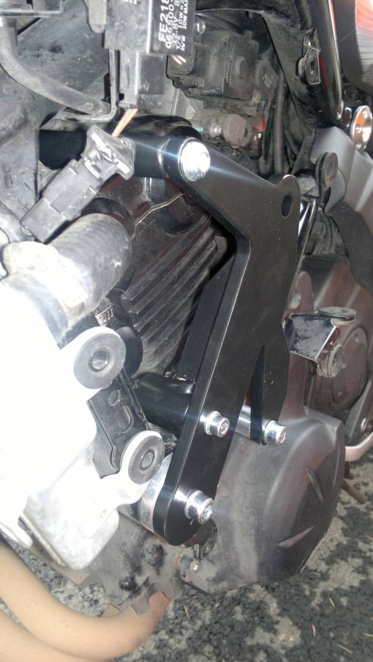
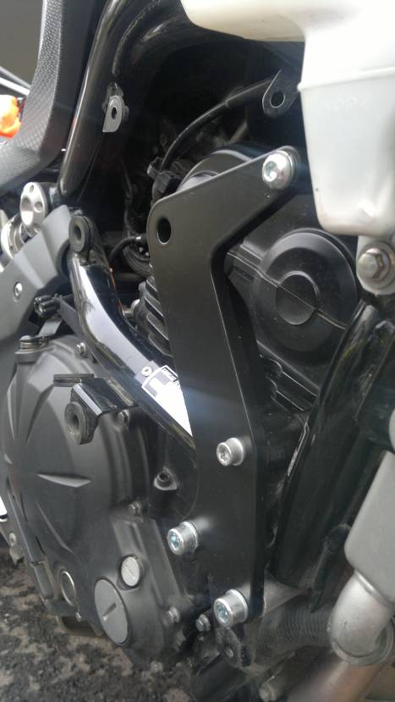
14, 15
14, 15
7
6
8
4
4
6
6

Use the rollers included in this kit instead of the crossed out rollers in the attached pictures.

Mounting Instructions, Left Side:
- Remove the motorcycle fairing.
- At the place of a steel holder, remove the original bolts from motorcycle.
- Insert ID.4 bolts into the steel adapter ID.12 and support them with ID.5 washers.
- Place the mounted ID.7 roller onto the M8 front bolt and ID.6 roller onto the rear M8 bolt.
- At the place where steel holder touches the frame or fairing, stick the 3M tape included in the kit.
- Finally, mount this assembly onto your motorcycle.
- Then, take the ID.8 bolt, M6 ID.10 washers and ID.9 nuts and mount them through the adapter and engine.
- Push the ID.13 strut above the engine and mount it onto the steel adapter. Use bolt and washer ID.14 and ID.15 table 3.

Mounting Instructions, Right Side:
- Remove the motorcycle fairing.
- At the place of a steel holder, remove the original bolts from motorcycle.
- Slip the ID.5 washers onto ID.4 bolts and push them through the ID.11 steel adapter.
- From rear side, mount ID.6 dural. rollers onto the bolts.
- Now, mount this assembly onto the motorcycle.
- Use the ID.15 bolt and ID. 14 washer to mount the ID.13 strut right above the engine table 3.
- Connect the adapter with the motorcylce with M6 ID.7 bolt, ID.9 washers and ID.8 nut.
- Finally, tighten all bolts on both sides.

Place back all fairing.

Mounting Instructions – Crash Protectors:
- Insert ID.3 bolt into the ID.2 adapter on the left side and place ID.1 roller underneath the adapter.
- Mount this assembly into the adapter on the frame.
- Mount the slider with ID.13 bolts and ID.14 nuts.
- Insert the ID.3 bolt into the ID.2 adapter on the right side and place ID.1 roller underneath the adapter.
- Mount this assembly into the adapter on the frame.
- Mount the slider using ID.12 bolts and ID.13 washers.

Follow the instructions shown on attached pictures during assembly.

Note: We recommend using blue color thread glue during assembly!
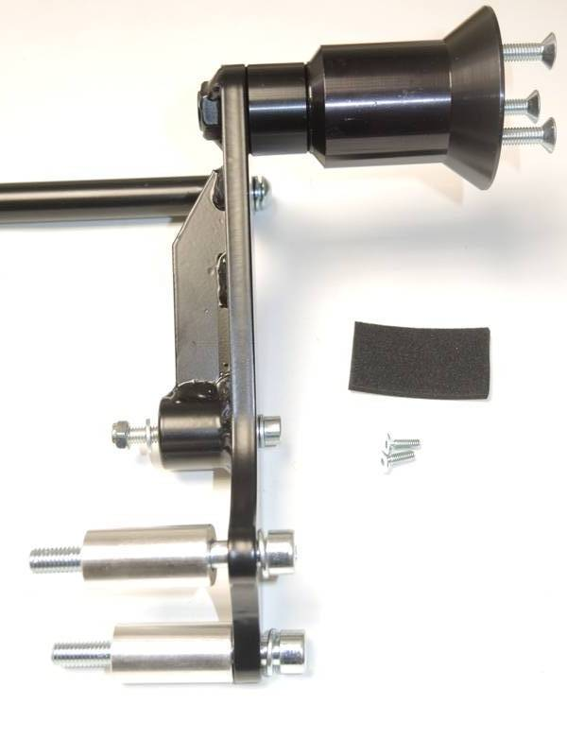
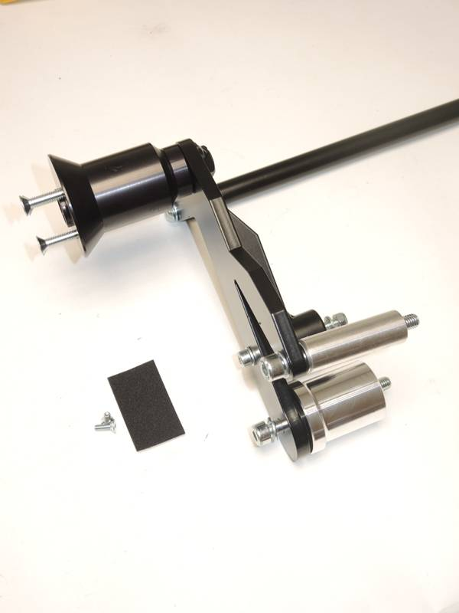
6
5
4
12
13
10
9
9, 7
9
7
8
11
4
5
4
6
5
8
6
10
5
14, 15
14, 15
13
4
13
12
L
R

