K24S
Kawasaki ER-6F 2009-2011

Kit for the left side: Kit for the right side
ID | Popis | Kat.č. | Ks
1 | Dural. adapter | DV316 | 1
2 | Alu cylinder - 10mm | DV1 | 1
3 | Bolt M10x40 | 854 | 1
4 | Bolt M8x80 | 843 | 2
5 | Washer M8 | 800 | 2
6 | Dural.cylinder – 56mm | 222 | 1
7 | Dural.cylinder | 220 | 1
8 | Bolt M6x60 | 872 | 1
9 | Nut M6 | 948 | 1
10 | Washer M6 | 947 | 2
11 | 3M tape | - | 1
12 | Steel.adapter | 532 | 1
13 | Bolt M4x16 | 876 | 2
14 | Bolt M6x25 | 877 | 3
ID | Popis | Kat.č. | Ks
1 | Dural.adapter | DV316 | 1
2 | Alu cylinder - 20mm | DV2 | 1
3 | Bolt M10x50 | 849 | 1
4 | Bolt M8x70 | 841 | 2
5 | Washer M8 | 800 | 2
6 | Dural.cylinder- 36,2mm | 221 | 2
7 | Bolt M6x50 | 867 | 1
8 | Nut M6 | 948 | 1
9 | Washer M6 | 947 | 2
10 | 3M tape | - | 1
11 | Ocel.adapter | 533 | 1
12 | Bolt M4x16 | 876 | 2
13 | Bolt M6x25 | 877 | 3
13 | Rod | X42 | 1
14 | Washer M8 | 800 | 2
15 | Bolt M8x20 | 824 | 2

1
3

2

5
4

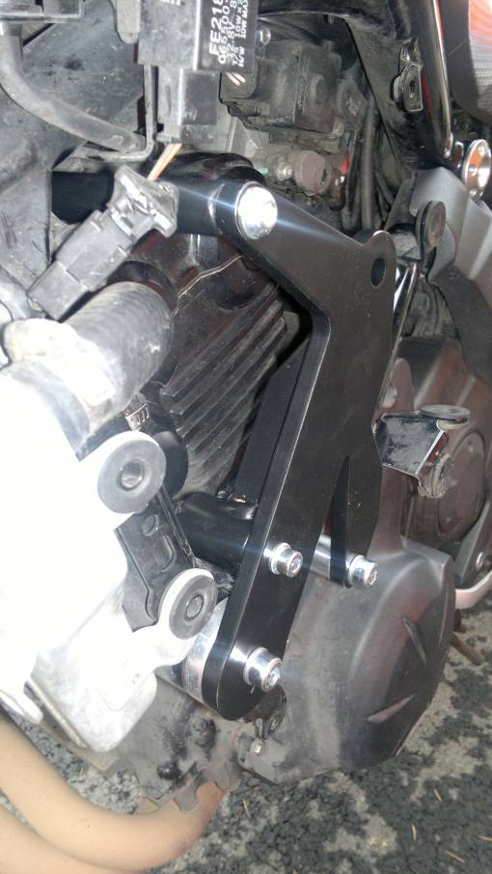
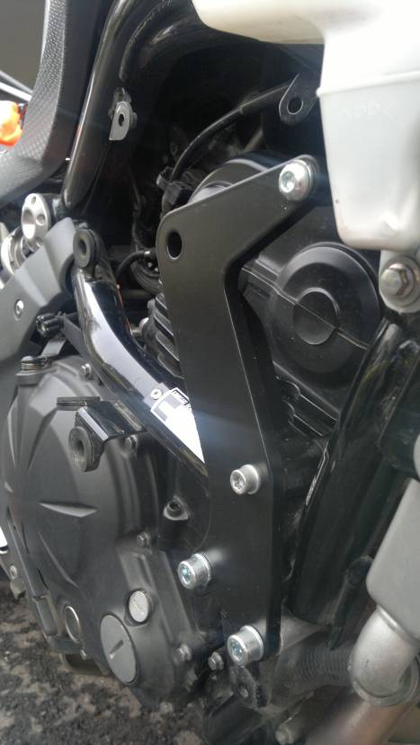
14, 15
14, 15
7
6
8
4
4
6
6

Instructions – left side:
- Remove fairing of motorcycle.
- Remove original bolts according to the pictures.
- Fit bolts ID4 with washers ID5 into steel adapter ID12 according to the pictures.
- Put cylinders on the M8 Bolts. ID7 is on the front bolt and ID6 is on the rear bolt.
- Stick 3M tape on the frame of motorcycle.
- Mount this kit on the motorcycle.
- Tighen adapter using Bolt ID8, washer ID10 and nut ID9.
- Fit rod ID13 into upper thread using bolt ID14 and washer ID15.

Instructions – right side:
- Remove fairing of motorcycle.
- Remove original bolts according to the pictures.
- Fit bolts ID4 with washers ID5 into steel adapter ID11 according to the pictures.
- Put duraluminium cylinders ID6 on the bolts.
5. Mount this kit on the motorcycle.
6. Tighten rod ID13 using bolt ID14 with washer ID15.
7. Tighen adapter using Bolt ID7, washer ID9 and nut ID8.

Put fairing back on the motorcycle.

Instructions – crash protectors:
- Fit adapter ID1 + cylinder ID2 on steel adapter using bolt ID3.
- Fit slider using three bolts ID14.
- Fit coloured cover using two bolts ID13.

We recommend to use the glue on all threads (blue colour – medium strong).
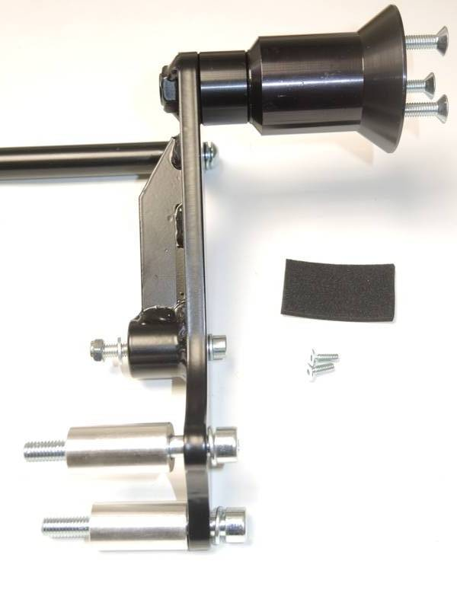
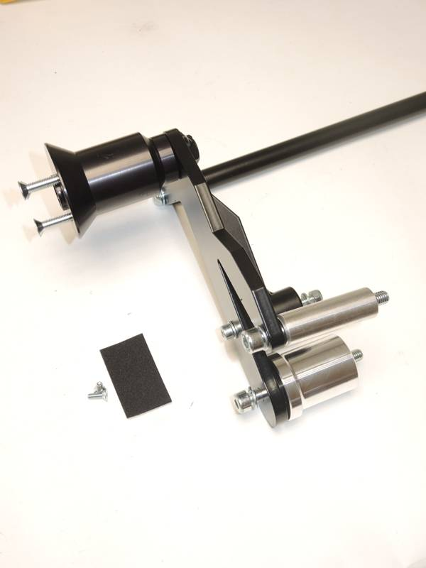
6
5
4
12
13
10
9
9, 7
9
7
8
11
4
5
4
6
5
8
6
10
5
14, 15
14, 15
13
4
13
14
12
13
3
2
1
3
1
2
L
R

