K24
Kawasaki ER-6F 2009-2011

Fitting kit left side: Fitting kit right side:
ID | Description | Cat.N | Qty
1 | Steel box | X1 | 1
2 | Bolt M10x80 | 852 | 1
3 | Dural.cylinder d=40 | 4 | 1
4 | Bolt M8x80 | 843 | 2
5 | Washer M8 (spring) | 800 | 2
6 | Dural.cylinder d=56 | 222 | 1
7 | Dural.cylinder | 220 | 1
8 | Bolt M6x60 | 872 | 1
9 | Nut M6 | 948 | 1
10 | Washer M6 | 947 | 2
11 | 3M Tape | - | 1
12 | Steel adapter | 532 | 1
ID | Description | Cat.N | Qty
1 | Steel box | X1 | 1
2 | Bolt M10x90 | 880 | 1
3 | Dural.cylinder d=50 | 5 | 1
4 | Bolt M8x70 | 841 | 2
5 | Washer M8(spring) | 800 | 2
6 | Dural.cylinder d=36,2 | 221 | 2
7 | Bolt M6x50 | 867 | 1
8 | Nut M6 | 948 | 1
9 | Washer M6 | 947 | 2
10 | 3M Tape | - | 1
11 | Steel adapter | 533 | 1
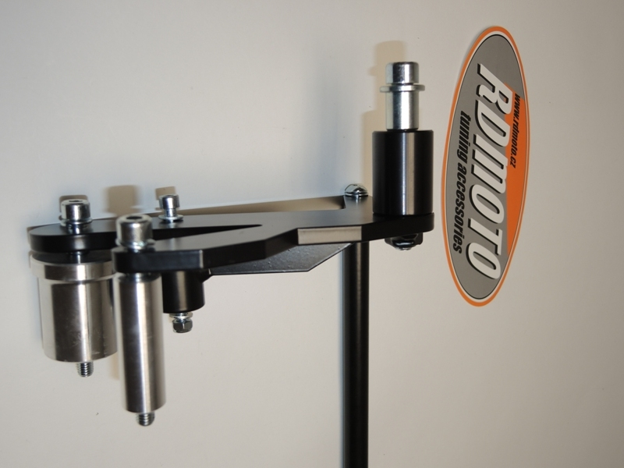
13 | Connecting bar | X42 | 1
14 | Washer M8 | 800 | 2
15 | Bolt M8x20 | 824 | 2

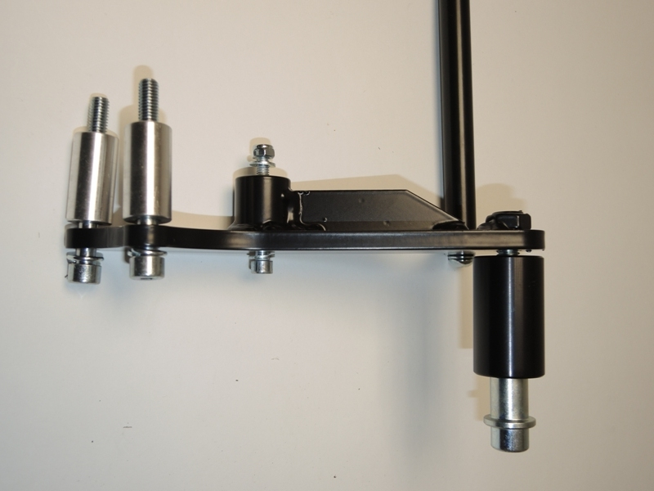
L
R
3

13
13
2
3
1
1
14, 15
2

11
14, 15

9, 7
8
10
10
9
6
9
8
5

12
4
5
4
6
7
4
5
4
6
5
5
4

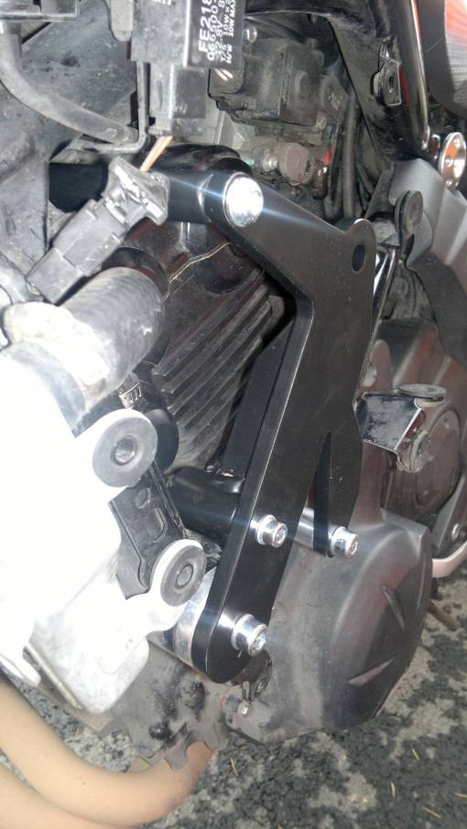
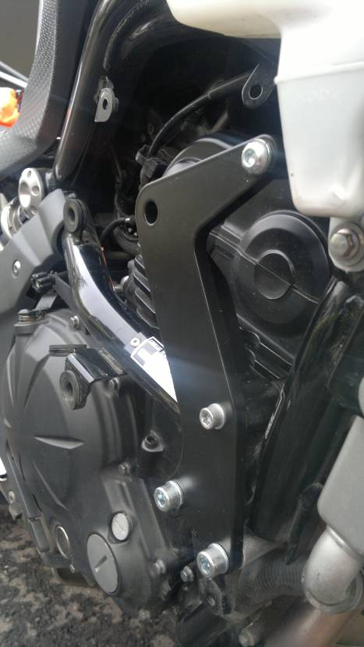
14, 15
14, 15
7
6
8
4
4
6
6
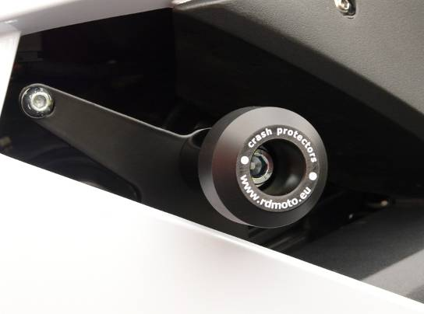
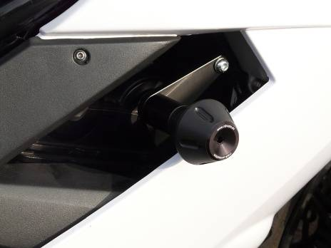

Instruction to assembly left side:
- Take out fairing from bike.
- Remove the orig. bolts from frame.
- Take steel adapater ID.12 insert bolts ID.4 and washers ID.5.
- Under front bolt M8 slip over dural.cylinder ID.7 and under the rear bolt M8 slip over dural.cylinder ID.6.
- Where is a steel adapter touch with frame or fairing sticking 3M tape.
- This set mounting on the bike.
- Bolt ID.8, washers M6 ID.10 and nut ID.9 use for connect the steel adapter and motorcycle.
- In front of engine inserted through connecting bar ID.13 and mounting it on steel adapter. Use bolt ID.14 and washer ID.15.

Instruction to assembly right side:
- Take out fairing from bike.
- Remove the orig. bolts from frame.
- Take steel adapater ID.11 insert bolts ID.4 and washers ID.5.
- On the bolts slip over dural.cylinders ID.6.
- This set to mount on the bike.
- Take bolt ID.14 and washer ID.14 to mount bar ID.13.
- To mount bolt M6 ID.7, washers ID.9 and nut ID.8.
- Tighten all bolts on theright and left side.

Put fairing back the bike.

Assembly instruction for protectors.¨

- Left side: insert steel box ID.1 and bolt ID.2into the protector.
- From back side insert dural.cylinder ID.3.
- This set mount on adapter.

- Right side: insert steel box ID.1 and bolt ID.2into the protector.
- From back side insert dural.cylinder ID.3.
- This set mount on adapter.

During installation, follow the attached photos.

Warning: We recommend use the glue of all threads. Medium strong.

