K25SDM
Kawasaki ZX-6R/RR 2009-2011

LEFT SIDE KIT |  |  |  |  | RIGHT SIDE KIT
ID | Description | Cat.No. | Pcs |  |  | ID | Description |  | Cat.No. | Pcs
1 | SLD adapter (cylinder) 20mm | DV10 | 1 |  |  | 1 | SLD adapter (cylinder) 15mm |  | DV9 | 1
2 | Bolt M10x58x1,25mm | 944 | 1 |  |  | 2 | Bolt M10x70x1,25mm |  | 898 | 1
3 | Bolt M6x20mm | 878 | 1 |  |  | 3 | Bolt M6x20mm |  | 878 | 1
4 | Bolt M10x40mm | 854 | 1 |  |  | 4 | Bolt M6x25mm |  | 877 | 1
5 | Dural. cylinder 8mm | 229 | 1 |  |  | 5 | Bolt M10x30mm |  | 882 | 1
6 | Poly. Nut 10mm | 227 | 1 |  |  | 6 | Poly. Nut 10mm |  | 227 | 1
7 | Dural. adapter | 541 | 1 |  |  | 7 | Poly. Nut 15mm |  | 228 | 1
8 | 3M tape |  | 1 |  |  | 8 | Dural. adapter |  | 542 | 1
9 | SLDM adapter | 537/B | 1 |  |  | 9 | SLDM adapter |  | 537/B | 1
10 | Bolt M6x20 | 1024 | 2 |  |  | 10 | Bolt M6x20 |  | 1024 | 2
11 | Washer M6 | 1023 | 2 |  |  | 11 | Washer M6 |  | 1023 | 2
12 | Washer M10 (spring) | 801 | 1 |  |  | 12 | 3M tape |  |  | 1

LEFT SIDE INSTRUCTIONS

- Dismantle side fairing and original bolts.
- Prepare adapter according to the picture. Mount this kit on the frame of motorcycle.
- Mount side fairing back.
- Put washer ID12, SLD adapter ID9 and dural. cylinder ID1 on the bolt ID4. Fit this kit into the adapter on the motorcycle.
- Fit slider using two bolts ID10 and washers ID11.

We recommend to use safety glue on all threads (medium strong).
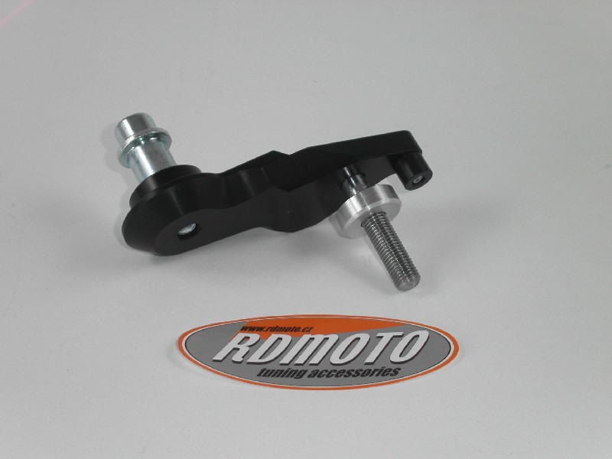

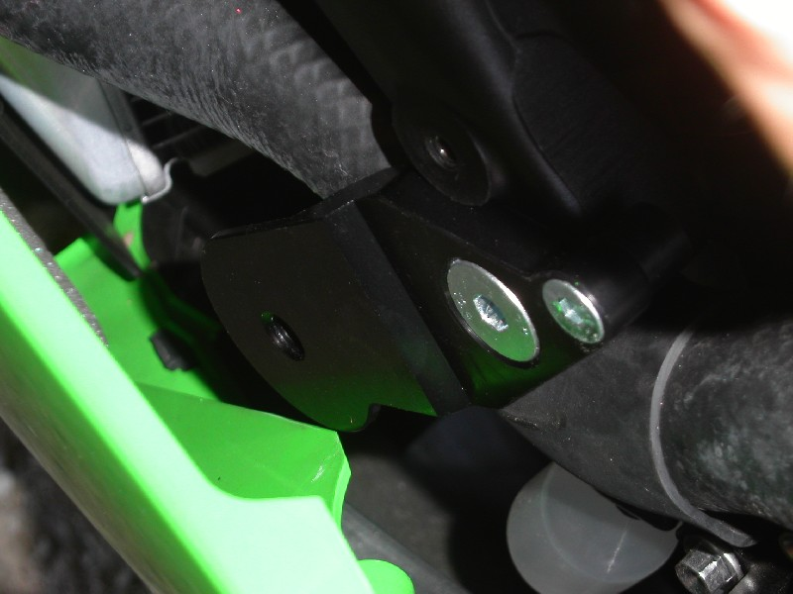
RIGHT SIDE INSTRUCTIONS

- Dismantle side fairing and original bolts.
- Prepare adapter according to the picture. Mount this kit on the frame of motorcycle.
- Mount side fairing back.
- Put SLD adapter ID9 and dural. cylinder ID1 on the bolt ID5. Fit this kit into the adapter on the motorcycle.
- Fit slider using two bolts ID10 and washers ID11.

We recommend to use safety glue on all threads (medium strong).

