K25S
Kawasaki ZX-6R/RR 2009-2011

Left side: Right side:
ID | Description | Cat.N | Qt.
1 | Bolt M4x16 | 876 | 2
2 | Bolt M10x70x1,25mm | 898 | 1
3 | Bolt M6x20mm | 878 | 1
4 | Bolt M6x25mm | 877 | 1
5 | Poly nut d=10mm | 227 | 1
6 | Poly nut d=15mm | 228 | 1
7 | Duralumin adapter | 542 | 1
8 | 3M tape | 3M | 1
9 | Bolt M10x20mm | 819 | 1
10 | Bolt M6x25 | 877 | 3
11 | Adapter moto | DV-317 | 1
ID | Description | Cat.N | Qt.
1 | Dural.adapter for SL01 | 316 | 1
2 | Bolt M10x58x1,25mm | 944 | 1
3 | Bolt M6x25 | 877 | 3
4 | Bolt M4x16 | 876 | 2
5 | Bolt M6x20mm | 878 | 1
6 | Dural. spacer d=8mm | 229 | 1
7 | Poly nut d=10mm | 227 | 1
8 | Duralumin adapter | 541 | 1
9 | 3M tape | 3M | 1
10 | Bolt M10x20mm | 819 | 1

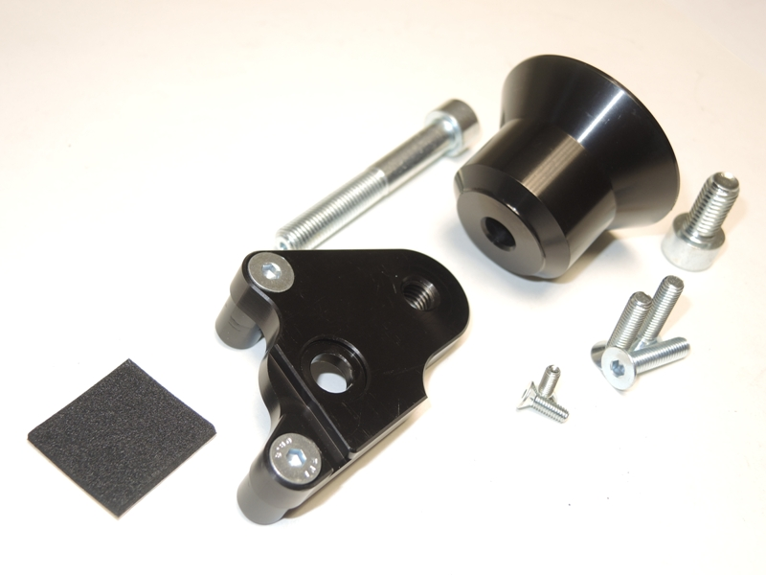
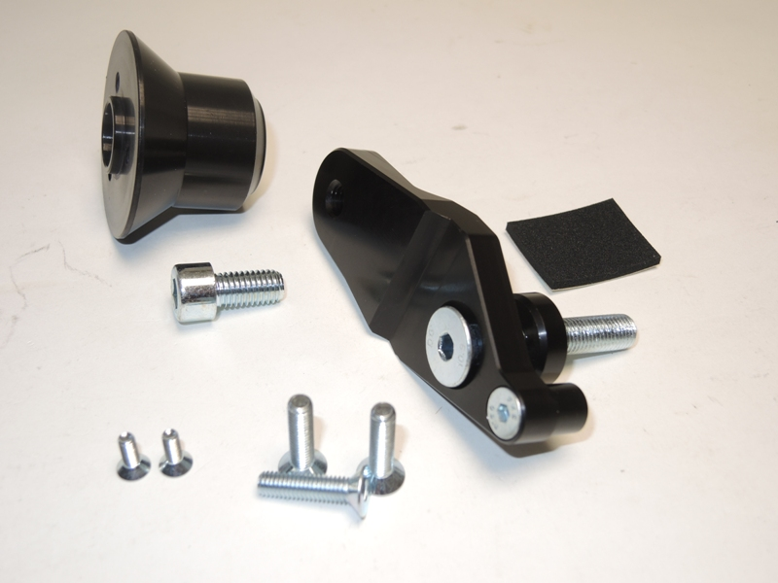

Installation – the left side:

- Remove the original side fairing and the bolt in the place of the installation.
- Bolts ID. 2 and ID. 5 insert into the duralumin adapter ID.8.
- From other side of the adapter put duralumin spacer ID.6 on the bolt M10 and put poly nut ID. 7 on the bolt M6.
- Where is bracket touching with frame stick 3M tape ID.9.
- This adapter mounting on the frame.
- Put fairing back on the bike.
- Bolt ID.10 put through dural. adapter ID.1 and tighten it to dural holder on the frame.
- Put slider and use the bolts ID.3 for mounting.
- Into the slider insert alu. cover, tighten it by bolts ID.4.
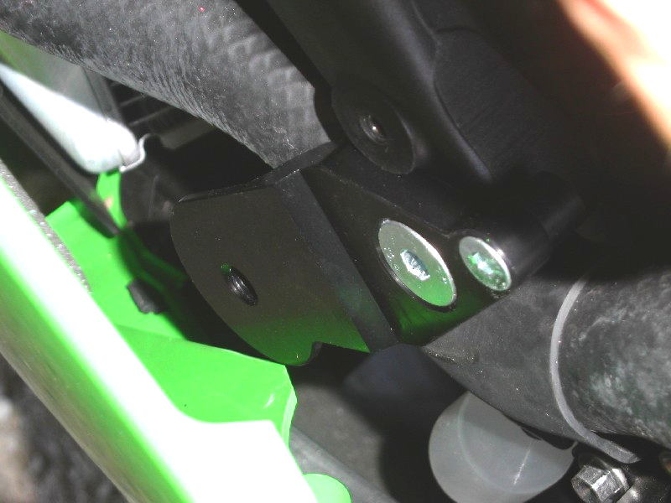
M6x20+poly.spacer

2

Installation – the right side:

- Remove the original side fairing and the bolt in the place of the installation
- Bolts ID.2,ID.3 and ID.4 insert into the duralumin adapter ID.7.
- From back side of the adapter mount poly nuts ID.5 and ID.6 on the bolts M6.
- Where is bracket touching with frame stick 3M tape ID.8.
- This adapter mounting on the frame.
- Put fairing back on the bike.
- Bolt ID.9 put through dural. adapter ID.11 and tighten it to dural holder on the frame.
- Place slider and use bolts ID.10.
- Into the slider insert alu. cover, tighten it by bolts ID.1

Warning – we recommend to use safety glue on threads of all bolts (moderate strong – blue colour).

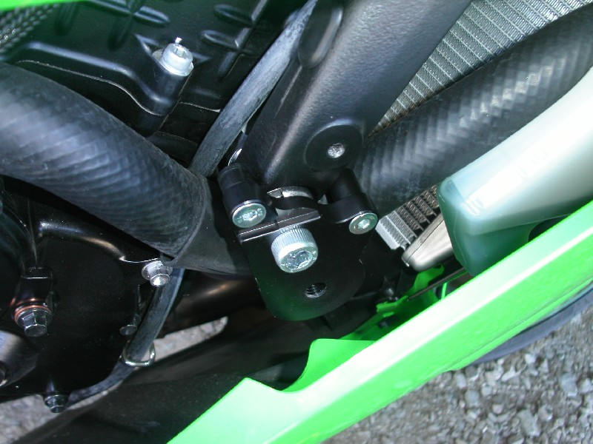

M6x25+Longer poly.spacer
2
3,5

