K25
Kawasaki ZX-6R/RR 2009-2011

Kit for the left side |  |  |  |  | Kit for the right side
No. | Description | Cat.no. | Pcs |  |  | No. | Description |  | Cat.no. | Pcs
1 | Steel box M10 | X1 | 1 |  |  | 1 | Steel box M10 |  | X1 | 1
2 | Bolt M10x58x1,25mm | 944 | 1 |  |  | 2 | Bolt M10x70x1,25mm |  | 898 | 1
3 | Bolt M6x20mm | 878 | 1 |  |  | 3 | Bolt M6x20mm |  | 878 | 1
4 | Bolt M10x45mm | 848 | 1 |  |  | 4 | Bolt M6x25mm |  | 877 | 1
5 | Dural. cylinder d=10mm | 1 | 1 |  |  | 5 | Bolt M10x35mm |  | 847 | 1
6 | Dural. cylinder d=8mm | 229 | 1 |  |  | 6 | Poly nut d=10mm |  | 227 | 1
7 | Poly nut d=10mm | 227 | 1 |  |  | 7 | Poly nut d=15mm |  | 228 | 1
8 | Duralumin adapter | 541 | 1 |  |  | 8 | Duralumin adapter |  | 542 | 1
9 | 3M tape |  | 1 |  |  | 9 | 3M tape |  |  | 1

Installation – the left side:

- remove the original side plastic and bolts in the place of installation
- give bolts (No. 2 and No. 3) into the duralumin adapter
- give the duralumin cylinder (No. 6) on bolts the other side of adapter and give poly nut (No. 7) on the bolt M6
- this prepared adapter mount on the frame of motorcycle and tighten all properly
- mount the original side plastic back
- use the bolt (No. 4), give steel box (No. 1) and the crash protectors on this bolt, give the duralumin cylinder (No. 5) on the bolt under the protector
- all this set mount on duralumin adapter

Warning – we recommend to use safety glue on threads of all bolts (moderate strong – blue colour).
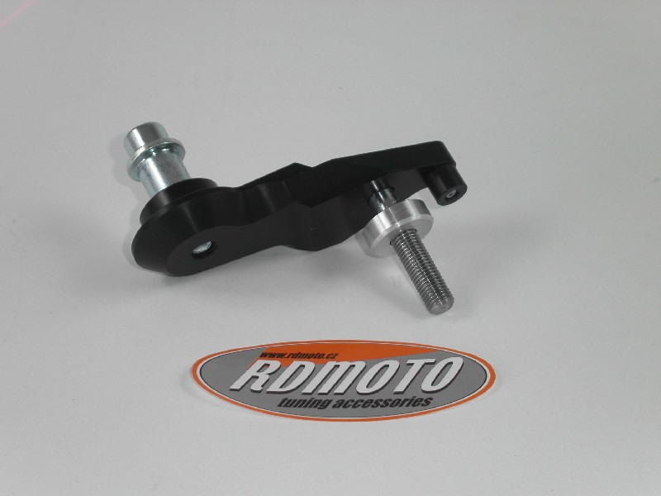

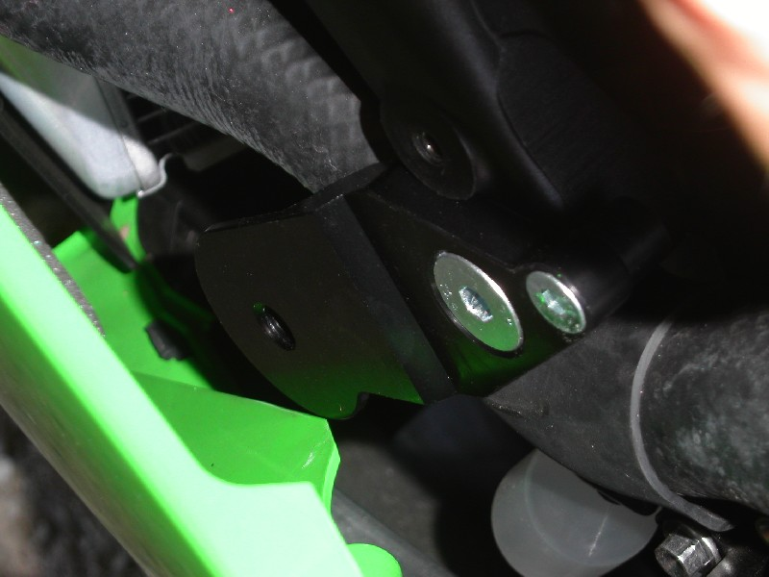
Installation – the right side:

- remove the original side plastic and bolts in the place of installation
- give bolts (No. 2, No. 3 and No. 4) into the duralumin adapter
- give poly nuts (No. 6 and No. 7) on the bolts M6 on bolts the other side of adapter
- use the bolt M10 for mounting of this prepared adapter on the frame of motorcycle and tighten all properly
- mount the original side plastic back
- use the bolt (No. 5), give steel box (No. 1) and the crash protectors on this bolt
- all this set mount on duralumin adapter

Warning – we recommend to use safety glue on threads of all bolts (moderate strong – blue colour).

