K26-2S

**Kawasaki ZX250R-Ninja 2008-**

|  |  |  |  |  |  |  |  |  |  |
| --- | --- | --- | --- | --- | --- | --- | --- | --- | --- |
| Kit for the left side | | | |  | Kit for the right side | | | |  |
| ID | Description | Cat.no. | Pcs |  | ID | Description | Cat.no. | Pcs |  |
| 1 | slider RDmoto | SL | 1 |  | 1 | slider RDmoto | SL | 1 |  |
| 2 | cap | SLcap.. | 1 |  | 2 | cap | SLcap.. | 1 |  |
| 4 | Slider adapter | DV-317 | 1 |  | 4 | Slider adapter | DV-317 | 1 |  |
| 7 | screw M6x25 | 877 | 3 |  | 7 | screw M6x25 | 877 | 3 |  |
| 8 | screw M4x16 | 876 | 2 |  | 8 | screw M4x16 | 876 | 2 |  |
| 9 | screw M10x25mm | 868 | 1 |  | 9 | screw M10x25mm | 868 | 1 |  |
| 10 | steel adapter | 626 | 1 |  | 10 | steel adapter | 627 | 1 |  |
| 11 | poly cylinder d= 150mm | 463 | 1 |  | 11 | poly cylinder d= 150mm | 463 | 1 |  |
| 12 | screw M10x30mm | 888 | 1 |  | 12 | screw M10x30mm | 888 | 1 |  |
| 13 | screw M8x25mm | 831 | 1 |  | 13 | screw M8x25mm | 831 | 1 |  |
| 14 | dural.bar AL16(M8)x209x30x30 |  | 1 |  |  |  |  |  |  |

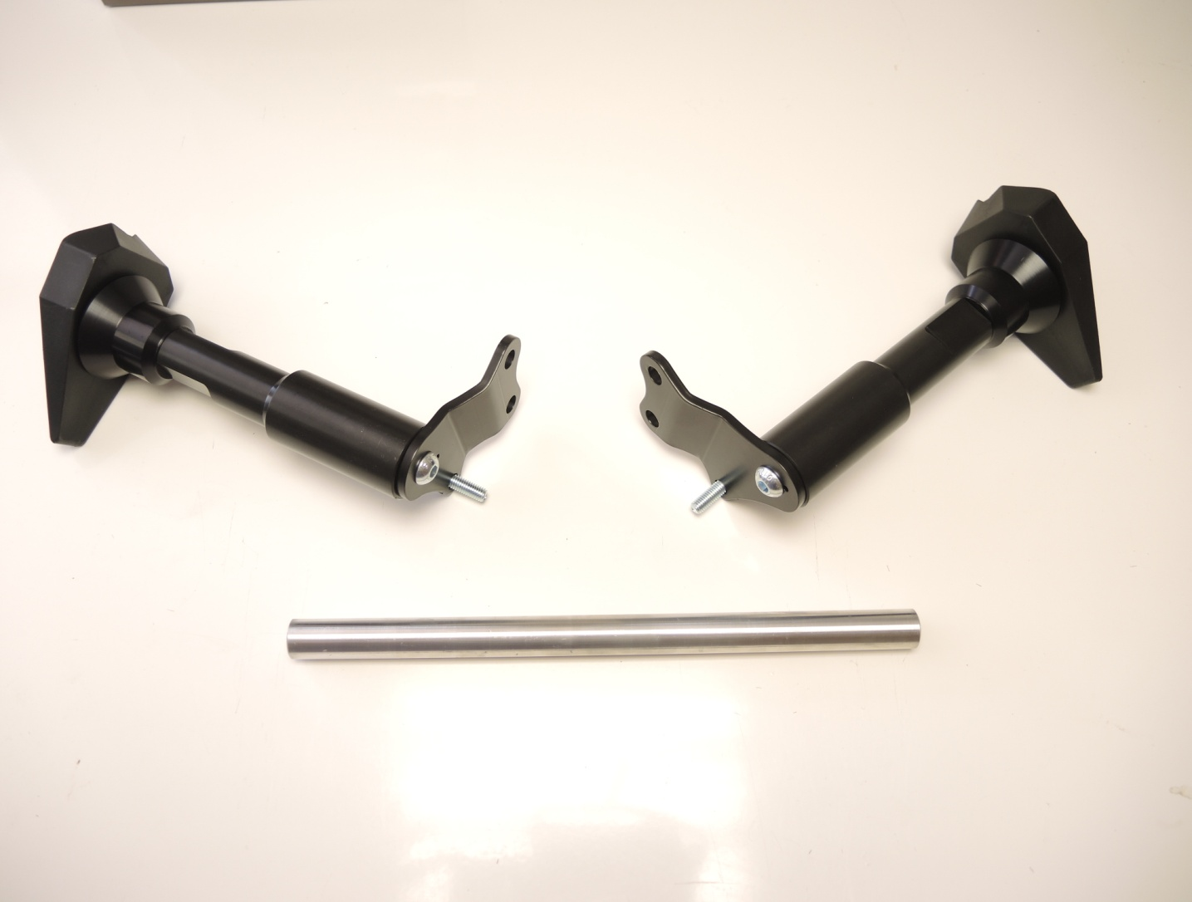

**Original screws**

**ID9**

**ID4**

**ID10**

**ID11**

**ID12**

**ID13**

**ID14**

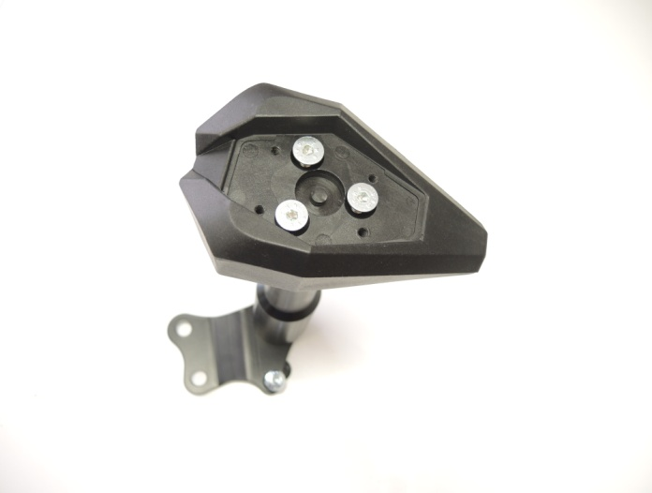

**ID7**

**ID1**

**Installation:**

1. Remove side fairing of motorcycle.
2. Connect steel adapter (ID10) and 150mm poly adapter (ID11) with two M10 screws (ID12).
3. Set rotation of poly rollers correctly (to prevent damage of fairing)
4. Now connect this adapter with frame of motorcycle using original screws.
5. Don’t forget to Place steel rod (ID14) between adapters using screws M8 (ID13).
6. Put fairing back (note: If poly roller touches fairing set rotation of poly adapters correctly)
7. Now place slider (ID1) on slider adapter (ID4) using M10 screw (ID9).
8. Tighten slider with three screws M6 (ID7).
9. In the end connect cover with two screws M4 (ID8).

**Warning – we recommend to use safety glue on threads. (medium strong – blue colour).**