K26-2
Kawasaki ZX250R-Ninja 2008-

Kit for the left side |  |  |  |  | Kit for the right side
No. | Description | Cat.no. | Pcs |  |  | No. | Description | Cat.no. | Pcs
1 | Steel box M10 | X1 | 1 |  |  | 1 | Steel box M10 | X1 | 1
2 | Bolt M10x40mm | 854 | 1 |  |  | 2 | Bolt M10x40mm | 854 | 1
3 | Steel adapter | 626 | 1 |  |  | 3 | Steel adapter | 627 | 1
4 | Poly cylinder d= 150mm | 463 | 1 |  |  | 4 | Poly cylinder d= 150mm | 463 | 1
5 | Bolt M10x30mm | 888 | 1 |  |  | 5 | Bolt M10x30mm | 888 | 1
6 | Bolt M8x25mm | 831 | 1 |  |  | 6 | Bolt M8x25mm | 831 | 1
7 | Dural.bar AL16(M8)x209x30x30 |  | 1 |  |  | 7 | Tape 3M |  | 1
8 | Tape 3M |  | 1

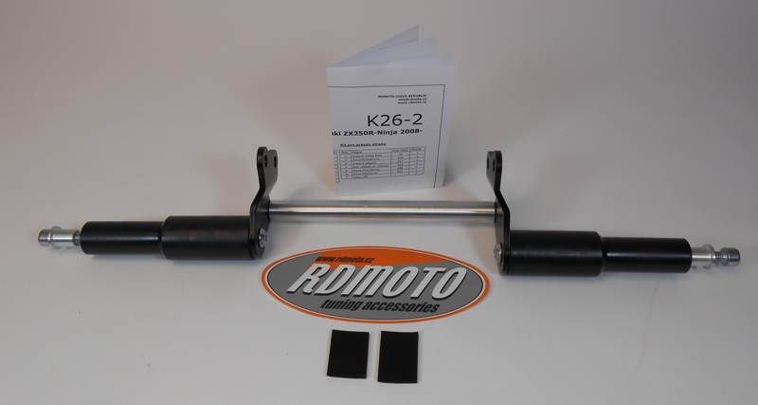

Installation:
- remove the side cowl
- use the bolts (No. 5) for gripping of poly cylinder (No. 4) to steel adapters (No. 3), screw up only lightly, that you can turn with this cylinder
- this prepared steel adapters mount to the frame of the motorcycle, use the original bolts, give duralumin bar (No. 7) between adapters, use the bolts (No. 6) for tightening
- mount side cowl back and turn poly cylinders right, cylinders should go together to cowl
- remove the side cowl again and screw up all
- mount cowl back, give steel box (No. 1) together with bolts (No. 2) into protectors, this prepared set mount into the thread in poly cylinder
Warning – we recommend to use safety glue on threads of all bolts (moderate strong – blue colour).
