K27SD
Kawasaki Z1000 2010-13

Kit for left side: Kit for right side:
ID | Description | Cat.no | QTY
1 | Slider RDmoto | SLD | 1
2 | Adapter for SLD d= 15mm | DV 9 | 1
3 | Washer M8 | 800 | 2
4 | Bolt M8x25 | 815 | 2
5 | Bracket for SLD | 537 | 1
6 | Bolt M10x45 | 848 | 1
7 | Dural. adapter | 549 | 1
8 | Dural. cylinder d=19mm | 460 | 2
9 | Bolt M10x100x1,25mm | 892 | 1
10 | Bolt M10x110x1,25mm | 928 | 1
11 | Plastic cover | X4 | 2
12 | 3M tape |  | 1
ID. | Description | Cat.no. | QTY
1 | Slider RDmoto | SLD | 1
2 | Adapter for SLD d= 15mm | DV 9 | 1
3 | Washer M8 | 800 | 2
4 | Bolt M8x25 | 815 | 2
5 | Bracket for SLD | 537 | 1
6 | Bolt M10x45 | 848 | 1
7 | Dural. adapter | 548 | 1
8 | Dural. adapter | 550 | 1
9 | Dural. cylinder d=8mm | 462 | 1
10 | Dural. cylinder d=11mm | 461 | 1
11 | Bolt M10x100x1,25mm | 892 | 1
12 | Bolt M10x80x1,25mm | 920 | 1
13 | Bolt M6x30mm | 863 | 2
14 | Plastic cover | X4 | 2
15 | 3M tape |  | 1

Instruction to assemble- left side:
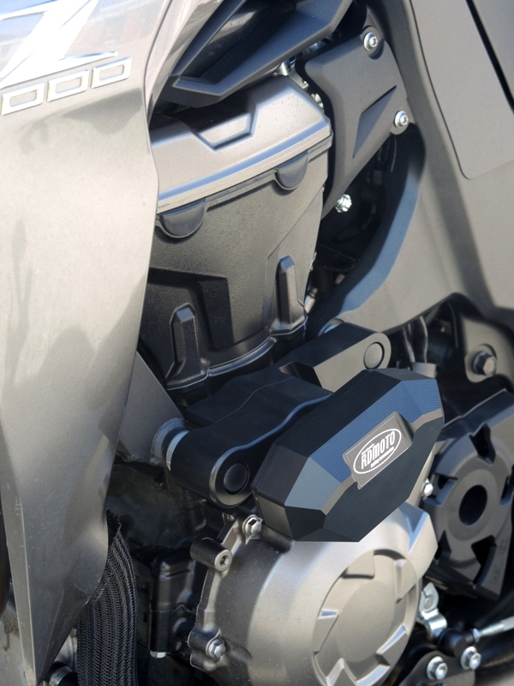
- Dismantle original bolt from frame.
- Connect duralumin adapters (ID 7 and 8) use bolts (ID 13).
- Insert bolts (ID 11 and 12) into the adapters, put on the bolts dural. cylinders (ID. 9 and 10) and mounting this set on the frame.
- Put on the bolts plastic cover (ID 14) sticking 3M tape on the frame, wher is touching point between frame and dural.adapters.
- By bolt (ID. 6) mounted dural. adapter for slider (ID. 2) and steel bracket (ID 5).
- Mounting slider (ID. 1) by bolts (ID. 4) and washers (ID3).

We recommend: Use the glue of threads- medium strong (blue color).

Instruction to assemble- right side:
- Dismantle original bolt from frame.
- Také adapter (ID 7),insert bolts into the adapter (ID 9 and 10) put on the bolt dural. cylinder (ID 8).
- This adapter mounting on the frame, put on the bolts plastic cover (ID 11).
- By bolt (ID. 6) mounted dural. adapter for slider (ID. 2) and steel bracket (ID 5)
- Mounting slider (ID. 1) by bolts (ID. 4) and washers (ID3).

We recommend: Use the glue of threads- medium strong (blue color).

