K27
Kawasaki Z1000 2010-13

Kit for the leftside |  |  |  |  | Kit for the right side
No. | Descritpion | Cat.no. | Pcs |  |  | No. | Description | Cat.no. | Pcs
1 | Steel box M10 | X1 | 1 |  |  | 1 | Steel box M10 | X1 | 1
2 | Dural.cylinder d=15mm | 9 | 1 |  |  | 2 | Dural.cylinder d=15mm | 9 | 1
3 | Duralový adapter | 548 | 1 |  |  | 3 | Duralový adapter | 549 | 1
4 | Duralový adapter | 550 | 1 |  |  | 4 | Dural. cylinder d=19mm | 460 | 2
5 | Dural. cylinder d=8mm | 462 | 1 |  |  | 5 | Bolt M10x60mm | 850 | 1
6 | Dural. cylinder d=11mm | 461 | 1 |  |  | 6 | Bolt M10x100x1,25mm | 892 | 1
7 | Bolt M10x60mm | 850 | 1 |  |  | 7 | Bolt M10x110x1,25mm | 928 | 1
8 | Bolt M10x100x1,25mm | 892 | 1 |  |  | 9 | Plastic cover - black | X4 | 2
9 | Bolt M10x80x1,25mm | 920 | 1 |  |  | 10 | 3M tape |  | 1
10 | Bolt M6x30mm | 863 | 2
11 | Plastic cover - black | X4 | 2
12 | 3M tape |  | 1

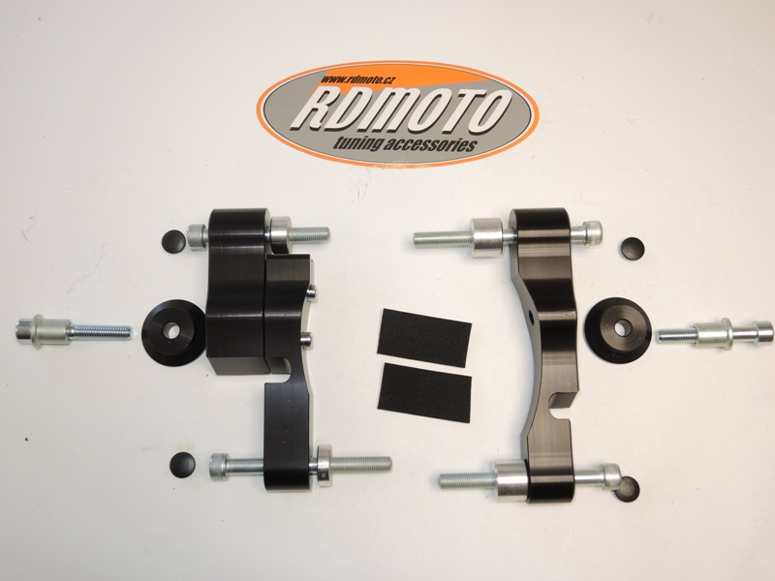

Installation – the left side:

- remove the original bolts
- compile the duralumin adapter together, which has a two parts (No. 3 and No. 4), use bolts (No. 10) for mounting this two parts together
- if you have mounted the adapter, so insert the bolts (No. 8 and No. 9) into the adapter, give the duralumin cylinders (No. 5 and No. 6) on bolts
- all this set mount into the frame of the motorcycle, tighten and give the plastic covers (No. 11) on the head of bolts, use tape 3M for mounting in the place, where the adapter touches the frame of the motorcycle or the engine
- give the steel box (No. 1) on the bolt (No. 7), insert to the protector and the other side of the protector give the duralumin cylinder (No. 2) on the bolt
- all this set mount to thread on duralumin adapter

Warning – we recommend to use safety glue on threads of all bolts (moderate strong – blue colour).

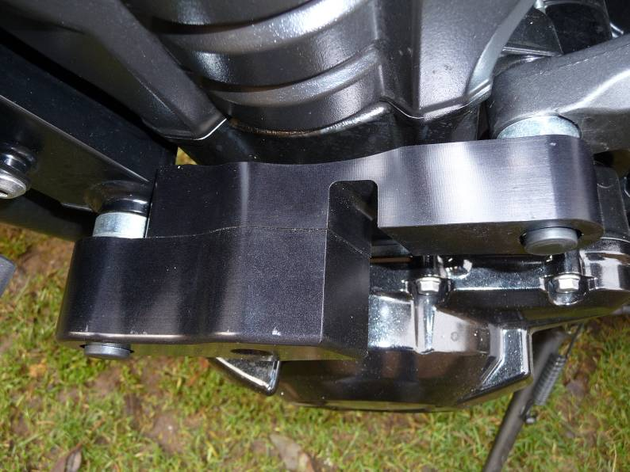
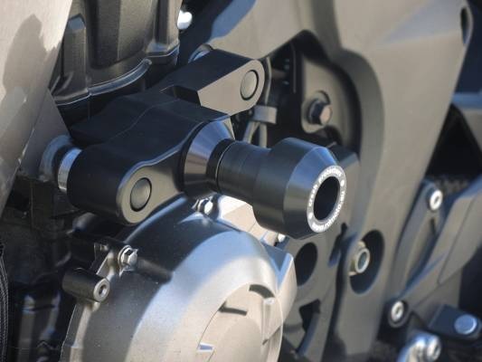

Installation – the right side:

- remove the original bolts
- take the adapter (No. 3), insert the bolts (No. 6 and No. 7) into the adapter, give the duralumin cylinder (No. 4) on bolts
- all this set mount into the frame of the motorcycle, tighten and give the plastic covers (No. 9) on the head of bolts, use tape 3M for mounting in the place, where the adapter touches the frame of the motorcycle or the engine
- give the steel box (No. 1) on the bolt (No. 5), insert to the protector and the other side of the protector give the duralumin cylinder (No. 2) on the bolt
- all this set mount to thread on duralumin adapter

Warning – we recommend to use safety glue on threads of all bolts (moderate strong – blue colour).

