K28S
Kawasaki Z1000 SX 2011-

Kit for the left side |  |  |  |  | Kit for the right side
No. | Description | Cat.no. | Pcs |  |  | No. | Description | Cat.no. | Pcs
1 | Slider RDmoto | SL | 1 |  |  | 1 | Slider RDmoto | SL | 1
2 | Cover | SLcap.. | 1 |  |  | 2 | Cover | SLcap.. | 1
3 | Adapter moto | DV-313 | 1 |  |  | 3 | Adapter moto | DV-313 | 1
4 | Bolt M6x25 | 877 | 3 |  |  | 4 | Bolt M6x25 | 877 | 3
5 | Bolt M4x16 | 876 | 2 |  |  | 5 | Bolt M4x16 | 876 | 2
6 | Duralumin adapter | 548 | 1 |  |  | 6 | Duralumin adapter | 549 | 1
7 | Duralumin adapter | 550 | 1 |  |  | 7 | Dural. cylinder d=6,5mm | 403 | 1
8 | Dural. cylinder d=3mm | 402 | 1 |  |  | 8 | Dural. cylinder d=16,4mm | 404 | 1
9 | Bolt M10x30mm | 882 | 1 |  |  | 9 | Bolt M10x30mm | 882 | 1
10 | Bolt M10x100x1,25mm | 892 | 2 |  |  | 10 | Bolt M10x100x1,25mm | 892 | 1
11 | Bolt M6x30mm | 864 | 2 |  |  | 11 | Bolt M10x60x1,25mm | 896 | 1
12 | Plastic cover - black | X4 | 2 |  |  | 12 | Plastic cover - black | X4 | 2
13 | 3M tape |  | 1 |  |  | 13 | 3M tape |  | 1
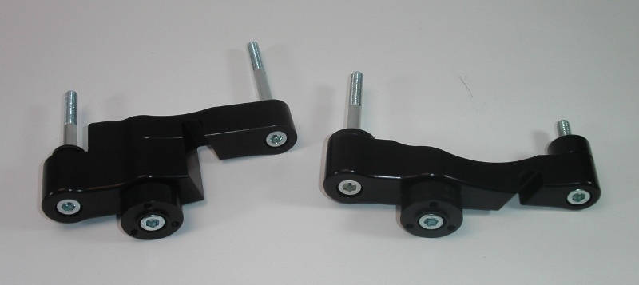

Installation – the left side:

- remove the original bolts and cowl
- compile the duralumin adapter together, which has a two parts (No. 6 and No. 7), use bolts (No. 11) for mounting this two parts together
- if you have mounted the adapter, so insert the bolts (No. 10) into the adapter, give the duralumin cylinder (No. 8) on the front bolt
- all this set mount to thread into the frame of the motorcycle, tighten and give the plastic covers (No. 12) on the head of bolts, use tape 3M for mounting in the place, where the adapter touches the frame of the motorcycle
- if you mounted duralumin cylinder, you can mount gripping for slider. Now use the bolt (No. 9) for mounting of duralumin cylinder (No. 3) on the duralumin adapter, you have to mount adapter with thread M6 up, then slider have the right rotation.
- put slider (No. 1) and use the bolts (No. 4) for mounting
- insert in slider the cover (No. 2) and use the bolts (No. 5) for gripping

Warning – we recommend to use safety glue on threads of all bolts (moderate strong – blue colour).

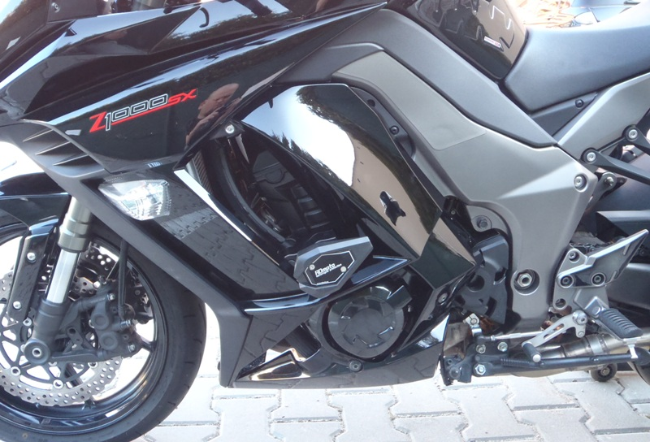

Installation – the right side:

- remove the original bolts and cowl
- take the adapter (No. 6), insert the bolts (No. 10 and No. 11) into the adapter, give the duralumin cylinder (No. 7) on the front bolt and the duralumin cylinder (No. 8) on the rear shorter bolt
- if you have mounted the adapter, so insert the bolts (No. 13) into the adapter, give the duralumin cylinder (No. 11) on the front bolt
- all this set mount to thread into the frame of the motorcycle, tighten and give the plastic covers (No. 12) on the head of bolts, use tape 3M for mounting in the place, where the adapter touches the frame of the motorcycle
- if you mounted duralumin cylinder, you can mount gripping for slider. Now use the bolt (No. 9) for mounting of duralumin cylinder (No. 3) on the duralumin adapter, you have to mount adapter with thread M6 up, then slider have the right rotation.
- put slider (No. 1) and use the bolts (No. 4) for mounting
- insert in slider the cover (No. 2) and use the bolts (No. 5) for gripping

Warning – we recommend to use safety glue on threads of all bolts (moderate strong – blue colour).

