K29S
Kawasaki ZX-10R (11-)
Kit for the left side |  |  |  |  |  |  |  | Kit for the right side
ID | Description |  | Cat.no. | Pcs |  |  |  | ID |  | Description |  | Cat.no. |  | pcs
1 | Moto adapter |  | DV 321 | 1 |  |  |  | 1 |  | Moto adapter |  | DV 322 |  | 1
2 | Bolt M10x50x1,25mm |  | 921 | 1 |  |  |  | 2 |  | Bolt M10x70x1,25 |  | 898 |  | 1
3 | Bolt M6x25 |  | 877 | 3 |  |  |  | 3 |  | Bolt M6x25 |  | 877 |  | 3
4 | Bolt M4x16 |  | 876 | 2 |  |  |  | 4 |  | Bolt M4x16 |  | 876 |  | 2

Instructions:
- We recommend to use the glue on all threads (medium strong).
- Remove original bolt from frame of motorcycle.
- Use bolt (ID2) for tightening moto adapter (ID1) on the frame of motorcycle.
- Note: longer bolt with adapter is on the right side.
- Fit slider on the moto adapter using three bolts (ID3).
- Fit coloured cover using two bolts (ID4).

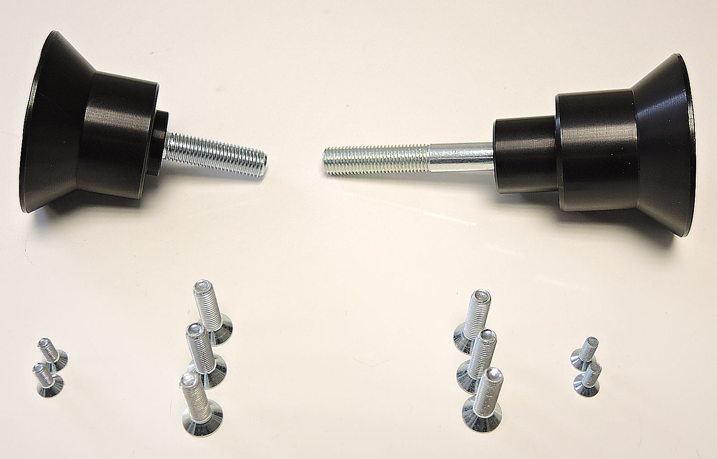

ID1
ID3

ID3

ID4

