K2
Kawasaki ZX-6R 2003-2004

Fitting kit left side: Fitting kit right side:
ID | Description | Cat.N | Qt
1 | Steel box M10 | X1 | 1
2 | Nut M10 locker | 810 | 1
3 | Bolt M10x140 | 953 | 1
4 | Dural.cylinder d=62mm | 151 | 1
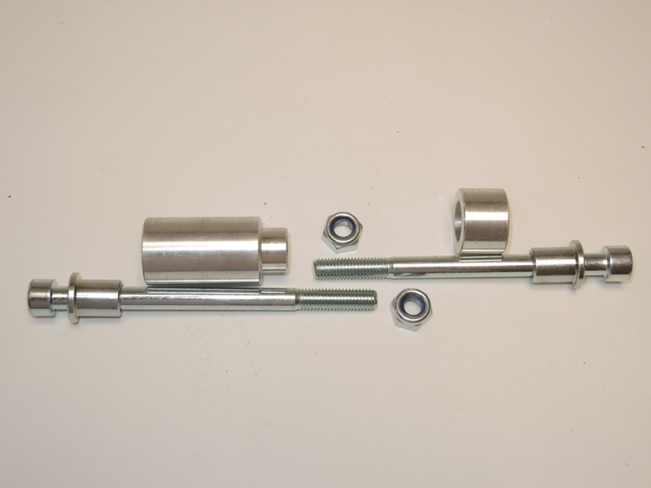
ID | Description | Cat.N | Qt
1 | Steel box M10 | X1 | 1
2 | Nut M10 locker | 810 | 1
3 | Bolt M10x130 | 883 | 1
4 | Dural.cylinder d=20mm | 150 | 1

4
4

2
1
1

3
3

2

Fitting instruction left side:
- Into the protector insert ID.1 and after insert bolt ID.3.
- Put the dural.cylinder ID.4 under the protector.
- This kit mounting on the frame.
- Tighten bolt by nut ID.2.

Fitting instruction right side:
- Into the protector insert ID.1 and after insert bolt ID.3.
- Put the dural.cylinder ID.4 under the protector.
- This kit mounting on the frame.
- Tighten bolt by nut ID.2.

Warning: We recommend use the glue of all threads. Medium strong.

